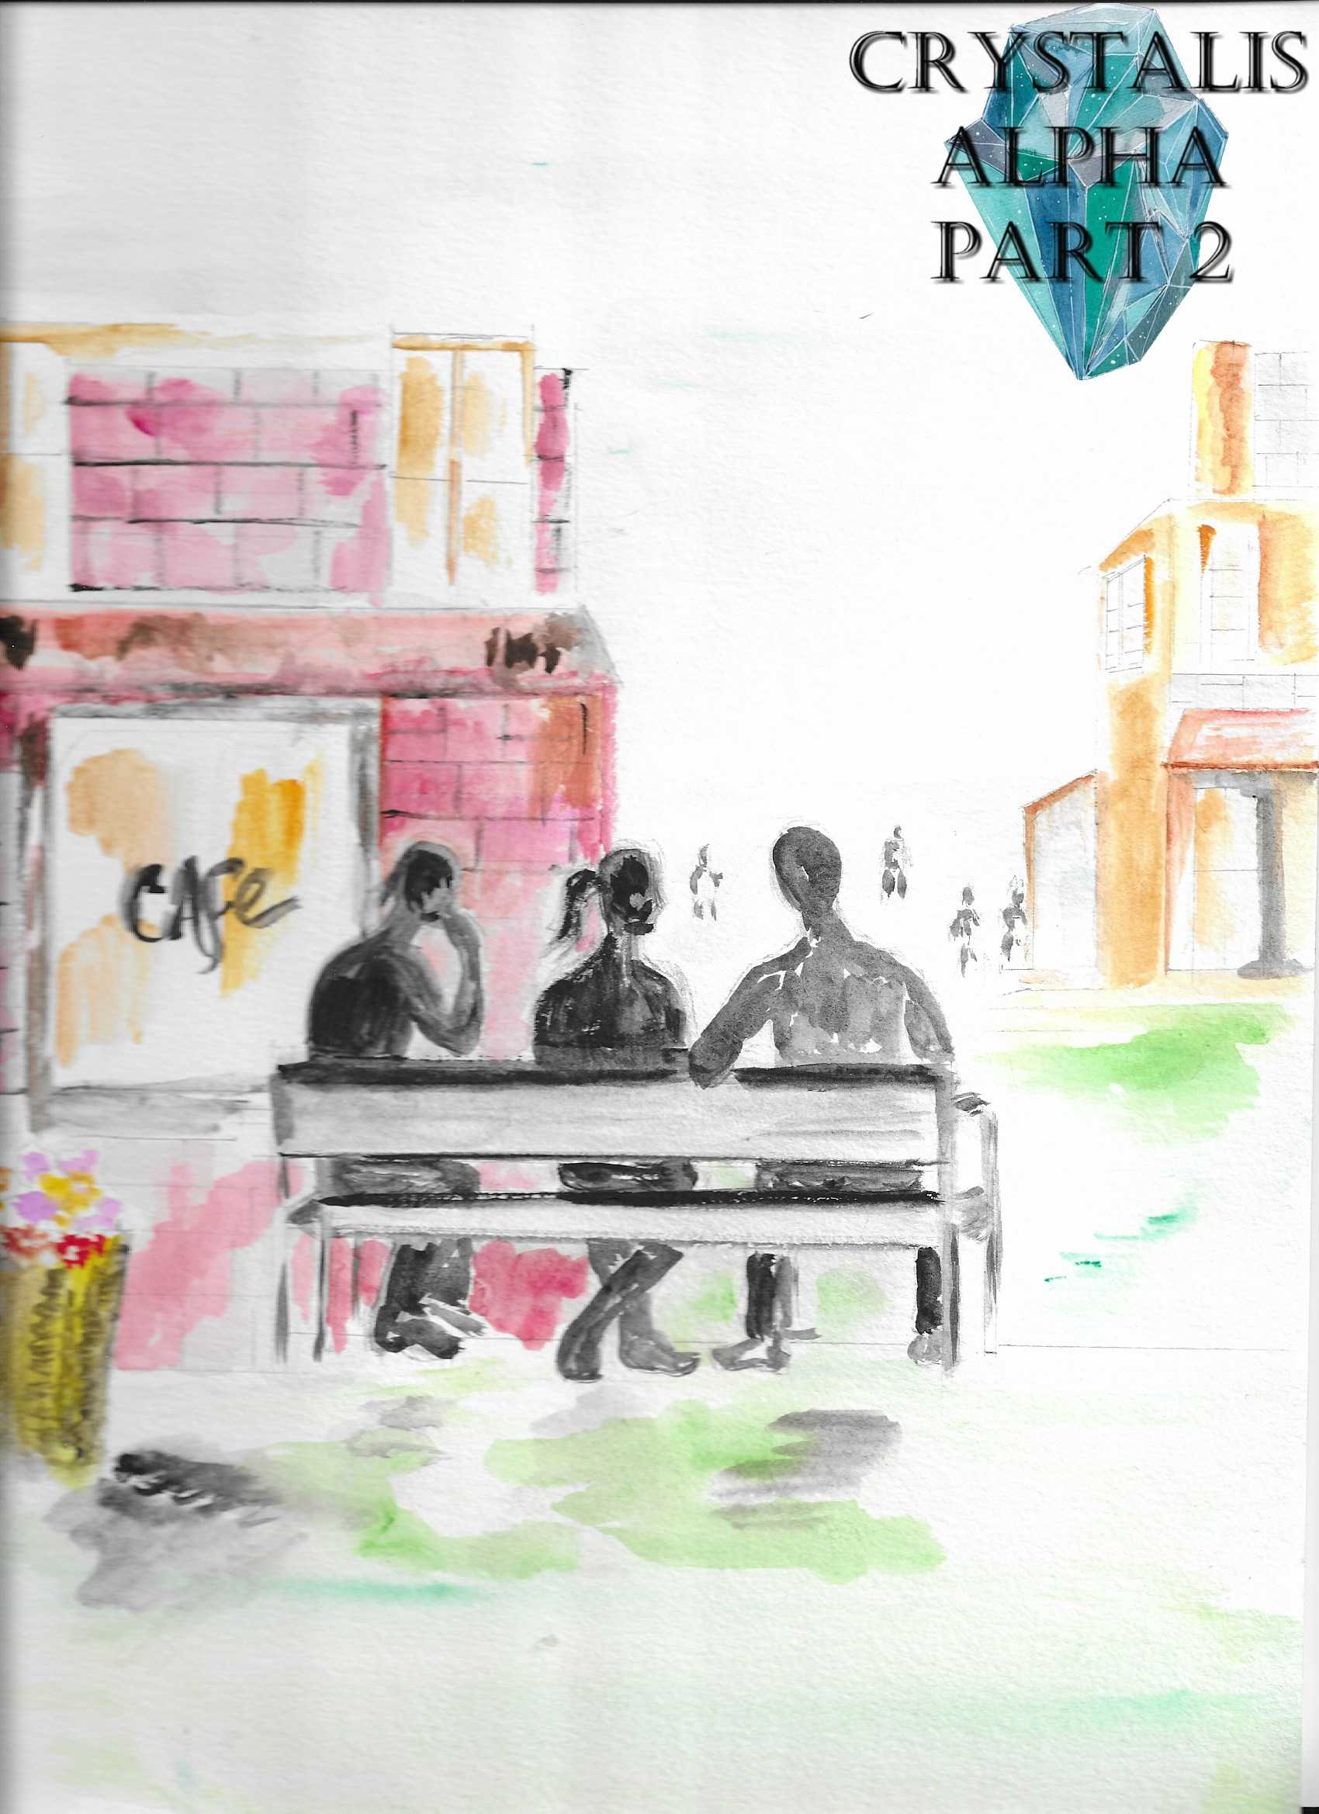

Crystalis Alpha (A Part of The Crystalis Saga)
Copyright © 2013 James Bullock
Copyright Registration #: TXU001847418
Cover art and design: Vickie Bullock (vickiesart.com)

All rights are reserved to the author. No part of this ebook may be used or reproduced in any manner whatsoever without written permission except in the case of brief quotations embodied in critical articles or reviews.

This is a work of fiction. Names, character, places and incidents are either the product of the author’s imagination or are used fictitiously, and any resemblance to actual persons, living or dead, business establishments, events or locales is entirely coincidental.

The Attack

Princess Serena of Gonaga and the Jaradians Jake and Jas gazed into the sky as Gonaga crumbled around them. After helping a woman out of her destroyed home, Jas realized something vital.
“Serena!” Jas said to gain the princess’ attention. “We still haven’t seen your sister.”
Only a couple of hours earlier the three were facing death. Now the entire land of Gonaga had a chance to perish. Only a couple of hours earlier…

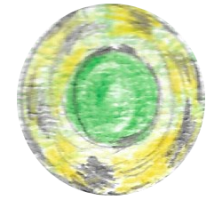

Empress Oni of Jarad made her presence in Gonaga known for the first time in nearly half a century by ordering her army to kill most of Gonaga’s militia. Trying to stop the empress’ commanded onslaught, King Goga III found himself badly wounded by his enemy’s energy. Jake and Jas were able to injure Jarad’s supreme ruler with their sword and sickles respectively, causing the empress to retreat with the help of Jas and Jake’s old friend, Dash. But Empress Oni didn’t leave Gonaga without the key handed down to King Goga III by his ancestors – a key that allowed someone to gain possession of the powerful, yet mysterious Gonagan Crystal.
Several guards stumbled into Gonaga Castle’s Conference Room when they saw Empress Oni leave. The sentinels instantly found Princess Serena slumped over her father’s motionless body. Two of the guards grabbed their majesty, taking him to the royal family’s personal medical area. Plopping on the ground alongside a staggered Serena, Jas and Jake attempted to console the mentally collapsing princess.
Thinking for a few moments, Jas wanted to know, “Princess, where’s your mom? A king has to have his queen, right?”
Princess Serena explained that her mother was from a country less than three hundred miles north of Jarad, “Yafan. My father… my fa--!”
Jake didn’t know what to do as the rising Princess Serena fell against him. Jake motioned for Jas to take his spot, but his friend refused. Two injured Gonagan sentries hobbled into the room to check on their princess after being alerted about King Goga’s injury. Quickly telling them why the princess was crying and why they suspected that her mother was in trouble, Jas practically ordered these defenders to recover their queen.
“Who is this kid?” one Gonagan asked the other.
Jas puffing his chest made Jake physically shake the princess back to their present moment before his friend did something that got them in trouble.
Collecting herself mentally, Princess Serena explained the possible situation her mother was in, “If Oni gains contact with Mother’s ship she’ll--”
Jas interrupted the princess by warning her listeners, “If you goons don’t get out there and find out where your queen is you’ll have another situation like we had in here!”
When Jas finished his blunt statement, Princess Serena let out a horrific wail followed by tears.
Jake punched Jas’ left arm; wondering out loud, “What is wrong with you?”
One guard tried to help his princess to her room as the other told Jake that they couldn’t go after the Empress of Jarad.
Jake verbalized his lack of understanding, “Your queen – the Queen of Gonaga – might be in life-threatenin’ danger, and you’re not gonna find her?”
Crestfallenly shaking his head beforehand, the sentry explained, “Oni’s army took out too many of our men. The king retired all of our battleships several years ago. I don’t know the status of the planes or if we have any capable pilots not injured. There is King Goga’s traveling ship.”
Jake responded upon processing the guard’s answer, “You’re tellin’ me the most powerful land in the world is doesn’t have a single war-ready ship with an army probably in the low double-digits? Do you think you can get that one ship ready for war?”
“That ship wasn’t made for war. And even if we did arm it, it’d take at least a week with our crew in such dire straits.”
As Jake and the castle guard continued their upsetting conversation, Jas noticed the other sentinel who escorted Princess Serena to her room had returned to his spot near the door.
Jas asked the princess’ former escort, “Why aren’t you guarding Serena’s room?”
Jas’ eyes almost popped out of his head when the guard told him, “She said she needed to take a walk.”
Turning to Jake, Jas yelled, “Serena’s run off!”
Jake shoved the talkative guard out of his way as he left the Conference Room.
Staring at the lush blue sky from her position atop Gonaga Castle’s front steps, Princess Serena said to herself, “What can I do? I can’t do anything to save Mother like this.”
A familiar sound of the castle’s large, immaculately designed, steel doors sliding open concluded the princess’ soliloquy. Not wanting to be a part of anything or speak to anyone at the moment, Princess Serena ran toward the streets. Gonaga’s first princess slipped around the front gate just as Jas and Jake exited her home.
Jas decided it’d be best for them to split up, “Jake, you go that way, I’ll go this way.”
“Right,” Jake agreed; stepping off the castle grounds. “She couldn’t have gotten too far.”
The former members of Jarad’s army scoured the town, asking anyone if they’d seen Princess Serena.
One woman told Jake she thought she saw little Princess Athena, “…but she was being dragged by the arm from the castle. I just thought it was a Gonagan soldier escorting her out of the area. Please don’t tell me I was wrong.”
Almost an hour had passed since his search began when Jas found Princess Serena on a bench near Gonaga’s famed Marketplace – the main source of shopping in the land. Jas honestly didn’t know if he should confront the Gonagan princess or just watch from afar. The sounds of footstep turned Jas’ attention from his original target to whoever was approaching him. Thankfully, the person responsible for those steps was Jake.
After Jake asked his friend why he was just standing and watching Serena, Jas said to his questioning comrade, “Look at her. Her father almost got murdered. She doesn’t know where her mom is--”
“And Athena might be in trouble,” Jake interrupted.
Telling Jas about his encounter with a townsperson during his search for Princess Serena revealed that Gonaga’s youngest child in the land’s royal bloodline may have been kidnapped.
“I don’t think we should tell her,” Jas whispered. “She’s already got enough on her plate. If we tell her about Athena possibly missing she might go off the deep-end. And who knows; maybe the old lady was wrong. Lets get Serena back to the castle as soon as possible and find out if that woman was right on our own.”
Jake understood where his friend was coming from, but felt they needed to confront Serena, “We can’t just stand over here in the shadows all day and wait for her to come our way.”
Moving from his position and taking a seat beside her, Jake tapped the unresponsive princess.
In a monotone voice, Jake said to Princess Serena, “You know we’ve been lookin’ all over for you? I wish you would’ve told me you were goin’ somewhere.”
Following a few moments of awkward silence, the princess solemnly responded, “Sorry, Jake. But I heard what the soldiers said. I don’t know how they’re going to get to Mother in time. If Father were…”
Jas finally left his hiding spot as Princess Serena stopped speaking – their royal host lost in thought for a moment.
The princess asked a nearing Jas, “How did you guys get here again?”
“We sailed,” Jas hastily answered.
“So where’s your boat?”
Jas stood in front of the princess with his left hand in the air so he could explain while counting down what was on his mind, “First of all, it took us almost a day to get here. Second, our raft was destroyed when we hit the shore. Third, we couldn’t catch Oni on a raft even it was still in good shape with three of us since me and big boy almost capsized the thing several times by ourselves.”
Princess Serena, Jas & Jake sat together on the bench, staring downward; all seemingly thinking of a way to get to the Queen of Gonaga before Empress Oni could. Neither of the three had enough time to really ponder on the situation because a slight rumble suddenly quaked Gonaga. Princess Serena’s face turned pale when she peered up. Above her homeland floated several small planes – mostly Gonagan military property. One of the aircraft’s doors unlocked as the plane lowered. A couple of people stood on the plane’s opened ledge.
Jas nudged Princess Serena with his elbow so he could ask her, “Is your mother with them?”
The Gonagan princess didn’t recognize who these individuals were. Fearing for her safety, Jas told Princess Serena that she should remove herself from the Marketplace.
Jake concurred with his friend, “Princess, if you know any good hiding places in the castle, find one and stay there as long as you can.”
Serena refused until Jake yelled at her to leave. Huffing loudly, Princess Serena followed Jake’s order and returned to the castle.
Jas trailed the princess after telling his other comrade, “I can’t let her go alone. You never know, y’know? You just find out what’s going on.”
Jake’s travel for answers quickly became a failure as Gonagans ignored him while scurrying for safety. Realizing that his best bet was to protect Princess Serena, Jake made his journey back to the castle. With his destination in sight, Jake felt a sense of relief flow through his body. That alleviation turned into anger when two Jaradian soldiers from a group of four tackled Jake from behind.
Kicking away two of the attackers responsible for taking him down, Jake found himself being beaten to his knees by stolen batons they took from the fallen Gonagan soldiers during their most recent invasion. Jake removed the sword holstered to his back instead of guarding his body from the heavy blows. Aiming for legs, Jake sliced the two soldiers who gave him an opportunity to rise from his prone position. The troops rolled in agony as blood poured from the deep cuts in their thighs. Jake sensed someone coming behind him. Spinning around, Jake sliced the approaching Jaradian’s baton-holding right hand off.
Smiling at the fourth and visibly youngest soldier, Jake motioned for him to, “Come on.”
The final standing Jaradian rushed Jake, only to meet Jake’s sword’s pommel sternum first. Barely able to breathe, the young warrior asked if Jake could put him out of his misery.
Derisively, Jake replied, “You’re not gonna die. You just shouldn’t do anything like blindsidin’ me. But if you don’t get outta here now, I will grant you your wish.”
“Are you sure?” the downed and fearful Jaradian asked. “I can go?”
“Go.”
Jake watched his former fellow soldier rise from the cobblestone road, hobbling from where he came. Just as Jake moved to restart his walk, he felt someone watching him. Jake turned to find a golden sword at his throat. The person holding this weapon, clothed in a hooded robe with his or her face masked, circled Jake. By the person’s movements, Jake figured out the swordsman was actually a woman of advanced age. Jake devised and successfully executed his plan of tripping his most recent attacker after she forced him to drop his sword.
What Jake didn’t predict was the swordswoman catching herself by using her weapon as a crutch. When she pushed herself from her near horizontal position, the woman prepared another attack. Jake leapt over her incoming swing, catching the sword’s fuller with the palms of his hands. The struggle to keep this sword from slicing him in two left Jake open for a kick to his abdomen that weakened his legs. A now-kneeling Jake glanced up after losing his grip of the enemy’s weapon to find her sword aimed for the top of his head.
Rolling backwards, Jake kicked the quickly approaching sword back at his foe. This mysterious attacker’s sword flew from her hands, landing tip first in the dusty ground. This swordswoman losing her weapon gave Jake the chance to retrieve his own. Not allowing the woman to grab the lost item by jumping in front of her sword, Jake pointed his blade at her now visibly masked face.
Jake asked, “Who are you?” as they circled each other like two hungry wolves over a fresh piece of meat.
Abruptly, the woman stated, “Just a test. You passed with flying colors. Don’t worry. We will meet again.”
Before Jake could attain a real answer, the woman slung something toward the stone road. A ball of smoke exploded from this thrown object, giving her the chance to escape.

Princess Serena led Jas to a secret hiding spot below Gonaga Castle. After the princess situated herself in the small, bomb shelter-like room, Jas figured it’d be okay if he went back out to find Jake. As thoughts of playing with Athena only hours ago still running through her mind, Serena just nodded to answer Jas’ question regarding if she’d be all right by herself. Jas gave the eldest Princess of Gonaga a hasty hug before taking his leave. While Jake ran through the castle’s front gate he noticed Jas heading his way. The look in Jake’s eyes explained their situation.
But Jas had to confirm his assumption was right by asking his friend, “Oni’s fleet’s back and they’re heading for the castle, right?”
Jake admitting Jas was correct brought another question from him, “Did you see Serena’s sister on your way back? That little mud pie isn’t anywhere in the castle, or she’s hiding somewhere not even your favorite princess can find.”
Jake verbally ignored Jas’ comment about Jake’s “opinion” of Princess Serena by telling his friend that Gonaga’s most secure building wasn’t so safe anymore, “Whatever you do, take Athena somewhere far away from here if you find her. I’ll get Serena and we’ll meet up at the shore where we wrecked.”
“Okay. She’s in a room underneath the castle. There’s a trap door between the foyer staircase and the wall. Just hurry up and get outta the castle after you find her.”

Sitting in the dark, Princess Serena’s mind started pondering, Father, can you imagine if Athena grew up and took Mother’s place? Wouldn’t it be great if she took the throne so I wouldn’t have to? Father…
A rumble rocked the princess’ thought process; asking currently unanswerable questions. Following the shaking, Princess Serena heard someone walking in her shelter. Gonaga’s first princess moved from her seat in case this person was here to capture her. She felt her way around the room to potentially avoid this unknown individual before her intended exit.
Serena’s heart rate slowed to normal when a recognizable voice came from the intruder, “Princess, are you down here?”
The princess answered with a question of her own, “Is that you, Jake?”
“Yeah, it’s me. I can’t see a thing down here. Where’s the light?”
As Princess Serena touched the wall behind her, Jake thought of a solution to their dark situation. The princess’ eyes turned from the darkness to a sudden flickering light dancing in front of her. Princess Serena wanted to know where this illumination originated, but Jake’s concern was about their current predicament.
“We gotta get outta here now!” Jake said. “Oni’s sendin’ a bunch of her soldiers this way for you and your sister.”
Before they could leave, Princess Serena had to find out, “Where are Athena and Jas?”
“Jas is lookin’ for Athena now,” answered Jake. “I don’t think she’s even in the castle. I guess she’s smarter than any of us.”
Princess Serena and Jake exited her home to find a horrible sight before them. Staring at the princess and her ally were eight Jaradian soldiers.
Quickly, Princess Serena asked, “Jake, what are we gonna do?”
Jake pulled out the sword holstered to his back, swinging it around as the invading Jaradians rushed them. Cowering behind Jake, the princess watched as her protector kicked and elbowed each charging Jaradian into unconsciousness. Jake periodically glanced behind him to make sure someone hadn’t grabbed the princess while he fought their attackers. Jake’s third momentary attention shift of attention in Princess Serena’s direction allowed a recovering Jaradian trooper to grab his legs. Raising his weapon in the air, Jake prepared for freedom by driving the sword’s pommel against this soldier’s head.
Before Jake could complete his action, another one of the eight soldiers tackled Jake from his left side. Several of Empress Oni’s militia stumbled to their feet, stomping their fellow Jaradian as Jake struggled from his horizontal position atop the castle’s front stoop. Peering into Princess Serena’s fearful eyes, Jake demanded she run.
Suddenly, the scared princess bellowed, “Get off of him!”
An extra exclamation to Serena’s order came when a bright golden aura exploded from her body. The troops surrounding and attacking Jake were sent sailing across the castle’s front yard by this immense energy. Stunned by the princess’ action lay Jake gazing at the color of Serena’s eyes changing from hazel to emerald. The aura that surrounded Princess Serena’s body started whipping around to hit each rising soldier between their eyes. Jake couldn’t believe what he was witnessing as his former mates collapsed. When the energy dissipated, Princess Serena fell to her knees.
“How did you do that?” was all Jake could ask after Princess Serena opened her eyes.
Between coughs, the first Princess of Gonaga responded, “I-I-I don’t know.”
Hoisting Serena off the ground, Jake asked if she needed him to carry her. Thankfully, the princess said she could make it on her own – causing Jake to restart his walk.
“That’s it?” Princess Serena said after following Jake for several silent seconds. “You’re just going to take me at my word and not ensure I’m okay?”
Jake never looked back or stopped walking as he responded, “Usually when someone of impressive power says what they say, they mean it. Hard to believe, I know.”
Jake’s response made Princess Serena think, Did he just say I’m impressive?
The princess and her fellow traveler were barely ten yards from the castle when Serena spotted someone out of the corner of her eye. That someone turned out to be a running Jas trying to gain the princess and his fellow sailor’s attention. Jake met his friend before Princess Serena could catch up.
“Did you find Athena?” Jake immediately asked.
In a disappointing fashion, Jas shook his head. Jas’ mouth opened so he could say something when another explosion rocked Gonaga. Jake and Jas couldn’t help but notice the paleness in Princess Serena’s face as Gonaga continued shaking. Turning around, a shadow of concrete & mortar covered all three awestruck individuals. Before anyone could react, the castle’s steeple crashed into the streets, atop the three fearful watchers.
Several eerily quiet moments passed until Jake pushed a few concrete blankets off of his body. Dust & debris clouded his vision, but Jake physically insisted on finding the other missing bodies. When Jake attempted to stand, an incredible pain shot through his left leg. Glaring down to see what was wrong with his left leg, Jake discovered a jagged piece of metal piercing the appendage.
Okay, Jake thought while clinching his fists. I can pull this out.
Noticing a piece of someone’s shirt blowing from the stones in front of him, Jake grabbed the item so he could bite down on something. With one hard yank the metal slid from Jake’s leg. Immediately after removing the unwanted insertion, Jake used his newly found cloth as a tourniquet. Jake pushed himself upwards, trying to get some feeling back in his leg. Before Jake could fully gain his balance, his eyes were taken away from his leg and placed on his surroundings.
Fires roared around Jake while homes crumbled from aftershocks. Jake started calling out for his friends until a slab of concrete moved beside him. A sigh of relief left Jake’s body when Jas revealed himself and Princess Serena. Jas wiped the dirt from his blond hair after helping Gonaga’s downed royalty to her feet.
Princess Serena said after she stopped coughing, “It was like a comet. A giant red ball came out of the side of the plane, destroying everything in its path. I saw her do it. I saw Oni do it.”
As Jake and Jas conversed minutes after reuniting, Princess Serena tried to calm the hysterical survivors nearby. The circling of another plane overhead turned everyone’s eyes to the sky.
Hovering above the crumbling buildings, a proclamation echoed from this unknown aircraft, “We have destroyed your land, your people, and King Goga! Now, we have the princess! We have Princess Athena!”
Serena screamed for her sister as the plane’s door opened to reveal her gagged sister being held by Dash. Running in the castle’s direction, Serena yelled for Dash to let Princess Athena go. Princess Serena’s mind was racing so fast she couldn’t understand what Jake tried to tell her as he grabbed her right hand. Realizing she didn’t comprehend Jake, he hoisted Princess Serena off of her feet and forcibly carried her behind Gonaga Castle. Jake marched into the castle’s garden even though Princess Serena was pounding his back with her fists. Near the garden’s back wall stood a patch of grass not the same color as the rest.
When Jake let her down, she screamed, “What are you doing? I need to get my sister!”
Rather than answer the princess, Jake found a handle in this discoloration of grass. Pulling this handle revealed a trap door that went underground. Princess Serena begrudgingly trailed Jake down the tenebrous stairway when he wouldn’t let go of her hand.
During their trip downward, Princess Serena admitted, “I’ve lived here my whole life and I never knew there was another underground passage.”
The two kept walking until touching solid ground.
After Princess Serena asked if Jake had a clue where the lights were, someone seemingly awaiting their arrival said, “I got it.”
With the sound of a switch flipping, lights flickered on to reveal a huge hangar housing a small passenger plane Jas – the person already in the room – called, “My newest toy.”
Jas continued speaking to Princess Serena, “This baby can get us to Jarad in less than a few hours. And it’s got enough room for all of us.”
Gonaga’s only free princess leapt for joy, embracing Jas.
She neared Jake to hug him too, but Jake stopped Princess Serena by saying, “We can be happy after we get the queen and your sister back.”
The princess ignored Jake’s words, continuously thanking him.
“What about me?” Jas asked; halting princess’ display of gratitude to Jake. “I’m the one who found this place thanks to some clever interrogating of some military officials. I’m the one who told Jake about it. I’m the only one who can fly between us. He even turned you down for a hug.”
To make Jas feel better, Serena kissed him on the cheek.
The Princess of Gonaga asked following the smooch, “Now, can we get going?”
Jas clutched his chest as if his heart was beating uncontrollably while Princess Serena opened the plane’s only door.
“I think I’m having a heart attack!” Jas jokingly said at a red-faced Jake.
Jake shoved his stumbling friend out of his way prior to telling Jas, “You’ll be havin’ a real heart attack soon if you don’t get on this thing and find Serena’s family.”
Hopping into the cockpit after making sure everyone was situated and opening the doors leading to a tunnel running underneath Gonaga toward the sea, Jas wanted his comrades to know, “This could be one of the craziest rides you’ll ever experience.”
Princess Serena slowly turned to see if Jake was laughing, only to have him inform his nervous associate, “Princess, he’s not joking.”
King Goga’s daughter quickly grabbed her seat’s sides when Jas yelled, “We’re comin’, Oni!”

…to be continued

