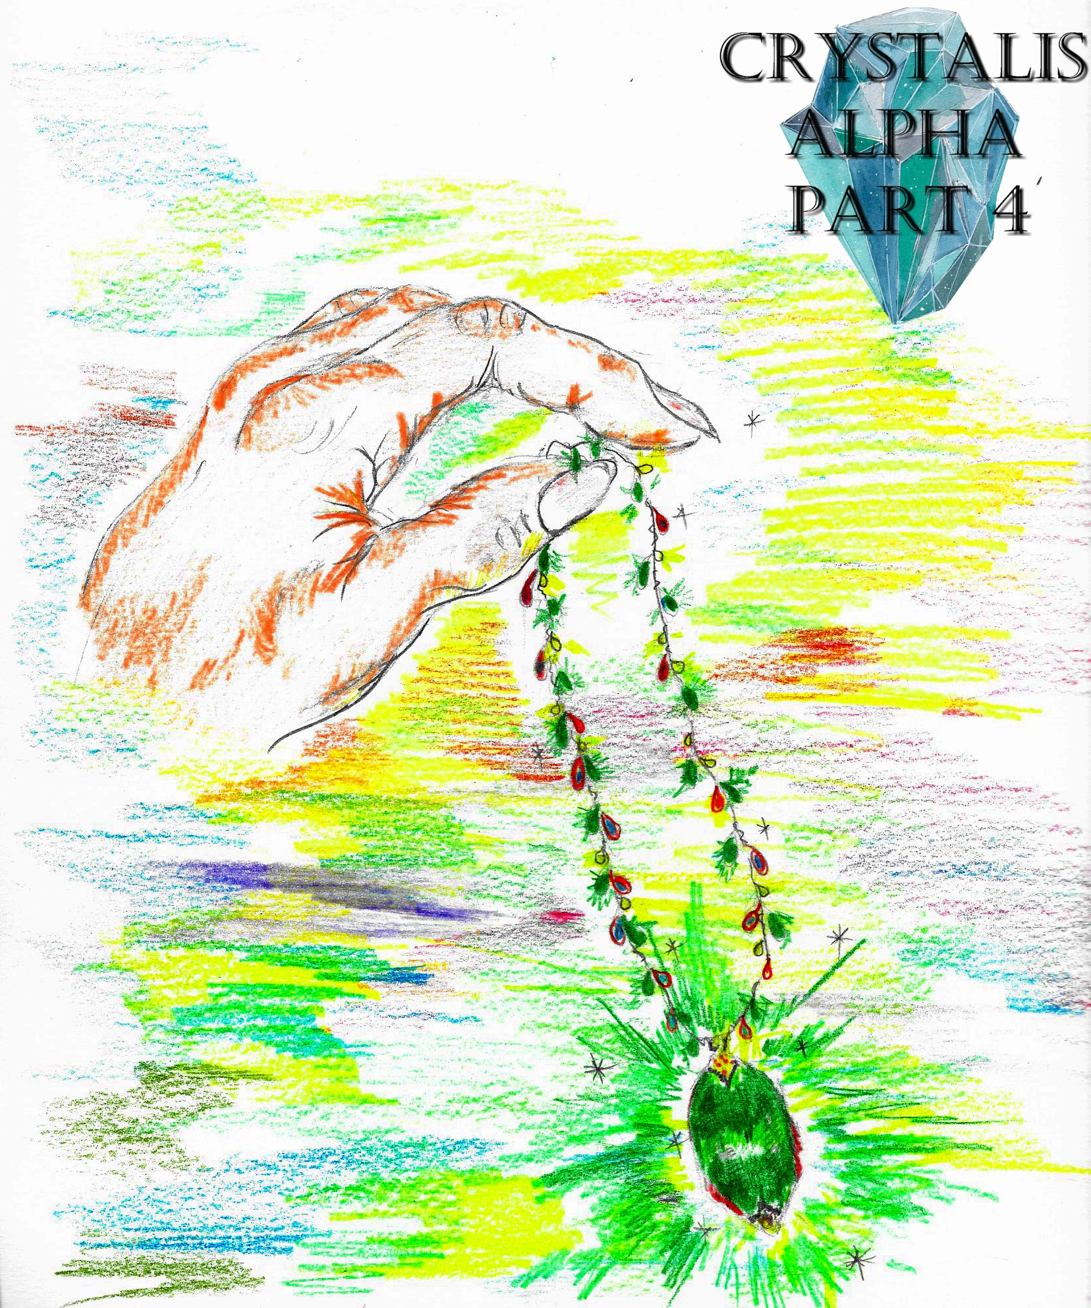
Crystalis Alpha (A Part of The Crystalis Saga)
Copyright © 2013 James Bullock
Copyright Registration #: TXU001847418
Cover art and design: Vickie Bullock (vickiesart.com)

All rights are reserved to the author. No part of this ebook may be used or reproduced in any manner whatsoever without written permission except in the case of brief quotations embodied in critical articles or reviews.

This is a work of fiction. Names, character, places and incidents are either the product of the author’s imagination or are used fictitiously, and any resemblance to actual persons, living or dead, business establishments, events or locales is entirely coincidental.

The Invasion

The usual silence heard from Jarad’s militia disappeared when their empress revealed the capture and interrogation of Queen of Gonaga via a verbal decree and the queen’s one-of-a-kind emerald necklace. After Dash informed his fellow Jaradians about Empress Oni’s plan to attain the Gonagan Crystal, Dash threw his sword into the crowd. The soldiers scattering gave Dash’s sword an open path to land tip first in the ground.
Dash remarked about his upright standing sword piercing the floor, “This ability to stay standin’, even in the solid foundation that is Gonaga’s power & heritage, is what every Gonagan will feel when we make their precious land ours. Isn’t that right, Ken?”
In an impressive show of agility, Dash jumped from his position behind Empress Oni, sailing over four rows of Jaradian troops prior to landing in front of a masked Ken.
As Dash walked around Ken, Princess Serena wondered to herself, How did he know Ken was standing there? If he recognized Ken, he might recognize me.
Wanting to humiliate Ken while putting more fear in the soldiers who fled when Dash pitched his sword, Empress Oni’s second-in-command pulled up Ken’s shirt; showing off his healing wounds. The soldiers gazed in wonder at Ken’s bruised and stitched body.
Still holding his victim’s covering, Dash continued speaking to his fellow soldiers, “As you can see, Ken has learned what happens if you defy us. And through that knowledge, Ken now realizes that the only place for him is in the ranks of Jarad’s best.”
Ken’s right arm shot from his side, clutching Dash’s left wrist.
Before his friend could do anything, Jake grabbed Ken’s powerful arm prior to saying, “This isn’t the time.”
Dash’s attention quickly turned to this intervening soldier.
Who is that? Dash thought. It sounds like…. But it can’t be Jake. He and his little buddy are stuck in Gonaga. And even if they did make it back, the two of them couldn’t beat me. My mind is just playin’ tricks on me.
As Jake forcefully lowered Ken’s arm, Dash said, “You see – this is a man of strength! A man of fortitude! And most importantly, he’s a man of loyalty! He’s not only loyal to his fellow soldiers, but he’s also, most importantly, loyal to the empress and Jarad. Look at the way he stands. Head high, shoulders back, ready for battle. Almost reminds me of myself. What’s your name?”
Lowering his voice in hopes of disguising it, Jake started rambling, “My… name. The, uh, the only thing about my name… it, uh, represents--”
Dash vocally stopped Jake’s bumbling words, “You know what? It doesn’t even matter. Your name is ‘Jarad’ because that’s what you so proudly represent. All of you! Your names represent your love for this land and nothin’ else. This man understands that. He curses the name handed down by his father and mother to be a part of Jarad’s history.”
Dash returned to the stage with his sword in hand before Empress Oni resumed her speech, “In its history, Gonaga has experienced my hand touch its soil thrice. The fourth feeling of my power will leave Gonaga bare of hope. My hand will take away any and everything Gonaga holds close to its heart. And then, it can be rebuilt for us… for me. All the years of waiting, all the years of being ‘bound’ by that treaty, I will stand atop Gonaga as its only queen. Now prepare yourselves for the greatest moment of your lives!”
While the soldiers filtered from the armory, Princess Serena, Jake, Jas, and Ken snuck back to the destroyed village for a wooden trunk Jas discovered while searching through the area’s remains.
“It’s the only physical connection I have to my past,” Jas told his friends during their trip. “I can’t leave it here not knowing what could happen.”
After retrieving the chest, Princess Serena trailed behind her friends as they carried Jas’ trunk. During the four’s trip, a siren sounding from Empress Oni’s palace stopped the Gonagan princess in her tracks.
Princess Serena hastily asked her walking companions, “Hey, you guys hear that?”
Instead of answering, the boys picked up speed. Jas, Ken, and Jake knew the sound meant Empress Oni’s ships were being boarded. The decision to stay alongside their enemies and not make the trek back to their own plane was unanimous among the princess and her allies.
Three ships had already set sail after the Princess Serena-led group arrived at the docks.
When the four disguised comrades attempted to enter the fourth ship, the ushering Jaradian told “fellow soldiers” Princess Serena and Jake, “Only got a spot for two more people. You two will have to get on the last ship.”
Following the usher’s order, the two incognito soldiers took a seat on fifth ship’s back row.
A Jaradian noticing no conversation happening between the last two entering passengers took it upon himself to talk to the lady, “You’re that amazing female soldier, right?”
The unidentified Princess Serena pointed at herself before confusingly asking the questioning individual, “Me? You think I’m--”
“Of course,” he replied. “You must be amazing to make it as a soldier in Empress Oni’s army. So how about you and me go out after we take over Gonaga? Let me show these goons how to treat a real woman. Whaddya say?”
Jake watched the princess trying to ignore her suitor without giving any indication she wasn’t one of them.
Several moments of constant questioning from this trooper angered Jake enough for him to speak up, “Shouldn’t you be concentratin’ on the task at hand? Worry about the ladies later. And when I say ‘ladies’, I don’t mean her. She-she’s… spoken for.”
Princess Serena’s mind couldn’t believe what she heard, Did he just say…?
Upon realizing Jake wasn’t bluffing, this flirting Jaradian came up with a pathetic excuse to get himself out of this predicament, “Aw, she ain’t that great anyway.”
Princess Serena nudged Jake when the situation ended to tell him, “That was very nice. But you didn’t have do that.”
Jake disagreed, “No, I had to. You’re doin’ everything like we want, and I can’t let some testosterone-driven idiot mess it up.”
“If I can go into ‘princess mode’ for a moment, may I ask by whom am I spoken for?”
Jake’s eyes dotted back and forth underneath his brown mask as he responded, “I-I didn’t…. Seriously, do we have to get into that right now?”
With Jarad’s vessels continuing through the foggy sea, the princess’ thoughts had the chance to vocalize themselves, “Something bad could happen if we’re not careful. Many people could die if we lose. My home, my family, everything could come crashing down without a thing to stop it.”
Jake peered down when he felt Serena’s right hand grab his left wrist prior to her asking, “Jake, when everything starts… can you promise not to leave me?”
Even with a mask on, Jake could see the angst disfiguring Princess Serena’s face.
“I’ve made a lot of promises – known and unknown,” Jake admitted. “I haven’t done too well at keepin’ them lately. But if there’s one I know in my heart I can keep it’s this one: Prin-… Serena, no matter what happens in Gonaga, no one will rip me from your side.”

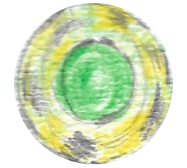

As Jas and Ken situated themselves on the fourth of five ships, a trooper close to Jas commented on his trunk, “Lotta stuff for a Jaradian.”
Jas responded with a story he thought any fellow Jaradian soldier would believe, “Yeah, I got this when we hit Gonaga last time. Poor sap never knew what hit ‘em, y’know?”
The inquisitive soldier slapped Jas’ left shoulder before enthusiastically shouting, “I hear ya!”
Unbeknownst to Jas and Ken, they were placed on the same ship as Dash.
Dash slowly rose from his seat so he could address Jarad’s forces, “Like Empress Oni said earlier – this day is ours. This is the day we finally make the world understand how great we are. Not only are we gonna win, we will be as kings known around the world!”
All the motivated, brainwashed soldiers screamed in approval of Dash’s words.
Jas shifted to his right to ask Ken, “You think we can pull it off?”
Instead of verbally answering, Ken simply nodded his head up and down. Moments later, the pilot informed Dash Gonaga’s damaged docks were in sight.
Dash decided to tell his allies once more before they landed, “I’m almost frothin’ at the thought of what we’re about to do. No man, woman, king, or queen thinks the mighty Gonaga can fall through unnatural causes. And you know what? They’re right. The planet spawned this moment. As controlled as our attack will be, it’s also organic. This is what the world needs.”
In front of Gonaga’s recovering townspeople floated an army ready to destroy everything those men, women and children held dear. When Jarad’s ships docked, the fishermen scurried to warn the unaware Gonagans to find haven while searching for safety themselves. Princess Serena stopped at the ship’s hatch during her exit. In front of the first Gonagan princess flowed violence like she’d never seen.
“They aren’t just taking over,” the princess whispered to herself. “They’re trying to enslave us.”
Jake frantically said to her, “We gotta go now!” in hope of shaking the princess out of her distressed-induced stupor. “If we don’t meet up with Jas and Ken…”
Princess Serena paid no mind to Jake not completing his thoughts. Jake’s eyes were the reason for Jake’s concentration loss upon seeing a robed woman standing in the middle of Jarad’s invading fury. Just as Jake stepped forward in hopes of confronting this woman, she vanished between the fleeing bodies and rampaging soldiers.
When Ken and Jas left the fourth ship, Ken observed Princess Serena and her Jaradian companion glaring aimlessly; yelling for them to get moving like himself. The duo heeded Ken’s words, with the princess leading her friends toward a ransacked building on the docks.
Princess Serena told Jake and Ken after they assisted Jas with his trunk, “We can get these dusty clothes off before anyone spots us.”
Almost immediately, Jake noticed that Ken seemed distracted as they reentered the war-torn streets with their swords unsheathed. Before Jake could question his unfocused friend about his current thought process, Ken ran off for his own mission. Ken’s form disappearing in the mix of smoke and celebrating Jaradians tying up captured Gonagans made Jas ask if they should go after him.
Jake decided against a pursuit of their running comrade, “I think Ken’s got plans we can’t comprehend right now. We had a plan that was meant for three people anyway. The three of us are here and we can complete it. Lets go!”
Jas stopped their progress by questioning if the princess could handle herself without a weapon.
The Princess of Gonaga vocally denied her lack of weaponry, “I brought this.”
In the princess’ hand lay a little pocketknife. Princess Serena’s proud smile turned into a grimace when Jake and Jas started laughing.

Ken’s travel took him to the source of his personal mission.
I know you’re close, Ken thought when he heard a man navigating Jaradians around foreign soil.
Ken realized the voice was that of his target. Walking around the building in front of him, Ken found Dash standing atop a destroyed water fountain. The hunting Ken ran forward with his sword in hand. During his commanding, Dash felt someone powerful nearing him. Quickly turning his attention toward the direction of this unidentified individual, Empress Oni’s right-hand man discovered something quite unnerving: a sword-carrying Ken charging toward him. Understandably surprised was Dash; hastily bracing himself for Ken’s thrusting sword.
The weapon barely missed its target when Dash fell to the ground. Before Ken could react, Dash leg swept his attacker onto his back. A backwards rolling Dash kicked Ken’s sword out of his hands. Several spectating Jaradians decided it was time to intervene on Dash’s behalf.
Empress Oni’s second-in-command demanded that the approaching soldiers, “Stay out of this!” as both he and Ken returned to a vertical stance. “I don’t need your help to beat this failed experiment.”
Ken lunged for his sword, but Dash stopped his aggressor by tackling him. With Ken pressed against the street, Dash wound back in preparation to drive his right fist through Ken’s face. Something abruptly stopped Dash just as his fist came within millimeters of his adversary’s nose. Dash peered down to find Ken’s right hand clutching Dash’s left wrist. Tears formed in Dash’s eyes; his body shivering.
A stunned Dash vehemently asked, “What’s this? What’s all of this? Ken… what are you doin’ to me?”
Energy unlike anything Dash ever felt surged through his body, forcing him to bellow, “No! I can’t…. Not now! Not ever! Empress Oni doesn’t want me…. Mother! Don’t let her…! No, I don’t wanna remember this! I don’t wanna remember any of it! It’s too painful! Ken, please don’t take me back there! Don’t take me back there!”
Ken’s grip tightened while sternly telling the pleading Dash, “This is for your own good. This is you. Everything about me is you. Every memory. Every moment. Every dream. Let your mind be free. You don’t want Oni to control you anymore. Let it go!”
Following Ken’s statement, an explosion of energy in the form of white light emitted from Dash’s body. Everything in a thirty-foot radius went flying, including Ken. People nowhere near the blast felt a rumble and saw its blinding elegance. When the light died, and his energy level returned to normal, a now smiling Dash stared into the dusty sky.
Barely an hour after landfall, Empress Oni’s two abduction squads had captured over one hundred Gonagans; taking them to a designated rendezvous point close to the nation’s main armory. The groups’ leaders wanted to find out what that mysterious, yet powerful light burst was. Those two commanding officers arrived at the flash’s point of origin, finding Dash sitting on his knees in the middle of a crater.
“What happened, Sir Dash?” came from the taller of the two scouts after they approached their empress’ steadfast confidant.
Rather than answer, Dash grabbed the hilt of his sword. The crystal clear double-edged weapon strapped to Dash’s back wasn’t so clear anymore due to a blood-colored hue wavering on the sword’s tip. Holding his weapon toward the sun, Dash could see a change in his appearance through the sword’s reflection.
What happened to my hair? Dash asked himself. Why isn’t it brown anymore? Why is it white? And what is this energy?
Against better reasoning, the statuesque soldier grabbed Dash’s shoulders to ask him, “Sir Dash, do you need some assistance?”
To the soldiers’ surprise, Dash tossed his sword into the sky. The sparkling light from Dash’s flying weapon crossing the sun like an eclipse startled his subordinates. Before the Jaradian troopers could regain their proper vision, Dash spun around to connect with a pair of debilitating kicks against their jaws. Ken couldn’t help but smile when he returned to the area to witness Dash catching his descending sword by its handle before it touched the ground.
Dash said after holstering his sword against his back, “Ken, I think it’s time we help our friends.”

Two miles east of Ken and Dash were Princess Serena, Jake & Jas defending several Gonagans to prevent another capture. The Princess of Gonaga followed Jake’s prior suggestion of standing behind Jas and himself while they fought. Without using their weapons, Jake and Jas awed the princess with their fast strikes and quick avoidances of counterattacks. Unbeknownst to a battling Jas and Jake or the watching Princess Serena crept a lone Jaradian ready to strike her down.
His plan was almost complete; all this soldier had to do was follow through with what he had in mind. With Princess Serena’s back to the preparing soldier, and his former comrades distracted by their fight, the trooper made his move. The Jaradian’s sword rose near Princess Serena’s unsuspecting head. As this man’s arms descended for the first and possible final cut on Serena, he felt something sting his right side. Before the eldest Princess of Gonaga could be struck down, she heard a painful grunt exhale behind her. Princess Serena turning around revealed an unconscious foreign soldier lying at her feet. Above the wannabe attacker, being bathed in waning sunlight, stood a white-haired man. Princess Serena quickly recognized this person. The princess’ cry for help alerted Jake immediately.
“What’s goin’ on?” Jake asked Gonaga’s startled royalty after knocking out their last assaulting Jaradian.
When Jake’s eyes locked on this stoic individual, Jake commanded, “Get away from her right now!”
“There’s no need for that,” a familiar voice echoed from a short distance.
Princess Serena, Jas, and Jake watched as Ken moved from his hiding place to position himself beside Serena’s unexpected savior.
Jas verbally confronted Ken, “You’ve turned traitor like him?”
The silent man everyone knew, but didn’t trust, clutched Jas’ incoming hand before his appendage could grab Ken’s dirty white shirt. After Jas yanked his limb from the person’s grip, Ken asked for everyone to settle down so Princess Serena’s protector could speak.
Flashing a bright, toothy grin, the man standing beside Ken reintroduced himself, “Hey, everyone. My name is Dash. You may not remember me, but I remember you. It’s good to see you again, my friends.”

…to be continued

