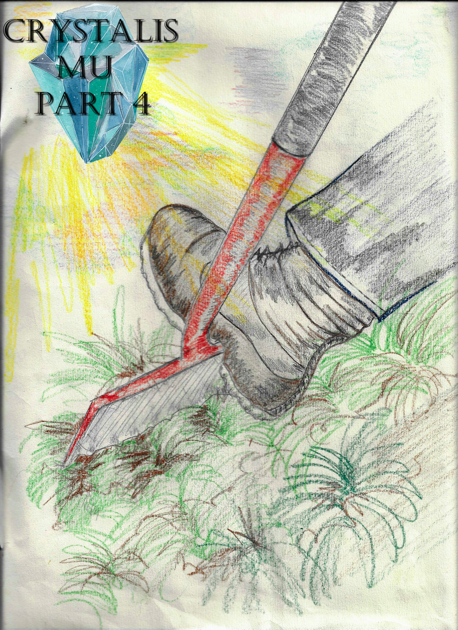

Crystalis Mu (A Part of The Crystalis Saga)
Copyright © 2013 James Bullock
Copyright Registration #: TXU001847418
Cover art and design: Vickie Bullock (vickiesart.com)

All rights are reserved to the author. No part of this ebook may be used or reproduced in any manner whatsoever without written permission except in the case of brief quotations embodied in critical articles or reviews.
This is a work of fiction. Names, character, places and incidents are either the product of the author’s imagination or are used fictitiously, and any resemblance to actual persons, living or dead, business establishments, events or locales is entirely coincidental.

Recondite

A few months had passed since the slaughtering of the first Princess of Gonaga Serena, her husband Jake, and their longtime friend Jas at the hands of Princess Onita – the daughter of Serena’s sister, Queen Athena of Gonaga – after she attained the Gonagan Crystal as a birthday present from her mother. This immaculate stone was the same one Empress Oni of Jarad stole and Serena used to restore Gonaga to the state it was in before Oni’s attack decades earlier.
Upon gaining possession of the crystal, Princess Onita seemingly became possessed by Oni’s spirit – a spirit believed to have gained some type of residency in the famed emerald stone. The combination of her natural born strength and Oni’s essence allowed the little seven-year-old girl to defeat four people who saved the world when they were barely ten years older than her. During the fight, Dash was knocked unconscious and presumed dead when his breathing slowed to a point where it was barely noticeable. Following his friends’ demise and the leaving of Princess Onita & her parents from the area, Dash awoke. Dash took his deceased companions’ weapons, returning home.
Princess Onita’s victory saw Gonaga cutting itself off from the rest of the world when rumors of the heroes’ death spread. Days turned into weeks that the governing officials from the lands of Majan and Tyrong gained no answer from Gonaga’s rulers. During this time, the Gonagan kingdom started a campaign through constant written and audible propaganda distributed by the Gonagan military to convince its people that their heroes passed from this world due to a freak accident during the princess’ birthday party at Gonaga Castle. It became a scary time for the few of those who remembered what their princess did, but couldn’t let the truth be known as some who were bold enough to voice the truth vanished without a trace.
Serena & Jake’s children Rini and Russell spent the months following their parents’ deaths in hiding with fellow orphan Jade – Jas’ daughter – though it seemed they were currently of no concern of Princess Onita. Sadly, Jade’s mother Raye passed away from grief not long after Jas’ demise. In Dash’s home the three orphans eventually stationed themselves after constantly moving into any house that would allow them or even lived in the nearby forest east of Gonaga Castle. Though they saw themselves as fugitives fearful of what was to come for them, Jade, Russell & Rini were determined to avenge their families.
To the shock and somewhat annoyance of everyone living underneath Dash’s roof, Princess Onita hadn’t hunted them down yet. Understanding it was inevitable for Princess Onita to come after the four sooner than later, Dash prepared his three students for that dreaded moment by training from sun up to sundown everyday. In that time, Dash’s pupils grew leaps & bounds both physically and emotionally. Unbeknownst to the four, Princess Onita was working on something else.
King Octavius – who, for some odd reason, accepted his daughter’s murderous actions as self-defense – entered the castle’s Situation Room to find the princess scanning an old map of the world. While it was naturally unreal, the king never questioned his daughter’s rapid growth. The seven-year-old Onita aged greatly during the months following her birthday, appearing three times her actual age. Coincidentally, Princess Onita’s features resembled both her mother and Oni more and more every week. When Octavius inquired about his child’s research, Princess Onita revealed that after many months of work she discovered a way to complete her greatest plan: the full resurrection of Jarad.
Princess Onita told her father with the dual voices of herself and what sounded like Oni, “By using the other key: another Gonagan Crystal.”
Seeing the awe in King Octavius’ eyes, the princess explained herself, “This map is confirmation of something I assumed for years. Identified here [pointing at where the castle stood now] is smaller marker noticeably made after this map was created. I remember mother speaking of more than one Gonagan Crystal existing, and I believe whoever had possession of the crystal last marked this map for their own secret knowledge. Underneath this castle lies an even greater power than the original crystal. If my belief is correct, I’ll be able to resurrect Jarad and have enough power left to complete my transformation.”
The king had to know, “If I may ask, why would you want to resurrect Jarad?”
“Because on that land lies Oni’s most trusted soldiers. If the second Gonagan Crystal posses the power that I believe it does, then we’ll finally have real soldiers. Soldiers without thought. Soldiers without a conscience. Soldiers with the sole purpose of serving their master. But before we get that far, I need to consult a great mind. On a remote island some two hundred miles west of Jarad is a doctor I need you to find. Bring Doctor Otto Vanski to Gonaga.”
King Octavius bowed in honor of his daughter’s wishes.
As the king turned to leave, Princess Onita asked, “How is mother?”
Her father slowly turned around to answer, “She’s… she’s not doing well. She hasn’t eaten in days. She barely drinks anything. I don’t understand how she hasn’t gotten over what happened.”
The anguish in her father’s eyes made Princess Onita ask, “You truly love her, don’t you?”
When Octavius nodded his head in a “yes” fashion, the princess said with great enthusiasm in her voice, “Amazing. Maybe I would’ve felt the same thing if I didn’t choose the path I’m on. But I love power. And just like human love, power can wreck you as much as it can build you. Stay strong, father. I’ll finally make Gonaga the land it is supposed to be.”

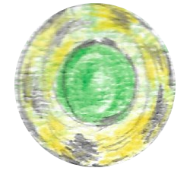

Following an exhaustive day of training, Dash sat down on the edge of his bed after turning on his radio.
It didn’t take long for Dash’s ears to perk with interest as the news reported, “Now, to our top story of the day. Dr. Otto Vanski – a scientist long thought to dead – has been invited to Gonaga Castle by the royal family. The purpose of Vanski’s visit is unknown at this time.”
I can’t believe he really exists, Dash thought. Serena used to talk about her grandfather banishin’ a mad scientist from Gonaga before her father was born. How in the world is he still alive?
Rather than sit inside and ponder questions he didn’t have answers to, Dash reentered his backyard to watch his protégés. The first person catching Dash’s eyes was Russell working on his sword techniques without a weapon. In front of Russell sat his little sister with her legs crossed in deep meditation.
Dash yelled, “Russell, give it a rest! You’ve been workin’ since five this mornin’!”
Russell didn’t respond and continued swinging his arms as if he had a sword in hand. Knowing Rini wouldn’t answer him by talking to her, Dash approached Rini.
Lightly tapping the top of Rini’s head, Dash said, “Knock, knock. Are you okay?”
As Dash assumed she would, Rini didn’t verbally respond. Instead, Rini lifted her right hand before shooting an energy beam to Dash’s left. The beam zoomed past Dash, toward Russell. Dash quickly turned to witness Russell obliterate his sister’s energy with a backhanded slap. Dash reentered his home, searching for the one person he believed would say something to him.
Thinking as he headed down the hall toward Jade’s room was the home’s owner, Only one person left. Hopefully she’s in a better mood than her counterparts. She usually is.
Peaking in after plucking on her door, Dash found Jade uncharacteristically lying on her bed.
“What’s wrong?” Dash asked his youngest student. “Normally you’d be jumping around, planning what you’d want me to cook.”
Dash taking a seat beside Jade’s bed caused Jade to sit up so she could look at him and say, “Uncle Dash, don’t you know what day it is? Many years ago today, you joined Father, Uncle Jake and Aunt Serena to destroy Oni and save Gonaga.”
Dash smacked his forehead in disbelief that he’d forgotten such an important anniversary.
“And now they’re gone,” Jade continued. “We’ve been left behind with the spirit of that same monster you killed controlling our cousin. I just wish….”
With Jade’s words trailing off, Dash looked to comfort his niece by saying, “I know it hurts. And in reality, I can’t relate to what you guys feel. I never had parents. Well, I did, but I don’t remember them at all. But I had friends – the best friends any loser like me coulda have. You three have each other just like we did and I know y’all will do your parents proud when this is all said & done. I’ll let y’all be alone while I go make dinner.”
Dash fixed the evening’s meal of meatballs and corn prior to calling everyone to the table an hour after Dash and Jade’s conversation. Russell quietly ate while Rini gazed into the distance, smacking one of her meatballs around with her fork.
Tired of watching Rini play with her food, Dash somewhat angrily asked, “Aren’t you hungry?”
“No,” Rini retorted. “Can I be excused?”
As Rini stood up, Dash did the same to verbally stop her, “Look, Jade explained to me why you guys are all depressed. Like I told Jade, I can’t sympathize with how you guys are feelin’ ‘cause I never had the privilege of havin’ parents. But those were my friends, too. And I’m hurtin’, too. That’s why I need you guys to stay focused on what’s here and now. And now, we have a mission to complete: Defeat Onita and remove whatever’s possessin’ her.”
Russell sternly asked Dash, “And you really believe that we can at least disable her? I mean, our parents could barely touch her from what you saw and overheard.”
There was little pondering in Dash’s mind before his response, “Russell, I know what Jake told you, and it’s true. Russell, you’ve probably gotten stronger than your dad was in his prime, and that’s amazing. Without even thinkin’, I’ve seen you and Rini produce energy that your mother had the hardest time makin’. And Jade, your passion and enthusiasm is just like your father’s; and that fire Jas had in his heart helped us win. You guys have been trainin’ for years, and it’s payin’ off big time now. But the problem is that you haven’t reached your pinnacle. If y’all will allow me, I’ll train you to reach your maximum so you can defeat Onita sooner than later. Whaddya say?”
Russell stopped eating to look Dash in the eyes so he could say, “Old Man, you got a deal.”

Not far from Dash’s home, under the hazy, setting sun, Dr. Otto Vanski arrived at Gonaga Castle. King Octavius greeted him at the door with a warm smile.
The two conversed as they entered the castle, but Dr. Vanski felt his time was of great essence, “Yes, but let’s catch up on old times later. So what’s this emergency?”
“This,” someone said from atop the staircase King Octavius and Dr. Vanski stood in front of with the dual voices of a young woman and someone from the doctor’s past.
The person before Vanski was a woman who somewhat looked like Oni at a young age.
“Is this her?” Vanski said in shock as he approached his answerer. “Is this Princess Onita of Gonaga? I can’t believe she’s…. She’s absolutely gorgeous.”
Prior to responding, the princess slightly smiled because of Vanski’s words, “Flattery will only get you so far, Doctor. You want to know why you’re here? It’s because you’re the only one who has the ability to sustain & restore the deceased.”
Princess Onita descended the staircase, walking past her guest to stand beside the king.
Grinning once again, Princess Onita told the doctor, “Out of everything you’ve done, nothing is more successful than this man I stand with: my vessel’s father. But what I have planned is even greater than King Octavius. Below this castle lies a crystal containing magnificent power; and with it I can resurrect the land this world wants to forget.”
The confused look etched on Dr. Vanski’s face caused the princess to explain herself, “Jarad. The soldiers that I trained and made my own were unmercifully killed and buried on Jarad by the Gonagan government after my demise.”
“Yes,” Dr. Vanski spoke up. “Then they sank it. For some reason, every land in the world thought it was a good idea to sink Jarad. So you want to return Jarad to its former glory?”
“No. I want the bodies that sleep on that rock. And that’s why I need you. You have Oni’s DNA; her essence. You have everything that could maintain those bodies if I found a way to bring them from the dead.”
The doctor’s eyes widened alongside the princess’ proclamation; responding excitedly, “My word. Princess Onita of Gonaga, it would be an honor to assist you in any task you need of me.”
“I’m glad to hear that, Doctor. And yet, I have something else to ask of you? It regards my namesake…”
Unbeknownst to Princess Onita, the king, and a now intrigued doctor, Queen Athena was listening from the library to the right of their position. When the conversationalists moved away from Queen Athena toward the Situation Room, the queen knew she had to do something. Queen Athena hastily plotted her escape after changing into some dark, baggy clothes, using her sister’s old bedroom window to jump eight feet into a row of shrubs. Creeping around the castle’s exterior, the Queen of Gonaga made her way to the front gate. Athena glanced at the palace she’d known as her home since birth with regret before leaving its grounds.
After an hour of sneaking and running to avoid identification, Queen Athena arrived at Dash’s home to find no one inside. Athena searched through the house until she looked through Jade’s bedroom window. The queen’s family & friends were in the backyard digging a hole. Leaving the house was Queen Athena with an intent to inform the four about a new dire situation. Rini was happily surprised to see her aunt; displaying her joy by tightly embracing Athena. The Queen of Gonaga was just as emotional after not speaking with her family for so many months. Dash had to physically pull niece and aunt apart so he could find out why the queen would risk harm to escape the castle for a family reunion.
Athena collected her herself, telling everyone what was occurring in her home, “Onita’s working on--”
“Gettin’ that other Gonagan Crystal,” a continuously digging Dash interrupted his queen when he realized what Athena was about to say.
“So what are you going to do?” Gonaga’s royalty inquired.
“Nothin’.”
The queen couldn’t understand why Dash would allow something like Princess Onita attaining another Gonagan Crystal to occur.
Taking a deep breath, Dash explained himself, “I can’t do much to stop Onita. But these three can.”
Queen Athena peered at Russell staring stoically into the hole Dash was working on. Blinking, Athena saw something that nearly floored her.
Serena? Gonaga’s queen thought before shutting her eyes tightly.
When Athena’s eyes opened, a clear, wavering image similar to that of Serena’s form stood in Russell’s place. The queen blinked her eyes again to make sure she wasn’t going crazy. Focusing on Russell’s position, Athena noticed his posture being exactly like the ghostly figure.
The apparent apparition eventually dissipated, giving a refocused queen the chance to ask Dash, “Do you plan to kill my child this time?”
“No. Our goal is the same as before. But this time, we might have to be a little more aggressive. And with these, Russell, Rini & Jade have a much better chance than we did. Jackpot.”
Dash dropped to his knees, dusting off the wooden box his shovel hit upon finishing his previous sentence. Leaning back after grabbing a handle on the container, Dash pulled out a large chest. Jade jumped in front of Russell to open the box, revealing the chest’s contents.
Before his pupils could do anything with what they saw, Dash explained the history behind this trunk, “You see, this is the chest that Jas found in Jarad that held his family history; your family history, Jade. To properly add to his and our history, we put our weapons in this chest after we beat Oni. Losin’ to Onita scared me a lot, so I buried the chest. This way, if anything really happened to me, you guys would still be able to fight like your parents.”
Dash grabbed each item prior to saying, “Now, just like we would’ve done, I pass these items of hope down to you. Jade, these are the golden sickles that Jas used to destroy Oni’s first form. Rini, this sword was originally your father’s. After his other sword was given to him, Jake gave this one to your mother. Serena carried this sword into battle with pride. And to this day it’s a symbol of what one person can do. And this sword, Russell, was handled by your dad.”
For some reason, Russell was a little hesitant about accepting the weapon.
When Russell started looking at the sword’s design, Dash audibly educated his students, “Jake got it from a woman he bumped into on the streets of Gonaga before our battle. As you can see, it holds four orbs in its handle. But those orbs except the last one turned into stone after your parents died. Each orb symbolized our life energies. If you notice, one is half black and half white. The amazin’ thing is the orb seemingly started all black, but the white came forth and settled outside; similar to Ken’s creation thanks to Vanski’s handiwork.”
Turning to Queen Athena, Dash told her, “And you might be the wielder of the greatest weapon of them all.”
After the queen asked what Dash meant, he explained, “Through your love, the vessel Oni’s spirit is usin’ – your daughter – is fightin’ the embodiment of evil Oni was; and, I guess, still is. If there’s a chance Onita can overcome Oni’s control it’s through your unconditional love.”
Dash excused himself following his comments. The darkening sky alerted Queen Athena that her time away from the castle was almost over.
Hugging everyone before leaving Dash’s home, the Queen of Gonaga couldn’t help but think, My love can overcome Oni’s evil spirit? Not even my sister could completely rid the world of Oni, and she was the strongest person I’ve ever known.
The queen reentered the castle as easy as she exited it hours earlier.
Several weeks passed with little progress in the search for the “Unknown Crystal of Gonaga”; as dubbed by King Octavius. Dash spent the majority of his days training himself, Russell, Jade, and Rini. A large part of Dash’s tutoring involved energy attacks. Dash explained to his students that the ability to turn their energy into physical manifestations would release their deepest strengths. On their first tries, Rini and Jade handled the tangible production of their energy with great ease. Russell, on the other hand, had a difficult time controlling his energy once it formed.
Slamming his right hand against the ground, Russell groaned, “I’m tired of this.”
While Russell stomped toward the house, Dash belligerently asked, “How are you gonna avenge your parents if you quit now?”
Russell snorted like a raging bull when he turned around. Dash motioned for Jade and Rini to return to the house so he and Russell could have a one-on-one conversation.
The teacher and his only male protégé met eyes as Russell inquired, “Who says I can’t beat her now?”
“I do!” Dash retorted. “You guys may be more powerful than your parents were at your age, but you’re still not half as powerful as Onita with Oni’s energy running through her.”
“I don’t believe that, Old Man. I’m gonna stop her.”
Starting to tremble with anger after his statement, Russell’s body noticeably stiffened as his muscles started bulging before he loudly stated, “I will!”
Immediately following Russell’s declaration, his energy level surpassed anything Dash ever felt from Russell. The son of Jake and Serena almost turned invisible as brown colored energy enveloped him. Russell’s eyes glowed a golden light. Dash had to step back from the force of Russell’s power.
“Sweet serenity,” Dash said to himself. “There’s no way someone his age could produce energy like that.”
Staring at the pulsating, brown energy dome, Dash moved forward to ask, “Russell, are you still in there?”
Russell’s intense focus suddenly broke when Dash repeated his question. Dash’s query ran through Russell’s head, finally sinking in.
Before Russell could answer Dash’s original question, Dash had another request, “Can you lower your energy?”
Russell acknowledged Dash by reducing his energy level to normal – disintegrating the energy dome and regaining his original eye color in the process. Amazed was Dash after Russell’s impromptu display of power.
When Dash questioned if Russell could raise his energy level to that point again, Russell cockily replied, “Yeah, I bet I can.”
Russell bracing himself for what he was about to do caused Dash to call for Rini and Jade. The gleam in Dash’s eyes intrigued the two girls who naturally assumed that the explosion of energy they felt from inside the house came from their caretaker.
Jade asked while she stepped into the backyard, “You really don’t think you can beat Onita by yourself, Uncle Dash?”
The same energy Rini and Jade felt moments ago poured from Russell’s body following Jade’s question. The girls’ eyes widened upon seeing the brown dome cover Russell. Jade and Rini could see Russell smirking at them from inside his creation. To Dash’s bewilderment, Rini and Jade were almost motionless while watching Russell.
Abruptly, Rini and Jade looked at each other before simultaneously asking Dash, “What’s so special about that?”
“‘What’s so special?’ Are you outta ya minds? Russell is producin’ more energy than I’ve ever felt from him. So I know it’s more than you’ve ever felt.”
Sucking her teeth and rolling her eyes, Rini explained her lack of excitement because, “We can do that, too.”
The two females decided to show Dash and Russell that Rini’s big brother wasn’t the only one who could unleash a great amount of energy with seemingly little effort. Shock ran through Dash’s body when Russell’s energy level hit a new maximum alongside Jade and Rini doing their best to match their friend and brother respectively. Instead of asking the girls questions like he did Russell, Dash stared at his students to see how long they could maintain their heightened energy levels.
Russell said at his little sister, “Pretty impressive,” when he felt Rini’s energy level reach his.
Matching the grin on Russell’s face, Rini replied, “I know, right? We could’ve shown off a long time ago, but we didn’t wanna make you look sadder than you already do.”
“I’ll show you who looks sad!”
Breaking through the dome, Russell rushed his sister. Dash couldn’t let a fight breakout featuring two people with energy levels so high that it could destroy everything around them including their home. Russell’s first attack was a simple right punch that Rini blocked with her crossed forearms placed slightly above her chest. A row of uprooted grass & soil flew in every direction thanks to the force of this brother and sister collision. Rather than wait for another strike, Rini sidestepped her older sibling to begin a race. Dash chased behind Russell as Rini egged on her brother while she ran backwards. Once Dash got a hold of his target, he demanded Russell to calm himself. Rini returned to her spot beside Jade after Russell’s energy level normalized again.
Happier than he had been for years, Dash congratulated his students on their actions, “That was absolutely phenomenal. And a display like that deserves a great meal. Lets eat.”
Rini entered the house first, immediately hearing a radio playing.
“Russell!” shouted Rini while sounding similarly to her deceased mother. “How many times do I have to tell you to turn off the radio when you’re done with it?”
Rini continued into the living room to turn off the buzzing radio.
Just as her hand touched the knob, Rini’s ears were grabbed by a news reporter saying, “This just in! After weeks of searching for the second mysterious Gonagan Crystal, Dr. Otto Vanski has uncovered a wall full of ancient writings similar to the old documents that mapped out the whereabouts of the crystal directly under the castle’s Throne Room. Not only that, but Dr. Vanski has also found a passageway through the wall! Our crews are at the scene where this is happening. We’re hearing word that Dr. Vanski is coming out!”
Rini urgently called everyone into the living room. As Dash, Russell & Jade confronted Rini about her outcry, Rini simply pointed at the radio. The four listened intently to a news reporter screaming for a word from Dr. Otto Vanski. Several people could be heard saying the doctor turned archeologist was holding something in a rag when he approached the hopeful questioner.
Exhaling deeply, Dr. Vanski said into the reporter’s microphone, “Ladies and gentlemen, King Octavius, Queen Athena and, of course, Princess Onita… I present to you the lost Gonagan Crystal.”

…to be continued

