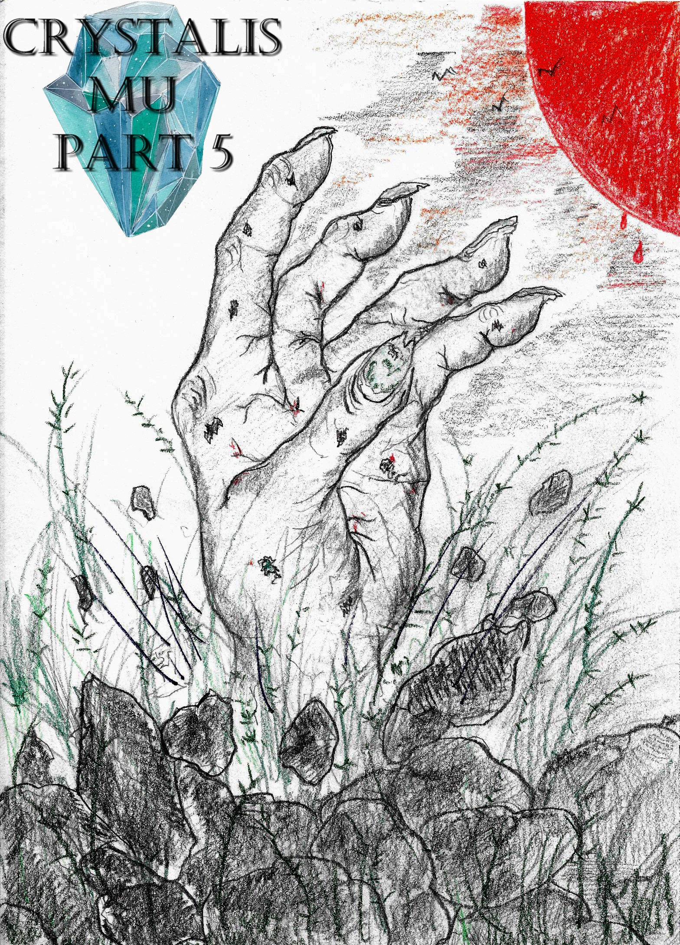

Crystalis Mu (A Part of The Crystalis Saga)
Copyright © 2013 James Bullock
Copyright Registration #: TXU001847418
Cover art and design: Vickie Bullock (vickiesart.com)

All rights are reserved to the author. No part of this ebook may be used or reproduced in any manner whatsoever without written permission except in the case of brief quotations embodied in critical articles or reviews.
This is a work of fiction. Names, character, places and incidents are either the product of the author’s imagination or are used fictitiously, and any resemblance to actual persons, living or dead, business establishments, events or locales is entirely coincidental.

Redemption

Dash, Jade, Russell & Rini stood in their living room, stunned at what they were hearing. Echoing throughout the room were the sounds of gasps from news reporters witnessing a historic moment: the discovery of a second Gonagan Crystal thanks to the research of Dr. Otto Vanski underneath Gonaga Castle. A news reporter so eager to get a word from Vanski commentated on what was happening before him. According to the enthusiastic reporter, Dr. Vanski graciously bowed prior to standing side by side with King Octavius and Princess Onita. As the norm over the past several months, Queen Athena was absent during this historic moment.
Through the noise, the doctor could be overheard saying, “King Octavius, Princess Onita, I present you with the missing Gonagan Crystal.”
Rather than accept the crystal still wrapped in a protective cloth, the king motioned for Dr. Vanski to hand this prized item to his daughter.
With the dual voices of her natural self & what could only be described as Empress Oni of Jarad in tone – a physical trait Princess Onita had since attaining the remaining piece of the original Gonagan Crystal from her mother – the Gonagan princess said to herself, “It’s finally mine.”
The news reporter commented on what was happening, including Princess Onita raising the covered crystal above her head. Suddenly, the cloth caught ablaze; engulfing Princess Onita in the process. King Octavius screamed for his daughter as the powerful consumed her until she collapsed. When the fire abruptly died out, Octavius approached his twitching, smoldering child. Princess Onita’s left arm shot from underneath her, motioning for him to stop moving. Not only was the princess starting to rise after being burned alive, but Princess Onita seemed unfazed by the unnatural occurrence. Though Princess Onita’s clothes barely covered her form, her body was unmarked from the flames that devoured King Octavius & Queen Athena’s offspring.
“I can’t believe what I’m witnessing!” the primary news correspondent said to everyone listening.
Princess Onita approached the admiring reporter to tell him and the people hearing her words, “Hello, Mr. Corbin. Hello, world. For those who do not know, I am Princess Onita of Gonaga – daughter of King Octavius and Queen Athena. I stand with the lost Gonagan Crystal; feeling its exquisite power. Very soon this power will shake the world and its waters will birth a land once ruled by the spirit that resides in me. If you have the ability, I suggest all the lands send a plane or ship to the area where Jarad once stood. You’ll be in for an unexpected surprise if you do so.”
There was audible confusion coming from everyone around the princess. Nearly two hours passed when Princess Onita’s earlier statement came true. Each nation felt a tremendous rumble shake its foundation. As suggested by Princess Onita, the lands of Majan, Tyrong, and Sonfa sent a single plane respectively to observe the waters where Jarad used to be. A third aircraft floated directly across from the two military planes. In the other airplane sat Corbin – the same newscaster who interviewed Princess Onita.
Dash and his students still had the radio on as they ate. Rini’s ear was the first to hear the yelping reporter. Leaving the table, Rini reentered the living room; listening closely to what Corbin was saying.
The news reporter abruptly stopped his ramblings to state, “The ocean looks like it’s bubbling.”
According to Corbin, the commotion below intensified until the sea split in half. In this growing water crevice sat a large rock. This rock floated from its watery holding, revealing its true size. The landmass continued moving upward until it hovered above the waters that released it. When this giant piece of the planet reached the apex of its flight, the ocean crashed into itself.

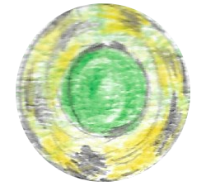

Like a majority of the world, General Hase of the Gonaga’s military forces had his radio on.
Becoming frustrated with the king and queen’s lack of concern about what was happening, Hase grew tired of just listening and demanded a nearby soldier to, “Prep the plane for that slab.”
General Hase hopped into his vessel, leading a group of three jets toward the location of this unusual situation. As each Gonagan aircraft neared the area, a noticeable light started emanating from the land’s edges. The news commentator continued narrating everything he saw, including General Hase’s jet descending toward the glowing landmass. It didn’t take long for Corbin to follow General Hase and his men. Before anyone could touch down, the lights spread throughout the visible area. The ocean gleamed as waves crashed against the recently unveiled surface. Unexpectedly, the illuminated waters transformed into solid ground, connecting to the landmass as the sea collapsed into its original form. Rather than stop his descent, General Hase and the other Gonagan soldiers landed on this newly formed rock when it stopped shaking and the sea calmed.
Unbeknownst to Hase was the fact he had an admirer on his trail: the news reporter Corbin. Cold ocean winds whipped Corbin while he pressed forward in the direction of General Hase. With a powered on walkie-talkie in hand, the news correspondent yelped to his listeners about his trek. Calling Hase’s name finally alerted Gonaga’s military members of the reporter’s presence.
“General Hase!” Corbin shouted one last time when he caught up to the three Gonagan soldiers. “May I ask why you decided to come here when everything’s so unstable?”
Turning to his follower, Hase calmly asked, “Is this being broadcast?”
When Corbin explained that the second walkie-talkie was being used to relay these unbelievable occurrences, General Hase said, “I told my men to get ready, and that’s what they did. I heard Princess Onita and I saw how uncaring the king was about what his daughter said. Then the world started shaking. I am the head of the world’s most powerful military force; I refuse to sit idly by and witness the planet change and potentially threaten our way of life without understanding what’s going on.”
While General Hase and the reporter continued talking, one of the Gonagan soldiers saw something protruding from the ground not far from them. Hastily, the pilots alerted Hase; leading him toward whatever this new point of interest. General Hase finally recognized what was before him and his men.
“That’s an arm,” Hase said out loud.
Corbin assumed the arm belonged to a deceased Jaradian soldier buried at sea following Empress Oni’s death. Looking past the arm revealed more gray colored limbs littering the ground. The general’s attempt at taking another step was halted by one of the hands suddenly latching onto his right ankle. Grunting was General Hase as he demanded his men help him. Hase kicked the hand away without assistance following several seconds of struggling. The general wasn’t done, stomping the appendage until it stopped moving. Turning to find out why no one aided him showed Hase nothing but Corbin’s walkie-talkie on the ground. Hase picked up the communication device, mumbling something when the sounds of screaming echoed.
Someone running could be heard while General Hase’s demanded, “Stay still!”
From the familiar voice of Corbin came a statement, “Thank you. I thought I was done for.”
Hase asked after handing Corbin his lost communication device & recounting the general’s recent harrowing moment, “Where are my pilots?”
“I don’t know. One minute I was standing. The next, those arms were dragging me away from you all.”
General Hase returned his attention to the walkie-talkie, telling everyone listening, “I don’t know what’s going on here, but it’s extremely dangerous. I’ve lost my pilots, and the other planes are just hovering above us. We need help. If the Gonagan military is listening, send a plane or something as fast as possible to help…. What is that?”
The voice of General Hase pleading for help changed into screams and something like carnivorous animals eating freshly caught prey. Gurgling from the site of this commotion reached the airwaves.
General Hase abruptly cried, “Get away from me, you monster!” before unnerving, cracking sounds similar to thick sticks being broken.
Picking up the two-way receiver again, Hase informed the people listening around the world, “They’re alive! It’s not just body parts. It’s the bodies. Someone help me now! Som--”
A loud thump sounded out, seemingly interrupting Hase’s words. But the general never said another word. The earlier chewing noise returned until the signal went dead.

Russell, Rini & Jade blankly stared at Dash as the radio replayed a message stating the broadcast had concluded.
Following several moments of silence in Dash’s home, Rini exhaustingly asked, “What just happened?”
A few seconds of thinking passed prior to Dash’s reply, “I can’t believe I’m sayin’ this, but maybe the dead has come back to life. If Oni can possess a little girl by using a piece of the Gonagan Crystal, it’s not out of the realm of possibility that she could use another crystal to resurrect the dead.”
Moving from his spot beside his little sister, Russell confronted Dash with a question, “So you’re tellin’ me that the dead Jaradians they buried at sea around there have come back to eat people?”
“Do you think it doesn’t sound crazy to me, too? But what other answer is there outside of General Hase losin’ his mind?”
The replaying radio message suddenly stopped during Dash’s response to Russell. King Octavius’ voice abruptly urged everyone listening to remain calm.
Gonaga’s king stepped away; allowing his daughter to speak once again to her audience, “People of Gonaga, please welcome back Jarad. In a few short hours, my father and I will arrive on the rock that floated out of the sea and has already taken the lives of those not worthy to step onto its soil. As my father, King Octavius of Gonaga, said… remain calm. I can guarantee you no harm will come to us.”
As Rini and Jade talked about the possibility of the walking dead – ignoring the princess’ message in the process – Dash pulled Russell aside to ask, “Russ, do you think you can beat Onita right now?”
“Maybe,” Russell responded as his surprised expression turned into one of unbridled cockiness. “But only as long as (Rini and Jade) hold their end of the fight and don’t get in my way.”
Behind Russell’s arrogant answer was a true faith in his ability – a vocalized confirmation of the vengeance burning through his soul. Staring into Russell’s brown eyes made Dash realize that this could be the last time they talked in such a calm manner.
Dash turned off the radio, causing Jade to cry out, “Hey!”
“Jade, I think we’ve heard enough for one day,” was Dash’s response to Jade’s complaining. “Onita’s headed to Jarad right now probably to resurrect all of the dead Jaradians.”
Rini wanted to know how Princess Onita hadn’t completely drained the crystal of its power by restoring Jarad.
Dash assumed that the amount of energy varied between the crystals, “And if that’s the case, there’s no tellin’ how much more she can do. Do me a favor and take a seat. I wanna tell you guys a story.”
After his pupils found their spots on the living room’s only couch, Dash verbally reflected on a time still freshly engrained in his memory, “When your parents and I fought Oni that day, a lot of lives were lost on both sides. Even though Oni was dead, the people were worried about Jarad. Next thing you know, Jarad started sinkin’. The story was a seismic shift destroyed Jarad’s foundation and the whole land collapsed into the sea. The day the news hit that Jarad was goin’ down, I was with Serena and Jas when Russell and Rini’s grandmother decreed that the Jaradians, though enemies of Gonaga, would get a proper burial on the land they called home – the land they died to defend under false pretense.”
Dash took a few seconds to collect his thoughts, looking at the floor until he started speaking again, “I always thought after the queen said that… would I want the same thing? If I really died that day would I want to be buried on Jarad as it fell into the ocean? I drank those questions away for years. And now, with a sober mind, I’m thinkin’ again. If the Gonagan Crystal had… has the power to restore, more than likely it can destroy just as effectively. It’s obvious that we’re not just fightin’ for revenge anymore. Just like all those years ago, we’re fightin’ for Gonaga’s survival. If Oni’s spirit is really possessin’ Onita, then she wants nothin’ more than to destroy Gonaga and make Jarad the real super power of the world.”
Russell angrily declared, “Forget that!”
Almost humorously, Rini and Jade gasped simultaneously following Russell’s statement.
Rather than react, Dash listened intently to Russell continue his thoughts, “Okay, maybe you’re fightin’ for Gonaga, but I’m fightin’ for my family. I’m trainin’ for retribution, not to save some stinkin’ rock.”
Dash couldn’t understand Russell’s priorities; saying to his eldest student, “Gonaga is all that mattered to your mother and your father. That’s why they fought. That’s why I fought.”
“And that was then. This is now, Old Man. The fact of the matter is that all you guys had to fight for was Gonaga. I have somethin’ more important.”
When Russell finished, Jade verbally admitted, “Honestly, I feel the same way. I love Gonaga, but I don’t care if I lived here or in Majan, I’d fight the same way to avenge Mother and Father.”
Dash slapped his forehead; muttering, “Kids these days. Well, I guess as long as you’re motivated, it doesn’t matter what you’re fightin’ for.”
Rini changed the subject by asking how they would get to Jarad without attracting too much attention.
“Well, that’s easy,” Dash explained. “We’ll sneak into the castle and use the plane that your parents and Jas flew to Jarad.”
Russell blurted out, “Is that really necessary? You could just fly me over there and leave the women here to do whatever.”
Like earlier, the ladies Russell was referring to responded in unison, “Really?”
Dash sighed upon saying, “Russell, don’t let your newfound power cloud your judgment. You might be powerful, but not enough to do this on your own.”
“Who says?”
Dash ignored Russell’s ignorance, ordering Rini and Jade to ready themselves for their leaving.
Still insisting he could do everything on his own, Russell grabbed his sword and headed for the front door.
Jade ran behind her best friend’s brother to grab his right arm and ask, “Russell, will you protect me if I get injured?”
Without hesitation, Russell whispered, “No,” before pushing Jade away.
The hurt look on Jade’s face as she whimpered, “Really?” slightly rattled Russell.
“Because you’re not goin’,” became Russell’s follow up statement to his previous declaration.
Stunned was Jade after she thought Russell’s disagreement with Dash destroyed any notion Russell had of fighting alone.
Once again, Jade’s subsequent actions made Russell speak again, “Could you see it from my perspective for once? I don’t need you or Rini ‘helping’ me by gettin’ killed.”
“But we’re the only ones that’s gonna save you,” Jade rebutted.
Before Russell could end the argument and leave, Dash walked out of the house while facing the direction of Gonaga Castle. Russell stomped & huffed when his sister passed him, following Dash and Jade. Arriving at their destination and sneaking around the castle proved much easier than expected thanks to the usual patrolling guards watching over the evacuation site until King Octavius and Princess Onita returned. On the south end of Gonaga Castle’s famous garden lay a door covered with fake grass that led underground.
Dash’s hands ran across the wall in search of something after walking down a staircase behind the door. That “something” was a switch to turn on a row of lights dangling from the ceiling.
After Russell’s eyes adjusted to the rush of light, Russell verbalized his disbelief about what was in front him, “Old Man, how is this hunk of junk gonna get us to Jarad?”
Dash thought to himself, I guess Jas would be mad about someone makin’ fun of his first baby. Him bein’ able to fly this thing one more time would be a thrill to see. He probably woulda killed someone if they tried to fly it without him knowin’. He took such good care of it… until he had Jade. She took his heart; just like this plane. Man, how many times did Jas pull me outta a bar when I was drunk outta my mind? I promised we would go together, but I’m still here. I’ll be seein’ you soon, though.
Once again, Jade and Rini pushed past Russell to jump into the plane first. Dash was right behind the girls.
Turning around, Dash stared at Russell; who was looking away.
When Russell refused to move, Dash jokingly said, “Don’t tell me big, bad Russ is scared of flyin’.”
“I just thought when you were talkin’ about a plane, you’d have somethin’ a little more nice and stealthy in mind. But that thing probably won’t make it off the ground. I guess that’s what I get for tryin’ to reserve my energy for the big battle.”
Jade spoke from behind Dash to agree with Russell, “I know, right. It’s fun, but it wears me out if I do it for too long.”
Dash had to know, “What are you two blabberin’ about?”
Taking his sister’s place by simultaneously speaking with Jade, Russell said alongside his friend, “Flying.”
Jade gently shoved Dash out of her way to show him what they meant. Standing steadily, Jade and Russell used their respective energies to propel themselves upward. The showcase turned into a race as the two fliers circled Jas’ plane. Seeing her brother and best friend playing around made Rini want to join the fun.
Watching his three students gliding in the hanger astonished Dash.
“Well I’ll be,” Dash said to himself. “So I guess you learned how to fly on your own, too. It took us months to perfect the art of flyin’. But you guys just do it without thinkin’? Well, thanks for wastin’ our time sneakin’ in here.”
Dash’s mind shifted back to Jake and Dash’s inability to fly the plane his friend once cherished, I guess Jas is the only one worthy of flyin’ you.
When Dash called an end to Rini, Jade, and Russell’s race, he ordered everyone to return groundside. Taking his first step on the staircase, Dash took one last look at the plane prior to turning off the lights and ascending.
Russell exclaimed before leaping into the sky when everyone made it topside, “To Jarad!”
“That boy will never learn,” Dash said as Rini and Jade followed Russell. “If he doesn’t shape up and fly right, Oni’s gonna kill him thanks to that little girl.”

…to be continued

