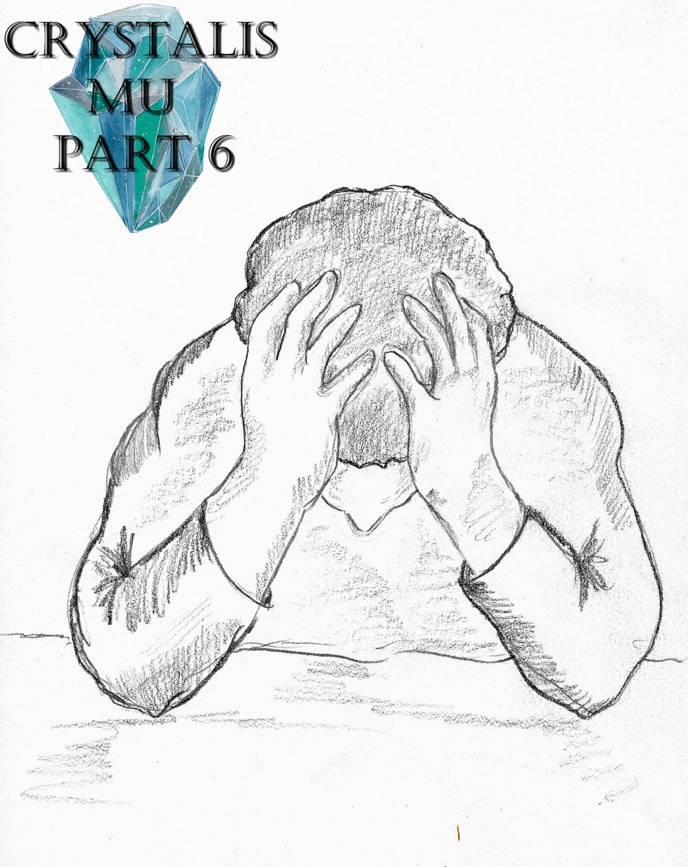

Crystalis Mu (A Part of The Crystalis Saga)
Copyright © 2013 James Bullock
Copyright Registration #: TXU001847418
Cover art and design: Vickie Bullock (vickiesart.com)

All rights are reserved to the author. No part of this ebook may be used or reproduced in any manner whatsoever without written permission except in the case of brief quotations embodied in critical articles or reviews.
This is a work of fiction. Names, character, places and incidents are either the product of the author’s imagination or are used fictitiously, and any resemblance to actual persons, living or dead, business establishments, events or locales is entirely coincidental.

Revelation

Alongside his protégés Russell, Jade & Rini, Dash flew toward the recently resurfaced Jarad. Still astonished was Dash at the revelation that his three students had taught themselves how to fly with their energy in an unbelievable short amount of time – something Dash and his friends didn’t fully master until months after defeating Empress Oni of Jarad. Rini inched closer and closer to her brother until she glided beside him.
With the wind blowing in both of their faces, Rini had to shout her statement aimed at Russell in regards to her brother wanting Jade and her to stay in Gonaga, “Who do you think you are? You better let us help you or you’ll be the one that needs a casket!”
Russell attempted to fly past his sister rather than respond. Jade refused to be left out of this one-sided conversation, catching up with her friends.
Thinking Rini was bothering Russell with unnecessary questions, Jade said to Rini, “Leave Russ alone. He’s just trying to help us.”
“Wow, Russell!” Rini yelled. “I can’t believe you’ve got Jade believing your made up hype!”
Russell smirked, telling his sister, “It’s not hype; it’s the truth! Anyone with half my strength would know that!”
“How’s this for ‘half’ strength?” Rini responded prior to punching Russell’s right arm.
Slightly hearing the continuous argument made Dash chuckle and say to himself, “Look at ‘em. They’re just like we were. We thought we were special, but these kids are like prodigies. I just hope that they can use it to their advantage.”
Seeing Dash lagging so far behind made Russell shout, “Speed it up, Old Man!”

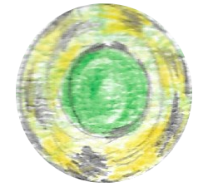

As Dash followed his students, King Octavius, Princess Onita, and a slew of Gonagan Royal Guards had already graced Jarad’s desolate ground. Gonaga’s princess led everyone toward the rusted, seaweed-covered ruins that was once Empress Oni’s fortress & home. Princess Onita stopped in front of the empress’ old residency, gazing into the cold darkness with her arms rising from her sides. Several deceased Jaradian soldiers embedded in the grit below rose from their tombs following Princess Onita’s action. A small grin formed on the princess’ face – completely opposite of her guards. The reanimated bodies circled everyone as the living soldiers prepared to strike them down if they touched their king or princess. Snapping her fingers, Princess Onita caused the corpses to halt their movement.
“Do you all want revenge, too?” Princess Onita asked these soulless beings.
The Jaradians giving Princess Onita no answer made her continue speaking, “Well, this is your chance to make the dream you’ve lived and died for a reality. When I received the Gonagan Crystal, I was given a divine power of resurrection. Sadly, the best I could do in bringing Jarad’s greatest warriors back to life was the walking dead after using so much of the crystal’s power raising Jarad from its watery grave.”
Princess Onita moved pass one of her Gonagan protectors, coming face to decaying face with the nearest Jaradian to stare in its soulless eyes.
The Princess of Gonaga waited to see if the undead creature would strike; feeling safe to continue speaking as her point of attention remained docile, “But even so, you are still Jarad’s elite no matter what you look like. Mix that power with the spirit that runs through me and you all now have the chance to destroy those who destroyed you. It’s time for you to take Gonaga once and for all!”
Princess Onita lifted her arms once again, causing the mysterious light that rose Jarad out of the sea to spread throughout the ocean.

Before he and his friends could see Jarad, the immaculate flash of light below them stunned Russell’s eyes.
“What was that, Old Man?” Russell immediately asked when the illumination died.
Dash hastily responded, “I don’t know, but it seemed to be comin’ from our destination.”
Russell picked up speed with Rini and Jade in tow. Landing on Jarad, Dash quickly noticed the lack of supposed walking dead that attacked the news reporter Corbin and Gonagan military personnel nearly a day earlier.
Jade wondered aloud exactly what Dash was thinking, “What happened to all the dead people?”
Before Dash could come up with an explanation for Jade, Russell grunted, “This stinks.”
Though no one paid attention to him, Russell couldn’t help but voice his frustration, “I came here to fight and defend my parents’ honor. And instead I’m sittin’ on a rock, kickin’ dirt. Forget this, I’m outta here.”
Russell jumping into the sky made Rini shout, “Russ, you come back here! Russell!”
Ignoring his sister’s command, Russell continued back home.
Dash calmed Rini by telling her, “Unfortunately, your brother’s got the right idea. I don’t feel Onita’s energy, or Octavius’ for that matter. There’s a good chance that they got what they needed and left. The only thing I don’t understand is why I didn’t sense Onita passin’ us.”
“We can worry about that later,” Rini replied. “We need to get back to Gonaga and make sure Russell doesn’t do something stupid.”

Some forty-five minutes after leaving Jarad, Russell returned to Gonaga to the sounds of screaming and explosions. As Russell hovered above the chaos, he saw someone familiar trying to maintain order as best he could.
Realizing whom this person was, Russell landed near him to ask, “Zack, what’s going on?”
Zack informed Russell, “I don’t know, man. One minute the bell starts ringing at the castle. The next minute, some dead guys are walking through the streets; picking fights with anything moving. We’re heading for the docks to get a ride outta here. You can come with us if you want.”
“I appreciate the offer, but I’ve got some business to take care of at Gonaga Castle.”
It wasn’t long into his trek north did Russell encounter one of the conscious corpses Zack alluded to marching aimlessly in searching for its next victim. The deceased Jaradian dripped gray saliva with each step; its decaying arms reached for its target. Russell stood still until the Jaradian was in touching distance. The dead individual lunged at his awaiting goal, only for Russell to sidestep him. But Russell’s action wasn’t a simple avoidance. Extending his right arm out as he moved, Russell drove his right fist through the deteriorated creature’s chest.
Russell whispered, “So this is the army of Jarad? I can see why you guys lost.”
With the slightly moving dead soldier still on his arm, Russell turned to find two more Jaradians coming his way.
“You want this?” Russell mockingly asked his new enemies.
Once again, Russell waited until his aggressors neared him before attacking. Russell slung his original attacker into the other Jaradians, knocking them down. While his opponents struggled to rise, Russell positioned himself for something.
Russell’s energy level increase when he told the Jaradians, “I’ve been workin’ on this for a while. Here’s a little move I like to call ‘The Rusting.’”
Russell created a brown ball of energy that eventually opened and turned into the shape of a dome on its side. Pushing the brown structure forward caused Russell’s energy to tip over and encase the living dead. The energy dome never budged, buckled or disintegrated as the Jaradians banged and slammed themselves against the construction.
Russell moved from his position, floating until he stood atop his energy structure and the things inside. Russell’s right arm punched through the middle of the dome’s ceiling to produce an implosion that sent decaying limbs everywhere and the person responsible returning skyward. After Russell returned to solid ground, two more Jaradians grabbed him from behind. The creatures had Russell in a death grip that made freedom feel like a false hope. Russell glanced from the four arms clinching his body to discover three more Jaradians approaching him.
Though Russell’s predicament seemed dire his mind remained calm. As the Jaradians tried to pull him down, Russell realized what he needed to do to survive. Like earlier, Russell’s energy level ticked upward; his eyes and hair radiantly glowing. Russell began emitting so much energy that it rattled the streets. Gonagans still in the area yelled at Russell to stop for risk of destroying more than the Jaradians shaking loose from Russell’s body, but he couldn’t hear their demands.

In Gonaga Castle sat Queen Athena feeling an immense power radiating from somewhere nearby. Though this energy poured from someone familiar, the queen didn’t exactly know who was its source.
Fear overtook Athena when she started thinking, Please don’t let that be Onita.
Concentrating for a few seconds, Queen Athena figured out, That’s not Onita.
Princess Onita, unlike her mother, knew immediately where the energy was coming from and its source. Gonaga’s princess left the castle grounds to find and make this power her own. Princess Onita ran through the streets & back alleys until she saw Russell rushing past her location.
Watching Russell walk toward Gonaga Castle, the princess tried to process her cousin’s strength while talking to herself, “I can’t believe this. How can someone produce so much power without something else like the Gonagan Crystal?”
Princess Onita’s mind suddenly focused on the day she slaughtered her family & friends; remarking, “Or hatred? That’s it, isn’t it? The same hatred that made me is what empowers you. You hate that I’ve joined with your cousin’s willing spirit. You hate that I’ve isolated your precious aunt. You hate me because I killed your parents. But there’s something deeper to your hate, isn’t it? You hate yourself. You hate that you let your parents die and you couldn’t do anything about it.”
Russell exclaimed when the princess stopped talking, “You know it’s not an inner monologue if everyone can hear you!”
The princess peered up to find Russell leaning against a nearby alley entrance. Rather than verbally respond, Princess Onita focused on the hatred encompassing Russell’s body. Russell yelled for Onita to fight, but his little cousin kept quiet and motionless. Suddenly, Russell felt something creep into his mind.
What’s goin’ on? Russell thought.
Princess Onita’s voice echoed in Russell’s mind, telling him, “That’s right, let the hatred consume you. And let me control that feeling through you.”
The quaking Gonaga felt courtesy of Russell’s energy returned as he Russell released an exponential amount of his power. Unlike minutes before, Russell couldn’t fully restrain himself, destroying almost everything in a twenty-foot radius. Russell slowly gazed at the rubble around him before turning his attention to the energy emanating above him. There floated the Princess of Gonaga directly over her gazing cousin. With a wicked smile on his face, Russell joined Princess Onita in the now dusty sky.
The princess led Russell into Gonaga Castle, heading in the direction of Queen Athena’s old room. Russell knocked the door down before entering. The rude action of Russell entering the room without acknowledgment made Queen Athena cower behind the bed. With each approaching step, the queen’s heart raced a little faster. It wasn’t until the movement stopped did Queen Athena open her eyes to find out who now stood in front of her. A sigh of relief exited Athena’s body when she saw the familiar face of her nephew. As Gonaga’s queen stood to hug Russell, Princess Onita stepped into the forefront.
Without even glancing at her daughter, Queen Athena questioned Russell about this potentially dangerous situation by simply asking, “What’s going on?”
The queen stepped back to examine Russell’s eyes. A cold emptiness reverberated from Russell, startling Athena. Before Queen Athena could do anything, Russell clutched his aunt’s wrists. Russell spun Athena around by her arms so she now faced her daughter.
Princess Onita’s lips parted to say, “We’re going on a little trip, Mother.”
Instead of responding to the princess, Queen Athena begged Russell to help her. Princess Onita grew tired of her mother’s pleading hindering their movement; utilizing a quick blast of energy from her right hand to put the queen into an unconscious state. The prior cries of his wife alerted King Octavius. When Octavius entered the bedroom, he found Athena lifelessly lying across the bed.
The agonized look in the king’s eyes made Russell inform his uncle, “She’s not dead.”

Dash, Rini, and Jade witnessed the same chaos Russell experienced when they arrived in Gonaga, but with less people in the area. Jade held Rini by her right arm when they descended to the ground and walked through the city.
Wondering aloud was Rini as a slight wind blew dust against her faded black boots, “What happened in the last few hours?”
Dash’s attention turned from his students to four Jaradian corpses now following them. Stubbornness ran through Rini and Jade – who had become insistent on testing themselves in battle. Dash shrugged his shoulders as a signal that he didn’t mind Jade & Rini having an impromptu fight; giving his pupils an opportunity to confront their targets. Jade and Rini were back to back, ducking and dodging every sloppy strike thrown by three of their attackers. The girls didn’t notice the fourth walking dead was inching toward Dash; though Dash was aware. Dash unsheathed his sword, using the weapon as a shield to prevent the dead enemy’s uncoordinated punches from connecting.
Dash sidestepped his attacking Jaradian’s surprisingly quick front kick, chopping off the corpse’s outstretched limb. Unable to balance on a single leg, the hobbling Jaradian started falling. As this one-legged adversary lost his footing, Dash used a quick sword swipe to decapitate the once-living soldier. Rini was mortified over the sight of Dash beheading the creature – her eyes widened and fixed as her body became rigid. This momentary focal shift left Rini open to have the back of her neck grabbed by a Jaradian. Rini yelped for Jade, but her best friend was chopping away at the two remaining aggressors with her father’s sickles. The soldier’s grip took away any thought Rini had of freeing herself. For a brief moment, Rini closed her eyes due to the pain. Rini’s few seconds of agony while she stared into the darkness felt like an eternity.
When Rini’s eyes opened, a gray energy beam shot past her flushed face. The living dead clutching Rini abruptly dropped to the ground, kneeling beside her now motionless, headless threat. Rini’s eyes peered at the right hand extended in her direction seconds later. The appendage belonged to Jade.
Jade reminded Rini, “Don’t worry, I got ya covered.”
Dash laughed at Jade being so Jas-esque with her statement. But Dash’s happy moment ended quickly thanks to the feeling of an approaching, evil energy. Rini and Jade’s faces also expressed concern as their heads tilted upwards. A plane shot across the sky. Like Rini and Jade, Dash immediately recognized this fast moving line above housing Princess Onita.
Jade was the first to question the princess objective, “She can’t be returning to Jarad. She’s not even going in the right direction.”
“She wasn’t by herself, though.” Rini spoke up.
Dash smiled upon realizing Rini was right in her assessment that not one, but several people were with the princess in Gonaga in flight.
Not wanting to worry his students, Dash only thought about the greatest question disturbing him, Russell, what are you up to?
Unbeknownst to Dash, Rini recognized her brother’s energy and feared for his safety just like Dash.

High in the darkening sky was Russell sitting beside his uncle while King Octavius woefully watched the unconscious Queen of Gonaga. Princess Onita told her fellow occupants that an island now coming into sight – a landmass some ninety miles north of Gonaga and east of Majan – was their destination.
Princess Onita looked at Octavius when they landed to say, “Welcome home.”
It didn’t take long for Octavius to vocalize his remembrance of this place, “He called it, ‘The Island of Vanski.’ An island all to the great doctor to create the empress’ wishes.”
A familiar masculine, yet weak voice said in the distance, “And her wishes were my greatest accomplishments.”
Dr. Otto Vanski revealed himself by exiting the wooded area to their left.
Dr. Vanski started speaking again after shaking the right hands of King Octavius and Princess Onita, “But I’ve done so much more alongside the Princess of Gonaga. Oooh, doesn’t that sound incredible. I’ve assisted Gonagan royalty again; and made history at that.”
“While that’s all well and good, Doctor,” the princess responded, “Oni had something immaculate she wanted to do after she conquered Gonaga. Unfortunately, she never had her opportunity.”
“Oh, I know, Princess Onita. I see you’ve brought Queen Athena for our next phase.”
The Princess of Gonaga happily nodded before asking Dr. Vanski, “And are my parents ready?”
As the island’s owner positively answered Princess Onita’s question, the king posed a query of his own, “What do you mean her parents are ready? We’re her parents.”
The doctor slightly laughed prior to leading his guests through the damp woods.
When King Octavius repeated himself, Dr. Vanski finally responded, “I believe she means Oni’s parents.”
Gonaga’s king immediately asked, “Aren’t Oni’s parents dead?”
“Almost,” the doctor replied. “The history books state that Oni killed her parents when she actually wounded them greatly thanks to an outburst of power – energy that she once didn’t understand how to handle. Oni contacted me after what happened that day and I was able to put them in a drug-induced coma. As the years passed, traditional methods of revival failed me. It was shortly before Oni planned her last attack on Gonaga that she discovered an alternative method – a method that would involve a human sacrifice and the exchange of energies & life forces. That’s why we need Queen Athena.”
Horrifically, a halting Octavius shouted, “You’re going to sacrifice Athena?”
Princess Onita refused to stop moving or answer her father due to them arriving at their journey’s end. An uneasy air of heaviness surrounded Dr. Otto Vanski’s home & laboratory.
Entering the facility, King Octavius spoke up again, “I don’t think we need to do this.”
With glee in his voice was Dr. Vanski when he informed the King of Gonaga, “Of course we do. If we don’t then Princess Onita will never rule to her fullest potential. Oni’s plan wasn’t just to revive her parents. Oni wanted to finish what she started. Oni wanted her parents to witness the magnificence of her new powers after attaining the Gonagan Crystal and taking Gonaga as her own. Once they realized what a powerful person she’d become, she would kill them and take their essence so they could live on within her and see the world molded in Oni’s image through Oni’s very eyes.”
“So why are we doing this now?” King Octavius replied. “Oni’s dead. There’s no point of this.”
Dr. Vanski opening his laboratory doors revealed to everyone the scarred and cold bodies of Oni’s parents using oxygen tanks and breathing tubes to continue living. Oni’s father was a small individual who had the facial features resembling a bird. Thankfully, Oni attained her looks from her mother. The thin, pale skin, pointy nose, small eyes & lips, and flowing black hair that made up Oni’s mother’s cranium left no question who she birthed.
After Dr. Vanski ordered Russell to lay & strap Queen Athena onto the empty table to the left of Oni’s mother’s resting spot, the doctor finally responded to Octavius’ earlier statement, “There is a point, my good patriarch, for Oni stands among us.”
King Octavius slightly gasped while thinking, Does he mean Onita?
The moment Russell began harnessing her down Queen Athena regained consciousness. Dr. Vanski welcomed the Queen of Gonaga to his lab, explaining her current situation.
Queen Athena screamed at her messenger, “You’re a mad man!”
Turning her attention to her nephew, Gonaga’s queen asked, “And Russell, why are you helping them?”
“I can answer that one,” Athena’s daughter replied. “I own his mind through his hatred of me. And through this hatred I’ve found the ability to control him. Now, if we can hurry this up.”
Dr. Otto Vanski attached a device that connected the queen’s head to Oni’s parents’ craniums.
Before the doctor could pull a switch and start the process, King Octavius demanded, “Stop this now! I will not let you sacrifice my wife.”
Behind her pained expression, Athena smiled listening to Octavius’ declaration.
“It’s taken my eyes far too long to see the truth,” the king confessed. “But now that I see, I must rid the world of these abominations. Through true love for Queen Athena of Gonaga I do this!”
Palming a lone hammer nearest him, Octavius started swinging the instrument to destroy equipment and control panels surrounding the king.
Dr. Vanski screamed as the king shattered vials & test tubes, “Stop this! You’re destroying my life’s work!”
The doctor’s commands made Russell grab the King of Gonaga in a chokehold from behind.
Shock moved through Octavius not because of Russell’s action, but the words Russell whispered into the king’s right ear, “Listen, I’m not really under Onita’s control. Just play along and we’ll get Aunt Athena outta here.”
Russell instructed Octavius to break free by biting Russell’s right wrist after pushing themselves directly in front of Oni’s father. Upon losing his grip of the king, Russell threw a kick that never touched Octavius’ abdomen, but his uncle pretended Russell’s “attack” had enough force to knock him atop Oni’s father’s body. Russell produced a small, brown energy ball that he threw at Gonaga’s king. Controlling his energy perfectly, Russell gave Octavius enough time to move.
Russell’s sphere hit Oni’s father, obliterating his body – forcing Dr. Vanski to cry in horror. Princess Onita confronted Octavius to stop him from freeing Athena. Before Onita could complete her task, a searing pain halted the princess’ action. This agonizing feeling came from Russell shooting his cousin’s back with three successive energy beams. These energized rays immediately singed the princess’ body.
Smiling, Russell asked the physically stunned Gonagan princess, “Hey, what can I say? I always thought I’d be a great actor.”
While Russell distracted Onita, Octavius helped Queen Athena free herself. Dr. Vanski tried to stop him, but King Octavius slapped the doctor down with ease. Once Athena’s feet touched the ground, Octavius led her out of the laboratory into the island’s dense woods. The escaping of her parents was unknown to Princess Onita due to Russell’s jumping & flipping as a distraction held her undivided attention.
Princess Onita’s continuous orders of, “Stand still!” at Russell fell on dear ears.
Spinning around the room to keep track of Russell finally revealed the lack of people in Dr. Vanski’s lab. Onita’s focus shifted again – this time to the rising body of Vanski.
Princess Onita kicked the doctor, shouting, “What happened to the queen? Get up!”
When the doctor made it to his feet, he discovered his laboratory containing only himself, Princess Onita and Oni’s mother’s body.
The Princess of Gonaga repeating her question about Queen Athena’s escape finally snapped the doctor into reality.
Dr. Vanski asked, “What are we going to do about the sacrifice?”
Glaring at the sore scientist, Princess Onita mumbled, “I think we can find a replacement.”
Abruptly, the princess punched Dr. Vanski in his stomach; pushing him onto the operating table Queen Athena once occupied.
The doctor pleaded as Princess Onita placed the draining device on his head like Dr. Vanski did to Athena minutes ago, “My princess, please don’t do this! I can’t die like this! My life’s work will fade away if you don’t stop! Please, Onita!”
With tears streaming down his cheeks, thousands of volts ran through Dr. Vanski’s body after Princess Onita ignored his begging and pulled the switch. The color drained from Vanski’s face as his body slowly stopped twitching. Oni’s mother’s lifeless form began moving not long after. The ding that sounded to signal the process’ conclusion gave Princess Onita every reason to approach Oni’s mother and gaze at this revival.
The person responsible for Oni’s birth quickly sat up; asking, “Where am I?”
Staring back at the inquirer was this slim woman with piercing black eyes.
“Who are you?” Oni’s mother questioned after locking eyes with this unknown individual.
“Who I am isn’t important right now. It’s who you are that intrigues me. Thanks to your favorite scientist over there – the man who gave his life to restore you – you’ve been given a chance to witness the world as you should’ve.”
It took a few seconds, but Oni’s mother remembered Dr. Otto Vanski, “He was my best friend when…--”
“When everything went wrong for you in Gonaga. When you were banished from the land you called home.”
The other woman in the room audibly recounted how Dr. Vanski escorted her to Jarad only to find out he couldn’t come back to Gonaga either. Oni’s mother and Vanski fell in love, but she later left him for a prominent raider whom she married and built Jarad into what it once was. Though she betrayed the doctor’s trust, Vanski stayed loyal to her and Jarad.
Oni’s only living parent finishing her story allowed her listener to finally introduce herself, “Don’t you recognize your descendant. I am Princess Onita of Gonaga, your great-great-granddaughter. And you are a widower. You’ve widowed two husbands, but never the original. With your blood coursing through me, I know the truth. You are the original Queen of Gonaga.”

…to be continued

