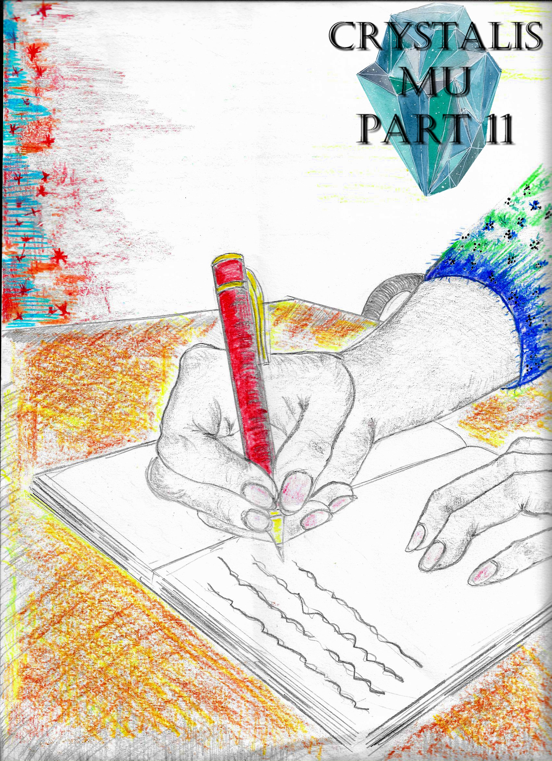

*Crystalis Mu* (A Part of *The Crystalis Saga*)

Copyright © 2013 James Bullock

Copyright Registration #: TXU001847418

Cover art and design: Vickie Bullock (vickiesart.com)

All rights are reserved to the author. No part of this ebook may be used or reproduced in any manner whatsoever without written permission except in the case of brief quotations embodied in critical articles or reviews.

This is a work of fiction. Names, character, places and incidents are either the product of the author’s imagination or are used fictitiously, and any resemblance to actual persons, living or dead, business establishments, events or locales is entirely coincidental.

## Resolve

In Gonaga, Dash, Ken, Rini & Jade helped the returning townspeople off their ships after this particular group of Gonagans shielded themselves from the Jaradian invasion via an island some fifty miles east of their homeland. During their current mission, Jade enjoyed the stories Ken told about her father Jas. But something uncomfortable sat in the pit of Jade’s stomach as she continued working. That troublesome feeling in Jade slowly became an urge to return to Jarad.

Observing the change in Jade’s demeanor made Dash ask her, “What’s goin’ on?”

No answer from Jade was given before she flew into the night. Jade’s energy hit a new peak as she flew faster than ever. Approaching the area where Jarad exited the sea, Jade couldn’t believe what she saw – the land of Jarad returning to its grave. The ocean waves ruptured the sea’s stillness with Jarad slowly sinking. Jade’s ears almost popped at the noise roaring below. To her dismay, Jade rightfully assumed Russell was still on Jarad. The thought of Russell drowning because she couldn’t save him in time frightened Jade to no end.

Flying over the plummeting rock, Jade cried, “Russell!”

Unfortunately for Jade, her pleas were muted by unexplainable sounds. Hopelessness started creeping into Jade’s heart when something shimmering caught her eye. Jade changed her direction, flying toward whatever was creating this light. Just as the ocean enveloped Jarad, Jade found a small piece of crystal following Jarad into the sea’s depths. Jade grabbed the clear rock without delay. Once again, Jade’s attention went beyond a single point of interest.

Directly below the spot Jade discovered the crystal lifelessly drifted a human figure inside the water. Taking a deep breath, Jade dove into the raging ocean to save whomever this person was. Increasing pressure and a lack of oxygen slowed Jade’s swimming, almost forcing her to turn around. In correlation with a bright illumination growing more profound underneath her target was an energy surge assisting Jade when she chose to press onward. This light revealed the unconscious person’s identity.

In Jade’s mind, she gasped the name, *Russell.*

Jade ignored all of the variables slowing her down to push toward Russell’s submerged body. When Jade reached Russell, she threw her arms out. Jade’s first swipe ended with her hands smacking Russell’s chest.

*I gotta do this right,* Jade thought. *If I don’t make it quick, we’ll both drown.*

Thrusting forward, Jade grabbed Russell’s waist. Under normal circumstances, Jade would’ve been able to carry Russell to safety. But Jade’s inability to breathe and her holding onto a lifeless body caused both to sink deeper into the tumultuous ocean. Suddenly, a green aura spread throughout the sea floor; covering everything including Jade and Russell.

*I can’t believe it’s gonna end like this,* is what ran through Jade’s mind. *Russell, you idiot. If you only let us stay in Jarad then we both wouldn’t be dying. I guess if there’s anyone I’d go down with, it’s someone like you, Russ – someone who wouldn’t cry even when facing death itself. I can’t be like Mother. I refuse to cry just like…*

Jade’s thoughts halted thanks to her body stopping its descent. Looking down, Jade discovered Russell no longer sinking as well. Jade’s inability to understand what was going on slowly faded as the stilling waters lulled her to sleep.

A rush of cold air smacked Jade’s body, waking her from what seemed to be a short, waterborne nap. Opening her eyes revealed to Jade her current circumstance – lying beside Russell on a rock big enough for five people. In Jade’s right hand sat the crystal – now emerald in color – she retrieved from the ocean. Jade forget about everything except reviving Russell. Beating on his chest, Jade screamed Russell’s name over and over again. Jade abruptly stopped when Russell started mumbling. As Russell went quiet, Jade assumed the worst.

The fearful pleas from Jade returned until she heard, “Jade, is that you?”

Jade looked beyond her tears to see Russell’s eyes opening. Jade’s arms tightly wrapped around Russell’s shoulders and neck when he sat up.

All Russell could grunt was, “You’re chokin’ me,” as Jade’s embrace tightened.

When Jade finally released him, Russell had to know how she found out he was in trouble.

A grinning Jade simply answered, “Women’s intuition.”

“You sure my parents didn’t tell you to come here?” Russell replied.

“You’re parents? How would they tell me anything?”

Russell took a few moments to collect himself before answering, “I dreamt about them. Or I think I did. It just felt so real.”

Jade plopped down in front of Russell so he could tell her about his dream, “I was in a dark place when I saw a faint light in the distance. I got up and walked to it. Every step I took, the light got brighter and surrounded the area more and more. Next thing I know, I see two people standin’ in the distance. Before I can reach them, I hear one of the people say, ‘It’s not your time yet.’”

With intrigue gracing her face, Jade asked, “Who was it?”

“I immediately recognized him. But before I could say something else, the other person – a woman – told me, ‘We’ll all die someday. It’s what we do with these fleeting days that matter most.’”

Russell stretched his neck before continuing, “Then he started talkin’ about the first Gonagan Crystal bein’ purified by the planet’s energy and how the remanin’ piece could be used to help us somehow. I really don’t remember how he said it, but I know me killin’ Onyda and her sinkin’ with Jarad buried the second Gonagan Crystal that holds both Oni and Onyda’s spirits now.”

Russell’s eyes widened after his story abruptly stopped. In his mind, Russell wondered why his body felt so good.

After Rini asked Russell about the confused look on his face, Russell said, “I got shot through the stomach. I should be in a lotta pain right now, but I feel fine.”

“You look fine,” Rini informed her friend. “No hole in your stomach or anything. So what else happened in your dream?”

Russell peered down to see Rini wasn’t a lying. A sigh of relief exited his body before Rini repeated her question regarding the conclusion of his story.

Taking a deep breath, Russell restarted the tale, “So after they told me all of that, they turned around to enter the light. Without lookin’ back, he told me, ‘We’re all very proud of you guys for not lettin’ what happened break you. You, Rini, Jade are truly heroes. Goodbye, my son.’ When they disappeared into the light, something roared like a beast. I looked up and saw this metallic man standing in the distance, pointing at something to my left. The next thing I hear was your voice.”

Jade patted Russell’s shoulders prior to saying that it was time to go home.

“What home?” Russell retorted. “Our homes were abandoned and probably aren’t in the best shape after what happened before our fight in Jarad.”

Jade peered at the clear, midnight sky during her response, “Well, I guess we’ll have to rebuild. Now come on.”

Pulling Russell by his right arm so he could stand up, Jade awaited his physical rebuttal for her assistance.

Russell’s rigid, yet willing arm made Jade say, “I’m shocked you didn’t say, ‘I don’t need help,’ like you always do.”

“I guess everyone needs help once in a while,” Russell said after gaining his footing.

A few, quiet moments passed between the two as Russell gazed at his friend until he simply said, “It is really good to see you right now.”

Though Jade’s face blushed upon hearing Russell’s words, she nonchalantly replied, “That’s what happens when you’ve been through so much – you start to understand how great your friends are.”

“Maybe you’re right.”

Motioning for Russell to fly alongside her, Russell joined Jade some twenty feet off the ground. Jade and Russell made their way toward Gonaga, listening closely to the calming ocean sounds resonating behind them. Almost reaching their destination, the noise had drastically changed from something soothing to joyously boisterous. Floating over Gonaga, Jade noticed people rejoicing near Gonaga’s wrecked Marketplace.

Jade spun in the air to tell Russell, “I guess the celebration is on.”

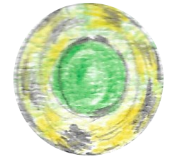

Weeks passed like the wind as the land of Gonaga slowly reconstructed. King Octavius and Queen Athena’s reconciliation stabilized the kingdom. Thanks to a thorough investigation of Dr. Vanski’s lab, Octavius discovered his origin and how his love for Athena destroyed the evil hold the doctor’s experiments forged.

Rini’s dream of going to college was put on hold due to Gonaga’s destruction. Rather than let her niece lose time doing nothing, Queen Athena offered Rini a chance to learn under the Gonagan military’s new commanding general. The day before starting her internship, Rini confronted her aunt to wonder if Queen Athena’s putting her niece in such an important position was the right decision.

“Why not?” the Queen of Gonaga responded. “I just know that one day you will lead… just like Serena.”

Rini wiped the tears streaming down Athena’s cheeks without realizing she too was crying.



Dash and Ken finally had the chance to talk days after Onyda’s defeat.

With a pitcher of water in hand, Dash started off their long-awaited conversation with a simple, “So, my brother’s gone off and started a family.”

Ken, sitting in the chair across from his older brother, grabbed a cup of tea on a table to his left.

After Ken took a sip, he gleefully told Dash, “It seems I have. We actually met not long into my trip from Gonaga to Tyrong. She was interested in traveling as well until we settled in Yafan two years ago.”

“Were you ever plannin’ on comin’ back?” Dash had to know.

“Actually, we were in the midst of returning when I heard about what was going on. That’s when I decided I should come back alone and send for her after everything settled.”

“You really believed we’d win?”

Taking another drink from his cup, Ken jokingly answered, “Well, that or I thought I would die with a sword in hand and a brother by my side.”

Dash finished off his water container he nursed for a half an hour before their conversation began. Rising from his seat to refill, Dash abruptly stopped when he noticed Ken staring at a picture from Jas’ wedding.

“You really missed out on a lot,” Dash spoke up.

Ken’s head slowly drooped as he replied, “Yeah, I know.”



With the help of her friends and family, Jade renovated her original home so that it was livable once again – a house torn apart by her mother as she grieved the loss of Jas.

The day Jade planned to move out of Dash’s house was a solemn one for the two. Packing the last of her things made Jade take a seat on the small bed she spent the past several months using following training sessions, as a way to temporarily escape the horrors of her reality, and to simply sleep. Dash entered Jade’s bedroom not long after she sat down.

While standing in the doorway, Dash told Jade, “It’s great that you’re movin’ on. Doin’ it just like Jas.”

Half smiling, Jade reminded Dash, “I’m just moving down the street.”

“I know. But it’s just gonna be weird not havin’ you around. As much as I love Rini and tolerate Russell, there’s somethin’ about you that I always adored. You just have a natural innocence that I haven’t seen before. And even when everything went down, you didn’t lose that innocence like Russell and Rini did. You’re probably stronger than all of us combined.”

Dash quickly turned his back to Jade to make sure she didn’t see the tears forming in his eyes.

“But it’s you who made us strong,” Jade said; moving beside Dash before embracing him. “You could’ve rolled over and died. Instead, you trained us without even knowing if we could win. You believed in us. Without my Uncle Dash, I wouldn’t be who I am right now. And I’ll never forget that.”



Princess Onita of Gonaga – whose mind slowly caught up with her early twenty-year-old body – found herself stricken with grief over the things she did while under Oni’s control. In hopes of soothing Onita’s soul, Russell took it upon himself to have a sit-down talk with his cousin. The awkward silence between Russell and Onita after he entered her room was broken by Russell asking how she was doing.

From her seat placed directly beside the bed Russell now sat upon, the princess admitted, “Not good at all. I just can’t get the images out of my head.”

Bluntly, Russell responded, “About how you killed your family. My family. Our family. Almost destroyed the world.”

Russell’s believed rudeness caused Onita to glare at her cousin. Once again, speechlessness crept through the room.

When Russell noticed the angst in Onita’s eyes, he mumbled, “But it wasn’t your fault.”

Princess Onita immediately verbalized her disbelief over Russell’s statement, “Wasn’t my fault? How wasn’t it my fault? I became a tool for evil. I sympathized with Oni, and then I became her harbinger of death. I am the reason you, Rini, and Jade are orphans. I am the reason Gonaga is wrecked and the world was paralyzed with fear. I am--”

Russell solemnly interrupted his lamenting cousin, “No, you’re not. Yes, you did all of those things in body. But you were bein’ controlled just like you said. In a lot of ways, you were created for what happened, and there’s nothin’ – no cryin’, blubberin’, or wishin’ – that can change that.”

Russell moved from his seat to hug Onita. When she recoiled to avoid the incoming action, Russell stopped his forward movement.

A long pause occurred between Russell’s attempted embrace and his subsequent statement, “Just like Octavius was a pawn thanks to how he was created, you were a pawn because of who you came from. The world will heal… but only if you let it happen.”

Princess Onita hastily asked, “What does that mean?”

“You’re the future of this land; the future Queen of Gonaga. If you aren’t able to forgive yourself you won’t be able to run Gonaga like you can and will. Onita, I forgive you. Now it’s time for you to do the same.”

Hearing Russell’s words rattled Onita’s heart like nothing else did up to that point. Russell was almost surprised when Onita left her chair, clutching her cousin tightly. But the princess’ mental status wasn’t the only thing on Russell’s mind. Since the day he killed Onyda, Russell thought about life outside of Gonaga. This nomad spirit rising in Russell made him question if staying in Gonaga was a good idea. After thinking about departing Gonaga for two days following his conversation with Princess Onita, Russell figured out one person who would understand what he was going through: Ken.

One night after a long day of work on Ken’s future house, Russell joined Ken at Dash’s kitchen table to ask him, “What is it like to have a home, but it’s not where you think?”

Ken didn’t answer without thought; looking Russell in his eyes for several seconds.

“So you want to leave?” Ken eventually said.

“It’s not that I wanna leave Rini or Jade, but I wanna see the world. Comin’ so close to death made me think more about what I wanna do. I never wanted to go to college, or even become a hero. I just wanted to find a place…--”

“A place where you belong.”

When Russell nodded his head to confirm Ken’s assumption was true, Ken explained what he believed made him leave Gonaga, “I had a dream. I remember standing on a boat with the sun beating my uncovered head. Though it was hot, I was smiling; smiling because I was finally free. That was my dream – a dream of my lifelong dream. When I woke up the next day, I left.”

Ken peered at Russell almost staring a hole through him before continuing his statements, “I knew if I stayed around, I wouldn’t truly be free. I survived Oni and Jarad, and I deserved to see the world. You’ve seen tragedy, too. Now that you have the chance to live your dreams, do it. Sail the seas. Ride the wind. Live this life like Jake and Serena would’ve wanted. They yearned for something simple, yet people like us… we need to find out what this world is truly worth.”

Three months after saving the world, Russell packed a few things for his trip. That same day witnessed Russell returning to his parents’ home. Rini discovered her brother sitting on their original home’s front stoop when she went looking for him after not seeing Russell around Dash’s house all day. Russell’s body language expressed he was holding something back from his sister.

Russell sensed what Rini wanted to know after she took a seat beside him; muttering to his sister, “Rini, I’m leavin’ Gonaga.”

Staring at the thick clouds, Rini assumed Russell’s statement was some melodramatic act to get a rise out of her.

Before Rini could verbalize her thoughts, Russell spoke up again, “I gotta get outta this place. There’s nothin’ left for me here.”

Rini continued gazing upward.

Seeing Rini wasn’t paying attention, Russell shouted, “Did ya hear me? I’m leavin’!”

The sincerity in Russell’s words finally made Rini believe her brother.

Looking at Russell, a bewildered Rini asked, “Oh my... you’re really leaving, aren’t you?”

Rini jumped from her seated position, yelling at Russell, “What about me? What about Jade?”

Monotone, Russell asked in regards to Jade, “What about her?”

“You’re just gonna leave without telling her? Almost everyday for the last three months it’s been you and her. You two have been practically inseparable since she saved you from dying in Jarad. And now you’re just gonna jump up and leave her high and dry?”

“I don’t know where I’m even goin’,” Russell informed Rini.

“Then why leave if you don’t know where you’re going?”

Rather than answer Rini, Russell walked around their home until he entered their backyard. Rini trailed her brother, waiting for him to say something.

Rini’s eyes actually widened when Russell said, “There’s so much out there that we don’t even know about. This world is so much bigger than just Gonaga. Out there is a place for me to finally be me. Rini, I know you don’t understand, but just hear me out. I *will* be back one day. And on that day I’ll tell you about the world... and what it’s worth.”

Russell was right about Rini’s inability to comprehend what he meant. But with a solid hug, Rini accepted her brother’s decision.

Whispering, Rini asked Russell while they held onto each other, “You promise you’ll come back?”

“Have I ever lied to you?” Russell said. “Just please tell Jade, ‘I’ll miss her.’ And I’ll bring her the world, too.”

Rini adhered to Russell’s wish about telling Jade of his plans, but did so that night following the brother and sister’s conversation instead of waiting until after Russell left. A fury unlike anything Rini had ever seen danced in Jade’s eyes as she exited her house to find Russell. While Jade headed toward his home, Russell concluded his preparations for leaving.

Closing the last suitcase of family photos made Russell contemplate what he was doing, *Why am I takin’ this stuff? I wanna start a new life and I’m packin’ stuff that just clings to Gonaga. The clothes on my back and the money in my pocket are all I need for this.*

It was almost midnight when Russell looked around the dark, slightly dusty building that once housed his family.

“I love you guys,” Russell said to the ghosts of his past.

Opening the front door revealed a surprising sight to Russell – Jade standing in front of him, her arms tightly crossed in front of her chest.

With a snide tone, Jade asked, “And where do you think you’re going at this hour?”

“Somewhere far away from your mouth,” Russell stated.

“Oh, how funny.”

When Russell tried to sidestep the physical blockade that was Jade, she stepped alongside him.

Becoming agitated over Jade’s action, Russell yelled, “What will it take for you to move?”

“An explanation.”

“I assume Rini told you what I said, so how much more of an explanation do you need?”

Jade glared at Russell – who refused to look at her in the eyes – prior to asking, “Why couldn’t you wait and do it properly? Why didn’t you let us all know before you did this? Why are you such a jerk?”

“Because that’s what I am. I’m an insensitive jerk who doesn’t wanna be around this place for awhile and doesn’t want anyone to stop me. Now if you don’t mind…”

Russell went to gently shove Jade out of the way, only for Jade to grab him by his right wrist. Understanding conventional tactics wouldn’t work, Russell created a blinding energy blast that staggered Jade long enough for him to fly away. Jade blinked feverishly until her sight mostly returned and she could follow Russell. After passing Gonaga Castle, Russell peered behind him for one last look at the place his mother once called home. To Russell’s shock was Jade on his heels.

Russell’s attempt at outmaneuvering Jade proved fruitless as well.

Realizing Jade wasn’t giving up, Russell shouted at her, “You just won’t quit will you?”

“Nope!” Jade responded; bringing their chase to a close as Russell floated to the ground.

After a short talk, Russell agreed to wait until morning so he could tell everyone goodbye.

The Jade-led gathering of herself, Princess Onita, King Octavius, Queen Athena, Rini, Dash, and Ken entered Gonaga Castle’s Courtyard to wish Russell a safe trip. When Russell arrived, laughs, embraces, and stories were exchanged for several hours until Princess Onita confronted Russell.

“You don’t have to leave,” Onita told her cousin. “Everything and everyone you need is right here. You… y-you keep…--”

Russell verbally stopped the noticeably struggling princess, “No, you are the one who will keep them safe. Onita, you’re stronger than you’ll ever know. I believe, trust, and have faith in you. So please, keep my knucklehead sister in line.”

Hearing Russell’s statement forced Rini to remind her brother, “You’re an idiot!”

Russell had no verbal response for his sister’s comment, so he simply hugged her. Feeling her brother’s embrace like never before brought tears from Rini until he let her go.

As Russell moved to his left, King Octavius spoke up, “Russell, I wish we could’ve gotten to know each other a little better before now.”

“Yeah,” Russell responded. “But what I do know about you is you were made from and for evil, but you’ve gained a pure heart. I now know why Aunt Athena feels for you.”

For the first time since they’d known each other, Russell and Octavius hugged. Athena couldn’t help but lightly cry upon seeing the action between her two of her remaining family members.

Without looking at her, and still holding onto Octavius, Russell whispered to his nearby aunt, “Thank you for helpin’ Rini. She’ll do you proud.”

Russell’s words made the tears barely flowing from Queen Athena pour out.

A smiling Dash told his pupil, “You’ve become quite a man. You take care of yourself.”

Russell laughed a little before he told Dash, “You too, Old Man.”

Following a stern handshake between Russell and Dash, Russell turned his back to everyone for his departure.

Abruptly, Russell said, “Well, lets go.”

Everyone appeared confused over Russell’s statement until Jade started walking toward Russell.

Rini immediately shouted, “What’s going on? Jade, you’re leaving, too?”

With her back to Rini and everyone other than Russell, Jade admitted, “It was the only way I’d let him go. Russell wanting to leave made me realize I’ve wanted to do the same thing. So after much prodding, he agreed. I’m sorry to do this to you, Rini, but we have to go.”

Jade quickly hugged everyone, sailing into the sky alongside Russell.

Rini shouted as Russell and Jade began moving away, “You better come back!”

Following a slight nod, Russell agreed to follow his sister’s command.

Neither Jade or Russell said a word until flying over Gonaga’s farmland when Jade asked, “What are you thinking about, Russ?”

Russell answered Jade with a question of his own, “Are you sure you wanna do this?”

“I’ll go wherever you wanna go, Russ.”



I have completed this book as proof of the great heroism seen nearly four years after the moment Russell defeated Onyda. From the day of Onyda’s death until the day I left Gonaga, I gathered accounts from everyone I personally knew involved and hurt by the situation that unfolded when Oni’s spirit possessed Princess Onita. Through journals kept by my father, Jake, and Serena, I was able to record their feelings during their last days. My name is Jade – the daughter and widow of heroes, and the mother to Russell’s only son. As I conclude this story, I must note that I’m returning to Gonaga to tell them the truth; and warn them. Dangerous people are searching for something they believe is connected to Gonagan royalty. If I don’t warn my family soon, everything Russell fought for will be in vain.

The End