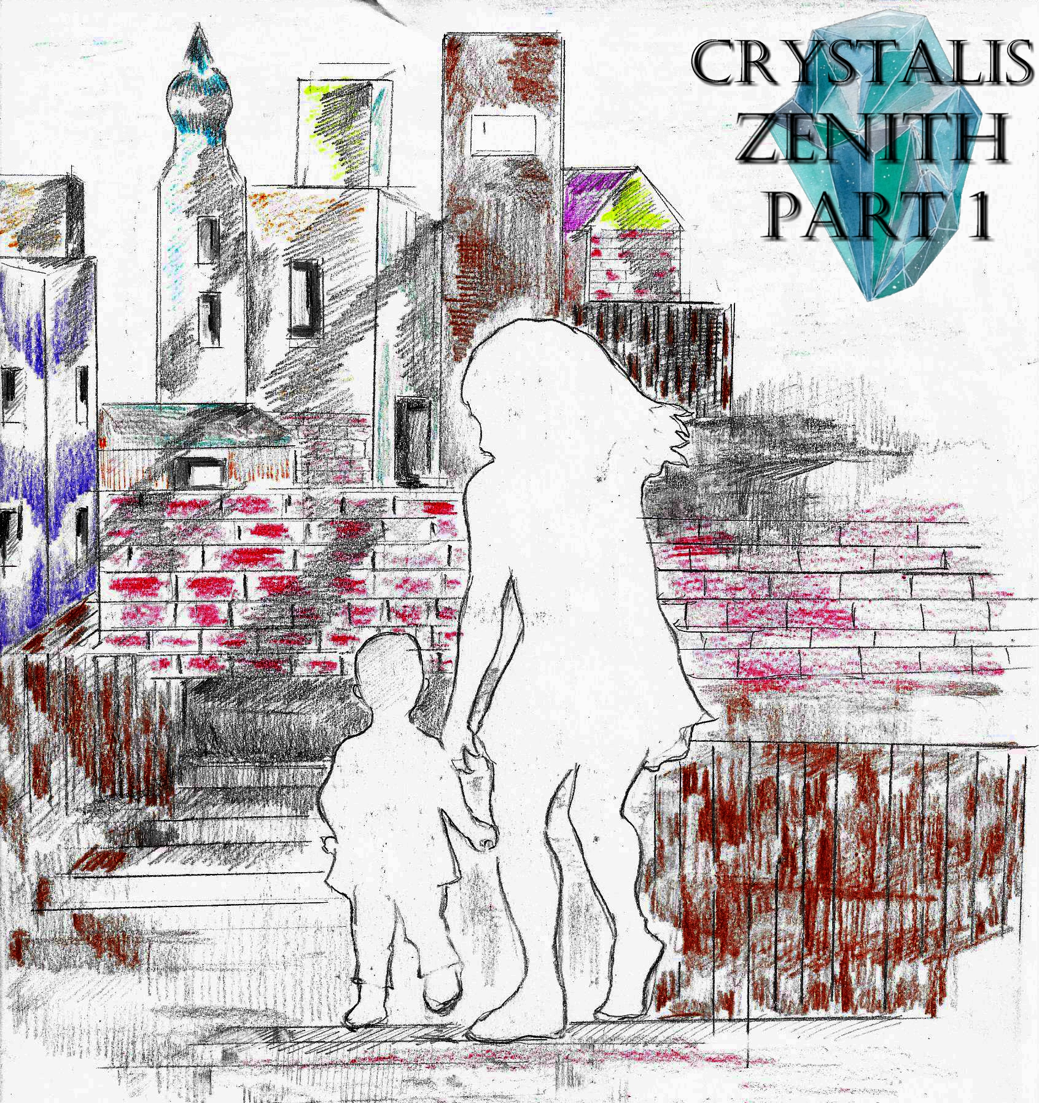

*Crystalis Zenith* (A Part of *The Crystalis Saga*)

Copyright © 2013 James Bullock

Copyright Registration #: TXU001847418

Cover art and design: Vickie Bullock (vickiesart.com)

All rights are reserved to the author. No part of this ebook may be used or reproduced in any manner whatsoever without written permission except in the case of brief quotations embodied in critical articles or reviews.

This is a work of fiction. Names, character, places and incidents are either the product of the author’s imagination or are used fictitiously, and any resemblance to actual persons, living or dead, business establishments, events or locales is entirely coincidental.

## A Farewell

Journal Entry 1,

I write this first entry en route back to Gonaga. My son and I have been traveling since the death of my husband. My son’s father was such a great man. My husband wanted so much more for not only us, but also the rest of his family in Gonaga. If it weren’t for them, my husband would’ve done such a thing. Soon I’ll be back home to tell his sister the bad news. I wish I didn’t have to, but they need to know.

Journal Entry 2,

I made it to Gonaga’s harbor three hours after writing the last entry. Gonaga has really improved since we left. The people worked really hard to rebuild Gonaga into something even more incredible than it was before. Gonaga’s Marketplace is just teeming with life again; shops for almost everything you could imagine especially when it comes to food. I never thought I’d see this place in such great shape. Actually, I never thought I’d see this place again. Even more shocking is the fact some people recognized me. They could see my husband in our son more than I ever realized.

Before heading to our destination, I visited my husband’s old home. Some nice people have repainted and refurnished the place. They were so warm to us when I told them about what happened all those years ago. I wanted to talk longer, but our journey wasn’t done.

We arrived at Gonaga Castle before nightfall. Once again, my familiar face allowed me to enter the castle with ease. Even better was the castle guard who remembered me was kind enough to watch my son while I talked with my best friend. I found my husband’s sister almost immediately.

As a precursor to the upcoming tight embrace and the kissing of my left cheek was the joyous statement, “It’s so great to see you, Jade.”

Rini – my husband’s sister – now works as an ambassador for Gonaga. She travels all over, keeping peace between the lands.

Taking a step back after releasing me from her sisterly grip, Rini asked, “So, where is he?”

I couldn’t stand it any longer. Everything I’d been holding back since the day of his death just came out. Rini consoled me, but I couldn’t stop crying. King Octavius and Queen Athena discovered I was in the castle shortly after my breakdown. When the king and queen found Rini and I, I’d finally calmed down.

I figured the best way to tell her was by simply being blunt, “I’m sorry. Rini… Russell’s dead.”

And just like her brother would’ve done in her situation, Rini subdued all of her rage. The reason for Rini’s anger wasn’t his death, but because of the promise Russell made to everyone when we left that he now couldn’t fulfill: a promise to return home and tell everyone of his experiences. Unlike Rini was Athena crying in Octavius’ arms.

The queen excused herself as Rini asked me a question that I didn’t want to answer, “What happened to him?”

I told her about what led to our final days together, “When we left Gonaga, Russ wanted to visit every land to find himself; find a new life. And for some reason he let me go with him. After hanging with him for a few months, Russell expressed his apparent newfound feelings. I still remember that day. We’d taken a couple of days to rest in Majan. Russell loved Majan. It’s such a cerulean town; almost every store has something to do with the sea. Well, during the first night while we were eating, he said, ‘Jade, you know the day we left, I didn’t want you to go?’”

Even though she was still reeling after finding out about her brother’s unwarranted fate, Rini listened intently to every word I said.

I continued my story for my sister, “So I asked Russell, ‘Why?’ while slurping down a giant piece of shrimp.”

“‘Well, I thought you’d might get hurt, or bored, or somethin’,’ Russ responded. ‘I really didn’t know it would be this much fun. Jade, you’re really a good friend.’”

I could see myself smiling from the reflection in Rini’s eyes as I quoted Russell’s follow up statement that changed everything, “‘But I would like to be more than that.’”

Using Rini as my plaything to make the story come across as profound as it is in my head, I grabbed her right hand like Russell did mine after his proclamation.

“Next thing I know, we’re getting married,” I said, feeling all warm inside just like I did that wonderful day Russell.

Rini quickly yanked her hand away, asking me why we didn’t wait and do it in Gonaga.

“Russell just wanted to do it,” I explained. “He didn’t want a big thing. I felt the same way. We were planning to do another one here, but… they showed up.”

Looking at her watch made Rini halt our conversation so she could return to her duties.

After hugging me, Rini said, “Tonight, we’ll eat here and catch up some more.”

Journal Entry 3,

Promptly at eight o’ clock, the king and queen, Rini and I entered the castle’s Dining Hall. Before we could sit down to eat, I had a surprise for everyone. I exited the room, grabbing our son to introduce him to his family. Everyone rushed him, playing with his full cheeks, little toes and fingers.

Rini asked me during the baby exhibition, “So, what did you name him?”

I embarrassingly answered, “I haven’t really named him yet. I’ve been so busy trying to get back that I’ve just been calling him ‘Junior’.”

Understandably, everyone started laughing at me. Sitting down to eat, Queen Athena wanted to know about the people who stopped our wedding plans in Gonaga.

I told everyone everything I knew – which wasn’t much, “When we made it Majan, they arrived not long after. Rumors started swirling that they were looking for us. One day, we encountered these five troublemakers attempting to get answers out of a vender we always got lunch from. They all wore hooded robes; I couldn’t see their bodies or faces. So Russell stood up to them by powering up. It didn’t take long before they knew, even five against one, they were no match for Russell.”

I looked at the smiling faces of my friends as I told our story, but knew those proud expressions would change when the tale concluded, “We returned to Majan a year later to settle in for my last month of pregnancy. We rented a nice home from a Gonagan family who experienced the whole Onyda thing. On what seemed to be just a normal day on Majan’s boardwalk, they appeared for another round. But this time they were a lot stronger. I don’t know what they did, but their stabilized energy levels were more than Onyda. Russell, even at full strength, couldn’t defeat them. And, unfortunately, I couldn’t help him when he needed me the most. When it was over, they wanted to know where was ‘the key.’”

Everyone listening to my tale assumed they were talking about the Gonagan Crystal until I continued, “Seeing Russell couldn’t speak, I told them we didn’t have it. Come to find out, they didn’t mean the Gonagan Crystal. Before I could discover what they meant, they left. Russell was in bad shape and had to be taken to a hospital. Later that night I went into labor. In the same minute Junior was born, Russell died. When the doctor told me that Russell had died, he was shocked by my reaction; or lack thereof.”

As I predicted, the smiling faces were gone during this portion of the story.

And yet, I kept talking, “I remember that doctor repeating himself, ‘Do you hear me? Your husband has passed away.’ But I already knew. Moments before I held Junior for the first time, I saw Russell’s spirit. He wasn’t hurting or worried. Russell just smiled like he did when we exchanged our vows. I don’t know how, but I think he knew he was about to die. He used to tell me during our trip back to Majan that he wanted to be buried there. And that’s what I did.”

I waited for Rini to scorn me about not letting everyone attend the funeral service, but she stayed quiet. I don’t know, but Rini seemed relieved I didn’t tell her until today. I don’t think she could’ve handled something so devastating again. Not long after my story’s conclusion did Uncle Dash, Ken, Ken’s wife Margaret, and their lovely, five-year-old daughter Rachel visit us.

The first thing Dash asked was, “Where’s Russ?”

I sat them down to give them the news. Dash couldn’t believe it, apologizing feverishly. Ken’s little daughter greatly lightened the solemn mood thanks to her fascination with Junior. When I asked her if she would like to feed Junior, Rachel enthusiastically nodded in a “yes” fashion. For being a baby herself, Rachel’s a natural mother.

Margaret – who is a stunningly gorgeous woman from Tyrong – was surprised about how quiet Junior was; telling me, “At that age Rachel would cry and cry around strangers.”

I never really thought about that with Junior. But Margaret’s right. Junior is really quiet for a baby his age, especially around people. I guess Junior’s like his grandfather Jake with his quiet confidence, because he sure didn’t get it from Russell or my father.

After sitting with us, Ken asked me, “Have you seen your father’s memorial?”

I had no idea what Ken was talking about; and the look on my face seemingly showed it. Ken, being the gentleman that he is, offered to take me to see it tomorrow.

“I would love that. Junior will finally see the greatness of his grandparents,” was my response as I finished off my last piece of steak (yep, always the lady – talking with my mouth full).

Journal Entry 4,

I haven’t written in a few days because of how busy I’ve been. The day after our big reunion, Ken and his family took me to “Gonaga’s Heroes Memorial” located about a mile south of Gonaga Castle. I was shocked when I saw these marble, life-size statues of Jake, Serena, Dash, Ken, and my father.

Ken told me before pointing to another statue in progress, “You know, they aren’t finished with this yet.”

I asked him who was that going to be as if I didn’t know already. All of a sudden, I felt something tug at my pants. It was little Rachel.

In that cute, soft voice like a female version of her father, she asked me, “Can I feed the baby?”

There was no way I would deny her the joy of being a big sister to Junior. Margaret helped her daughter feed Junior as Ken and I conversed. Ken started our talk by asking if I was in Gonaga to stay.

I didn’t even hesitate in my answer, “Probably. The main reason I left is gone. I think Gonaga would be a great place for Junior to grow up.”

Ken, even though he didn’t mean any harm, brought up the possibility of “them” showing up again.

Before I could say anything, Ken grabbed my shoulders to tell me, “Don’t worry, we’ll protect you and Junior if they show up here.”

Yesterday, I hung out with Rini – who took the day off for me. Before we began our walk, I tried to give her a chance to back out of it so she wouldn’t lose a day of pay because of me.

In a tone that I will admit I’ve missed, Rini lovingly said, “You have to realize I haven’t seen you in three years. I miss our time together. You’re like the sister I never had.”

“Well, this wedding ring means I am your sister now,” I said before we shared a hearty laugh.

We walked down the same streets we did growing up; talking about old times involving Russell and how he obviously liked me, but never had the guts to say anything – or at least that’s what Rini said. We ended up having lunch on a bench outside of the Marketplace. There, I asked about Princess Onita.

“She’s doing much better than before you left,” Rini informed me. “I think she’s got a lot of Mother in her. I guarantee if Aunt Athena and Uncle Octavius have another kid, Onita will pull a Serena in a heartbeat and step aside for her little brother or sister to rule.”

I love the fact Rini still talks about her mother so positively. Serena never gave up. My mother didn’t have that same will to live after my dad’s death. But I do miss her. I miss her more now that I’m a mother than I did when she died. I really want to end this entry on a high note, but I can’t help that my day with Rini brought up such powerful feelings.

Journal Entry 5,

It’s been almost two months since I’ve written. There really hasn’t been much to write about anyway. I’m living with Rini until I can get a place of my own. Junior seems to really like it here. Rachel’s been spending the days with Junior and I as Ken and Margaret work with Dash. They’ve been running Jake & Serena’s shop with the food, and weapons, and stuff after they rebuilt it. I’ve said it before and I’ll say it again, Rachel’s a natural. I think Junior already has his first girlfriend. I would

Journal Entry 6,

I don’t know what to do. I believe this will be my last entry. They appeared before I finished my last entry. Those robed monsters slaughtered all of the guards on their way into the castle. Rini tried every strategy possible, but nothing could stop them; not even Rini herself. She used every last bit of her energy. Octavius and Onita tried to help, too. I couldn’t save them. I had to think about Junior. I know they’d get Junior if I didn’t run. I’m sorry Rini, Octavius, Athena. Please forgive me. I hope Gonaga survives this.

Journal Entry 7,

I’ve been riding from land to land for three months now, trying to keep a great distance between us and them. I can’t believe I’m writing this, but shortly after my leaving Gonaga, it was reported those five murderers killed Rini, Octavius, and Onita. I don’t know how Athena survived. Why does everyone around me die? First Father. Then Mother. Russell, Rini, Onita, Octavius, they’re all gone.

I’m on my way to Yafan. A wonderful family Russell and I met when we first went there has offered to take Junior until all of this settles; a family that won’t have any connection to the death and pestilence that I’ve dealt with. I will leave this journal with the family in hopes that one day Junior will understand why his true father and mother are not taking care of him. Junior, I love you. Russell loved you. Please, don’t end up like us. Goodbye, my son.

…to be continued