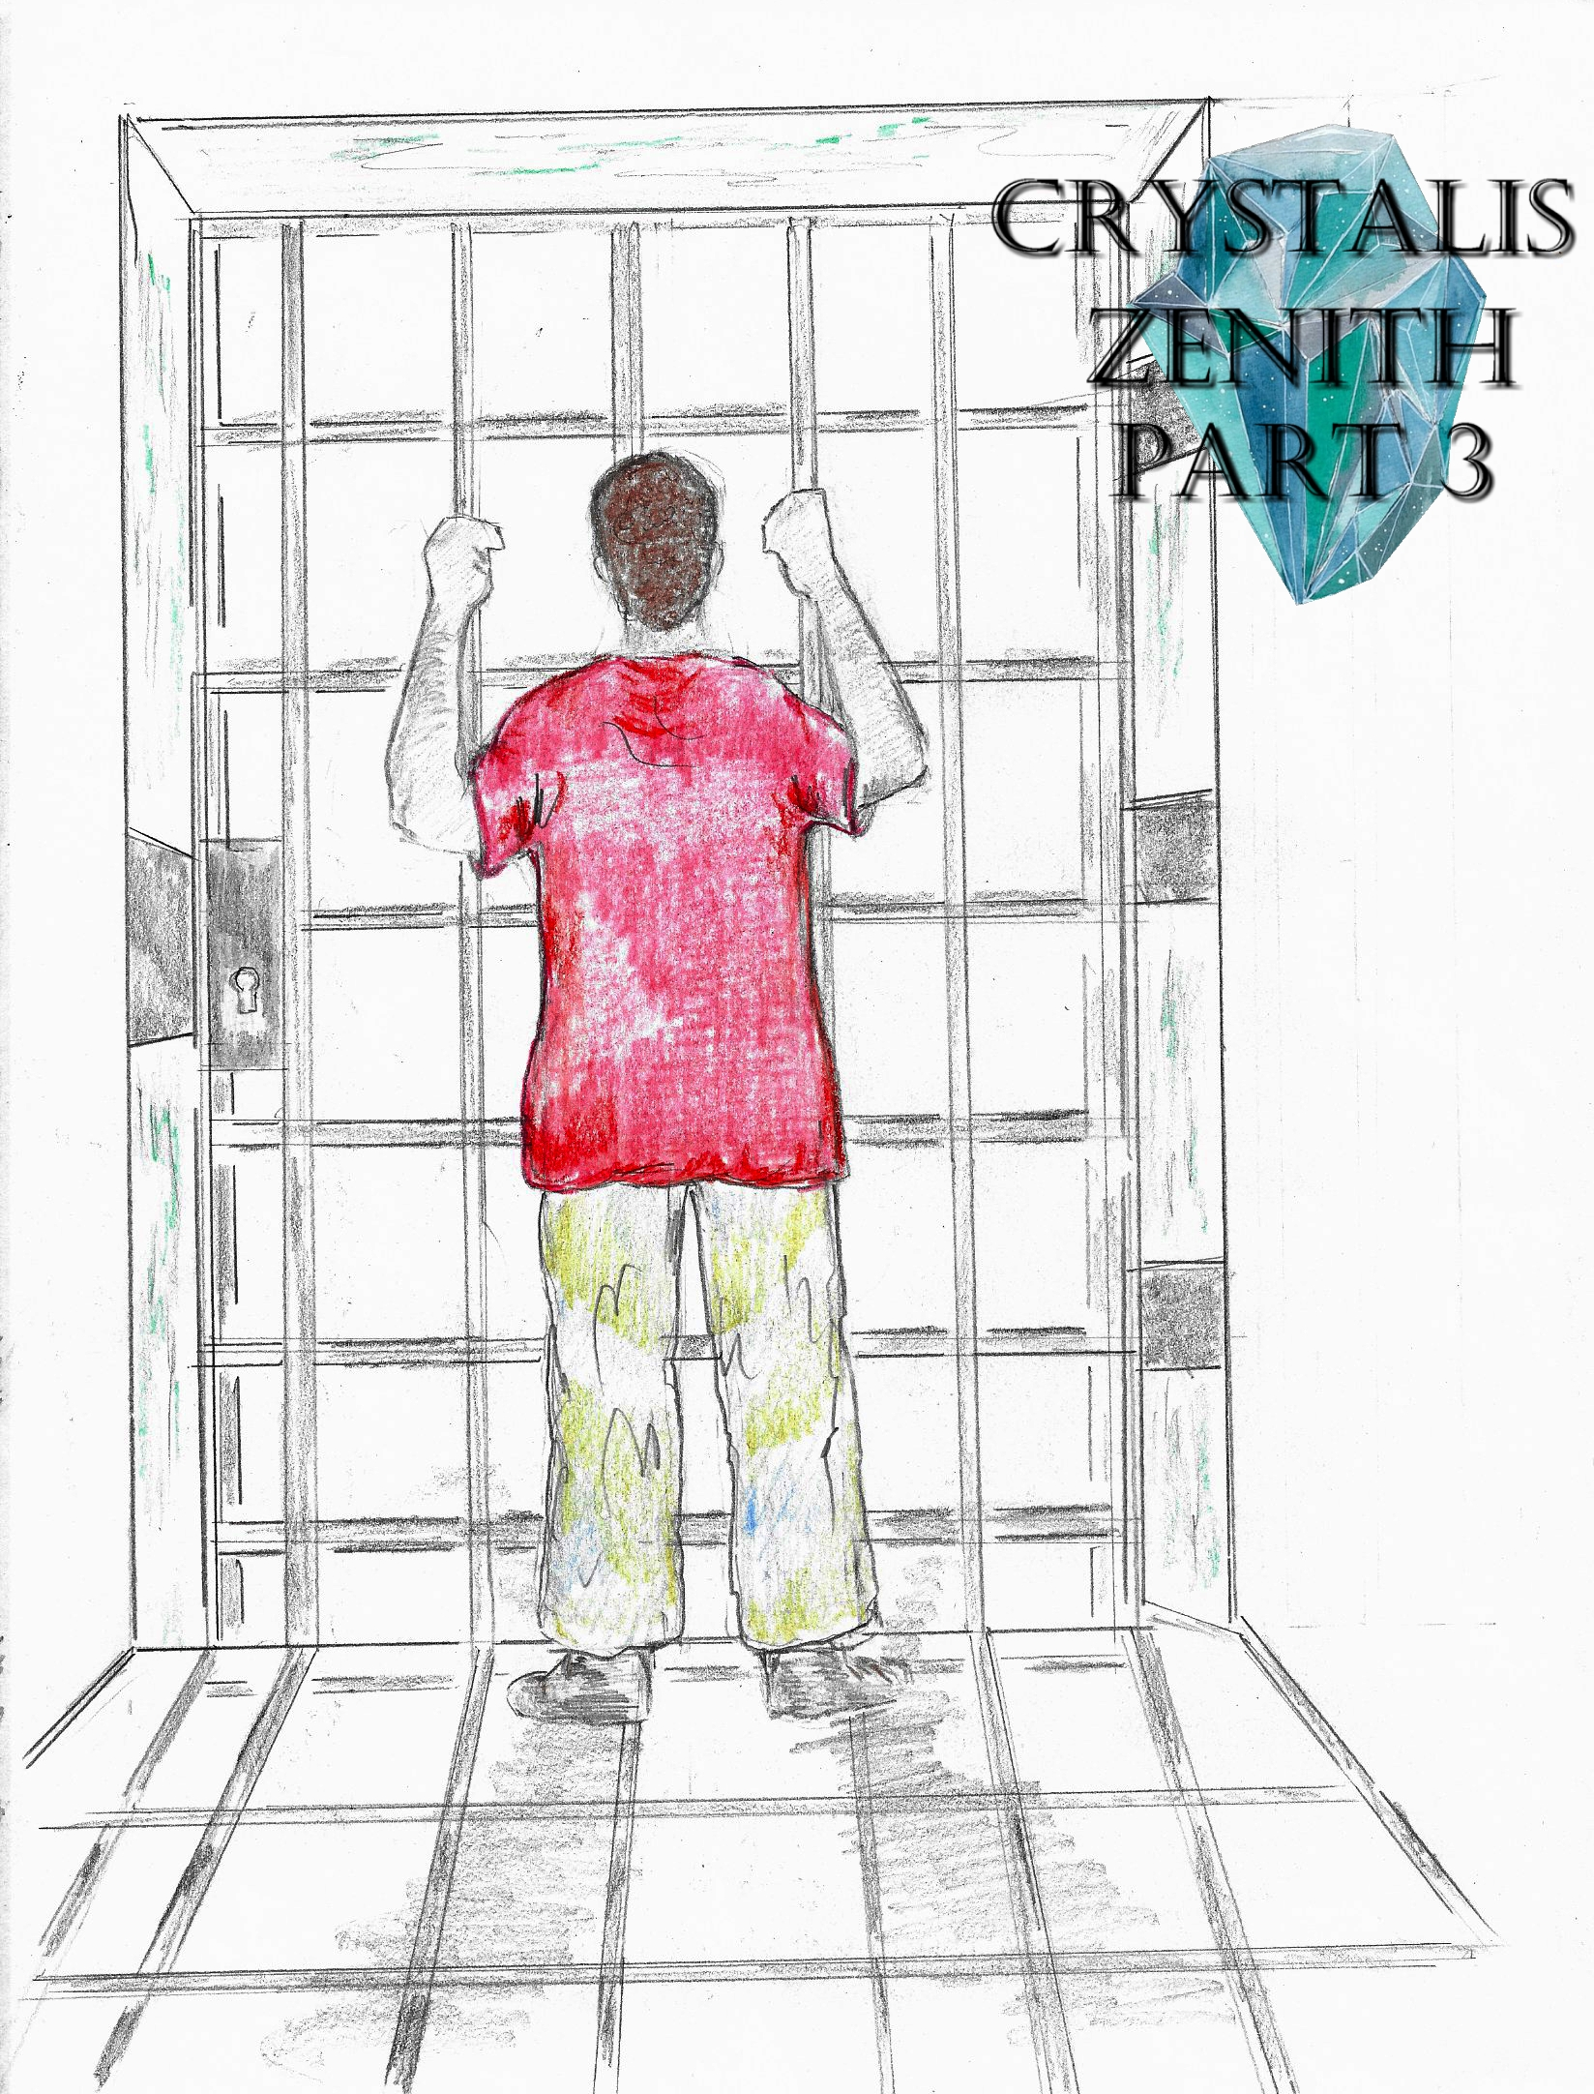

*Crystalis Zenith* (A Part of *The Crystalis Saga*)

Copyright © 2013 James Bullock

Copyright Registration #: TXU001847418

Cover art and design: Vickie Bullock (vickiesart.com)

All rights are reserved to the author. No part of this ebook may be used or reproduced in any manner whatsoever without written permission except in the case of brief quotations embodied in critical articles or reviews.

This is a work of fiction. Names, character, places and incidents are either the product of the author’s imagination or are used fictitiously, and any resemblance to actual persons, living or dead, business establishments, events or locales is entirely coincidental.

## A Wise Truth

Maverick awoke facing a steel door in what appeared to be a prison cell. It seemed like only minutes earlier that Maverick went through a portal to rescue his friend Miri from a group of robe-wearing individuals that abducted her. Prior to Maverick confronting the person who revealed Miri’s capture – Casimir – Maverick’s best friend was brutally attacked and hung from a tree by another member of this “order of people not made for this world”, Ove.

The dingy area Maverick lay on was wet from ceiling drippings. As Maverick gained his bearings, he overheard two men talking alongside nearing footsteps.

A loud banging on Maverick’s cell door was a precursor for the apparent guard to declare, “Time to go.”

Maverick approached the room’s only entrance to be released, but the jailer wouldn’t let him out until Maverick put on the handcuffs lying beside the door. Maverick obliged so that he as wasted little time as possible in hopes of quickly saving Miri. The doorkeeper led Maverick down a dimly lit hallway toward two massive doors featuring a map of the world literally carved into its wooden exterior. Above the doors was a sign that read, “None Shall Enter Without Baqir.”

The doors opened to reveal a structurally circular room. Maverick covered his eyes as they adjusted to the sudden rush of light. When Maverick lowered his hands, he saw the same four robed people who attacked Miri and himself standing side by side. Even with anger starting to overcome his senses, Maverick kept visibly calm and observed three egg-shaped crystals of various colors seated on a small, round platform. The red, blue, and yellow crystals sparkled brightly.

The man known as Casimir stepped away from his peers to greet Maverick, “Welcome to our home.”

Maverick grumbled, “Looks more like a cave to me,” when he recognized Casimir’s voice.

Casimir laughed before confirming Maverick’s claims, “Yes, this area was made for seclusion. But no man or beast can enter this cave. That is unless we are the ones who bring them.”

“I really don’t care what this place is. Why am I here? And where is Miri?”

“Yes, to the point as always it appears,” Casimir replied. “You are here to help us become the only people to find the lost city.”

Intrigue enveloped Maverick’s subsequent question, “There’s a lost city?”

Returning by his comrades, Casimir explained the basis of his previous statement, “Before the hands of King Gonan touched the land that would later become Gonaga, he lived in another place. High above the clouds this piece of paradise sits. Hundreds of years after its creation, the land known as ‘Baten’ experienced an uprising. From that revolution came the banishment of Gonan, his followers, and the king and queen.”

Maverick had to know, “So why wasn’t this taught to me or anyone that I know?”

Casimir suddenly stopped walking prior to telling Maverick, “Not every truth is so easily accessible. Some writings are only shown to those who search diligently for them. King Gonan documented the story of his banishment during the building of Gonaga. Seemingly realizing that his future ancestors would think of him as nothing more than a rebel who came into power, he hid his writings. Somehow, the words written by Gonan found its way here; where I discovered them as a child.”

Maverick shouted when his mouth dropped open, “A child?”

“Yes, similar to you, I never knew my parents--”

“What?” Maverick interrupted Casimir after the startling statement regarding his family. “I know my parents very well.”

“Excuse my comments,” Casimir responded, showing his covered back to Maverick once again. “Sometimes I say preposterous things without thinking. Let me continue with the story. During my growth, I met these four: Hamza, Agrona, Ove & San. All of us orphans. We’ve never had a life outside of these cold walls.”

Maverick audibly pointed out that only three people occupied the room outside of Casimir and himself.

Casimir informed Maverick that the fifth member, San, was on a special quest. Impatience grew in Maverick since Casimir’s tale had nothing to do with Miri.

Even though Maverick’s anxiousness shown in his movements, Casimir went on with his story; speaking about the writings of Gonaga’s first king, “Gonan described Baten as, ‘…a place where paradise meets Hell.’ The land where people with similar beliefs are held high while others aren’t so blessed. Vision and patience are beaten down by mediocrity and a lack of individuality. The people of Baten have a singular purpose: to serve their royal family and follow their decrees. Baten is the land where leaders are really needed. So we started searching the globe for what Gonan called ‘The Sky’s Five Keys.’ When each key is retrieved, a lock is opened.”

A smirk formed on Maverick’s face as he asked Casimir, “You’ve been searching for years, but can’t find any keys without me?”

“No,” Casimir retorted. “We have the first three. But to find the last one, we do need you and your friend.”

The sigh exiting Maverick’s body came from a relieved thought, *So, they’re not gonna hurt her?*

Casimir noticed Maverick’s shoulders slumping as if his guest had just let out a huge breath before resuming his explanation, “I attained the first key inside a cave outside of Tyrong’s Great Volcano. Once the key was in my hands, the first lock opened – the volcano itself.”

Like a light bulb going off in his head, Maverick audibly remembered some of his educational lessons, “Is that what caused the eruption that nearly destroyed Tyrong almost thirty years ago?”

A pleased Casimir confirmed Maverick’s assumption as, “Correct, my astute friend. Hamza was next. You remember Hamza, Maverick? The giant who crushed the garbage bin. Our large friend dove into the sea’s depths near Majan. The next stronghold destroyed thanks to Hamza’s successful journey saw the ocean become restless.”

“The Majan Tsunami happened a year after Tyrong’s volcano erupted,” Maverick said to himself – bringing a slight chuckle from Casimir apparently due to the observation.

“Next was Ove’s mission,” Casimir continued. “The desolate plains of Jarad held the third key. Ove almost suffered a terrible demise as the land began to sink into the ocean without warning just as completed his quest; rushing as fast as possible to the only portal home. And now there’s Yafan.”

Making his way toward Casimir, Maverick quickly asked, “What are you gonna to do there?”

Casimir sidestepped Maverick’s incoming hands as his guest reached for Casimir's robe, shifting his body so Maverick collided with the nearby wall.

Titling his covered head upward, Casimir declared, “We are going to find the key of Yafan. Ove sensed its power inside the park your friend attacked him. But it’s San’s duty to find Yafan’s key.”

Baqir – the person who escorted Maverick to the circular room – reentered the room to return Maverick to his cell. The knowledge of Miri’s safety allowed Maverick to leave without rebuttal; though he couldn't help but worry about his homeland.

Several hours passed for a jailed Maverick until Baqir returned with the words, “Casimir needs to talk to you.”

Casimir could be heard laughing from the Maverick-dubbed “Crystal Room” as Maverick approached the occupied space’s large doors.

Rushing Maverick enthusiastically, Casimir alerted his visitor, “Good to see you again. San has completed his mission. Watch.”

A platform holding the three crystals lowered. Inside each crystal shown San standing in the wooded park where Ove and Casimir appeared before Maverick & his friends. A motionless San abruptly threw a rectangular-shaped, orange colored item into the air. Gathering winds rocked the trees surrounding San as the object flew upward. Alongside Casimir and the rest of his hooded allies, Maverick watched a gigantic tornado form. Casimir turned to look at Maverick and observe the concerned expression on his face. This destructive force laid waste to everything in its path for five minutes. And as suddenly as the phenomenon occurred, the tornado died.

Maverick begged Casimir to let him go back home, but Casimir refused while stating, “You have nothing to worry about.”

“What do you mean ‘I have nothing to worry about?’ My family could be hurt, or worse! I need to help them, now!”

“You have nothing to worry about because every lock that opened saw no direct loss of life. Your friends and family might be injured, but not dead. I’ve given you nothing but the truth thus far. You must stay here until San returns.”

Maverick paced back and forth in the Crystal Room until San returned with an orange crystal in hand. San laid his crystal on the platform as Casimir approached Maverick, putting his hands on his visitor’s shoulders. Casimir’s action disgusted Maverick enough for him to pull away.

“I thought you’d be happy, Maverick,” Casimir said.

Maverick immediately asked, “About what?”

“You going home.”

Coming face to hooded face, Maverick rejected the option of leaving without Miri.

Casimir reminded Maverick that he didn’t have to worry about Miri’s safety before telling him, “You have three hours. When those hours are up, you’ll return here. And be forewarned – you cannot escape us.”

Maverick peered down to find Casimir’s right hand extended in his direction. When Casimir realized Maverick wasn’t going to shake hands, Casimir stepped aside so Maverick could witness a portal appearing on the wall adjacent to them. Before Maverick could ask about the gateway, the man he learned was Hamza pushed Maverick into this wavering exit.

*What in the world did I do to get myself into this?* Maverick thought, swirling through the perpetual darkness toward an expected destination of Yafan.

Just as he thought there was no end to his travel, Maverick found himself approaching a bright white light. Maverick pushed through the opaque abyss, reaching the illumination. Suddenly, Maverick hit solid ground. Looking around revealed to Maverick that he was now in Yafan’s destroyed park.

Maverick collected himself, running home. During his trip, Maverick observed distressed people searching for loved ones, helping the wounded, and trying to figure out how a tornado appeared without warning. Like so many houses around his neighborhood, Maverick’s home place was wrecked by the tornado. Somehow, most of Maverick’s room survived the unnatural disaster. Not far from his bed was a tattered piece of paper featuring his mother’s handwriting.

Maverick assumed it was about his sudden disappearance, picking up the sheet to read it out loud, “We don’t know where you are, but we love you. We’ll try to make it to the shelter before our house caves in. Hope you’re safe. Love, Mom & Dad.”

Maverick thought, *Maybe they made it to the underground shelter*, as he raced toward Yafan United Hospital.

A half of mile north of the hospital stood a steel refuge that survived the destructive winds. Maverick knocked on the shelter’s front door to come in.

Someone suddenly tapped Maverick on his left shoulder to tell him, “Everyone’s out, Maverick.”

Maverick turned to discover Jeff’s father was responsible for the message.

When Maverick asked if his parents were okay, his best friend’s parent informed him, “I believe they’re at your classmate’s home. What’s her name? Oh yeah, Miri. They’re at Miri’s house.”

Following a quick, relieving conversation about Jeff’s positive recovery, Maverick ran toward Miri’s home. Seated on the front porch of an almost untouched structure were Miri’s parents waiting for their daughter’s return.

Upon seeing Maverick’s face, Miri’s mother confronted him with a question, “Where’s our daughter?”

Once again, Maverick figured telling a lie was the best option, “I think she got away. I wasn’t with her, but I think she’s safe. Do you know where my parents are?”

Miri’s dad spoke up, “They’re at the library... or the remnants of it.”

Maverick thanked Miri’s parents and promised to find Miri before beginning another run. Approaching the wrecked Athenaeum he spent too few hours inside, Maverick found his mother lying on a cot, but his father missing.

Surprisingly, Maverick’s mother voiced her displeasure at seeing her only child, “Maverick, why did you come back?”

“Why shouldn’t I have?” a perplexed Maverick asked.

Tears started flowing from Maverick’s mother’s eyes, bringing Maverick to his knees beside her resting spot.

She blurted out, “I don’t know where he is?”

“Who?” Maverick asked. “Where who is?”

“Your father. He went looking for you after helping everyone. When he didn’t come back, I thought he found you, and you two were safe somewhere. But now you’re here… and he’s--”

Maverick quickly embraced his sobbing parent.

After several seconds, Maverick’s mother shoved him away to tell her son something else very important, “I hadn’t planned for this until my dying days, but I think you need to know now. Maverick, I’m not your real mother.”

Maverick’s face lost all color as he collapsed into a seated position. Were Casimir’s words a slip of the tongue, or did he really know something Maverick didn’t about his own life?

A bewildered Maverick feverishly said, “Yes you are,” repeatedly until the only woman he’s known as his mother physically stopped his words by covering his mouth with both her hands.

Almost somber in tone, Maverick’s maternal guardian explained to her son, “No. Your father and I adopted you when you couldn’t even speak. Maverick, your family… your real family is in Gonaga. If there’s ever been a chance to find them outside of our deaths, this is it. Maverick, use this time while Yafan can do nothing for you to find them.”

Maverick didn’t want to abandon his mother in such a helpless state, but she commanded him to leave, “I’ll be fine. Your birth mother told me something the day she gave you to us, ‘Take care of him. He’s the last hope.’ I don’t know what she meant, but going to Gonaga could help you find out. Here. Here is some money for your trip.”

When Maverick saw that his mother wouldn’t allow him to stay, he hugged her and graciously accepted the money prior to returning to the park. Maverick immediately noticed the portal that would return him to the cave.

Shooting through the void yet again, Maverick verbally confronted an approaching Casimir upon reentering the Crystal Room, “You know the truth?”

Before Casimir could ask what his aggressive guest meant, Maverick grabbed Casimir by the front of his robe to demand, “Who are they?”

Casimir’s partners were about to attack Maverick for latching onto their spokesman in such a violent manner.

Casimir shooed his comrades away, asking Maverick seconds after his dismissive action, “Your birth parents? You want to know who they are?”

“And what about Miri?” Maverick said. “I wanna see her!”

Casimir motioned that he wouldn’t speak again until Maverick released him.

After Maverick obliged the request, Casimir told his questioner, “Second question first. If you’d like to see your precious Miri, look into the crystals.”

In the multi-colored gems Maverick saw Miri sleeping in an elegant white room.

Disturbed, Maverick asked Casimir, “What’s wrong with her?”

Casimir assured nothing was the matter with Miri, “She just needed some rest,” before talking about their next destination. “To find your answers, we must first return to Gonaga. Gonaga holds the fifth artifact; and only you have the ability to find Gonaga’s key.”

…to be continued