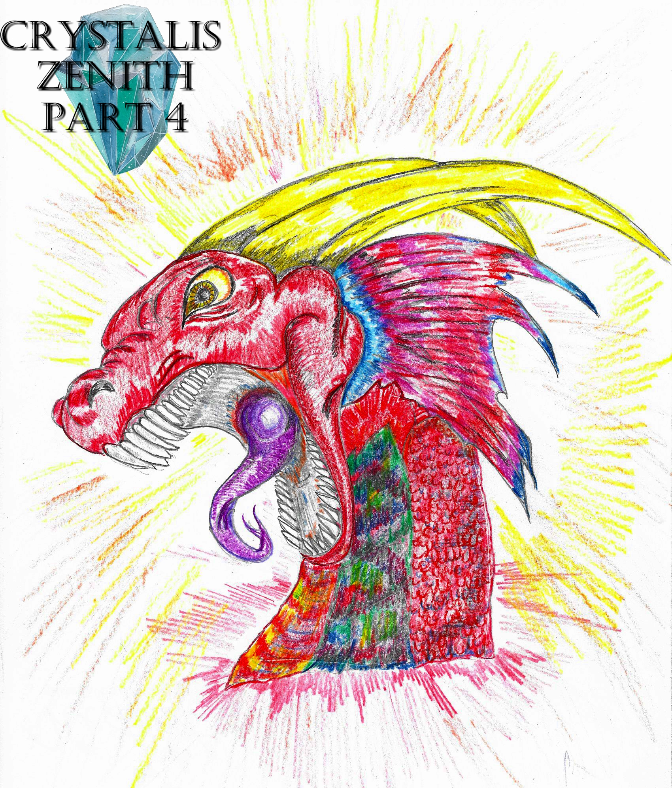
Crystalis Zenith (A Part of The Crystalis Saga)
Copyright © 2013 James Bullock
Copyright Registration #: TXU001847418
Cover art and design: Vickie Bullock (vickiesart.com)

All rights are reserved to the author. No part of this ebook may be used or reproduced in any manner whatsoever without written permission except in the case of brief quotations embodied in critical articles or reviews.
This is a work of fiction. Names, character, places and incidents are either the product of the author’s imagination or are used fictitiously, and any resemblance to actual persons, living or dead, business establishments, events or locales is entirely coincidental.

A Homecoming

In front of Maverick stood Casimir shrouded by his hooded, black robe. Maverick’s quest to rescue his friend Miri from Casimir and his group of similarly dressed individuals calling themselves an “order” was deterred by his mother informing Maverick that she and his father adopted their only son. Before this life-altering revelation, Maverick’s hometown of Yafan was ripped apart by a tornado caused by San – a member of the aforementioned “order” – retrieving one of “The Sky’s Five Keys” that would supposedly allow Casimir entrance into the lost city of “Baten”. Following the natural disaster, many Yafanites were injured and Maverick’s father lost. Maverick realized he had to forget about his mother’s words and save Miri – Casimir’s capture for the sake of acquiring the final key in Gonaga.
On the Crystal Room’s west wall – the area where the Casimir and everyone else brought these supposed “keys” that looked more like crystallized eggs – swirled a portal that Casimir confirmed would take everyone to Gonaga. Casimir’s allies San, Ove, Hamza & Agrona entered the portal before their spokesman.
As Casimir stepped forward to follow his comrades, Maverick gabbed Casimir’s right shoulder to inform the only person in the room other than himself, “I’m only going on one condition: You have to let Miri go when you get your key.”
Casimir lowly declared, “You have my word when this is all over.”
Releasing Casimir, Maverick trailed him into this gateway to Gonaga. Several moments passed during Maverick’s voyage through the abyss. Just like last his return to Yafan through a portal, Maverick moved alongside Casimir toward a white light. Going through this illumination saw Maverick find himself many feet above an exquisite grassland. Everyone was prepared for the drop except Maverick.
Maverick screamed during his descent, “Someone help me!”
Without much effort, Hamza threw his arms forward, catching Maverick before he could hit the ground. Maverick dusted himself off, thanking the giant of a man. The farmers who saw them were stunned watching five people in hooded robes moving alongside an older teenager down a dirt road in the city’s direction. During their walk, Maverick tried to strike up a conversation with the person who saved him from falling to his potential death.
Maverick nonchalantly asked Hamza, “So, how did they find a robe big enough for you?”
When Hamza didn’t answer Maverick, Casimir felt the need to give their acquaintance an explanation, “Hamza hasn’t spoken since the day he found the Majan key.”
Maverick had to know, “So what happened to him?”
“I believe the ocean’s pressure crushed his vocal cords.”
Not long after their short conversation did the six reach Gonaga’s exquisite north entrance.
Seeing the bustling Gonaga Marketplace in the distance, Casimir told Maverick, “We will walk around the town. Maverick, why don’t you go look for your family? We’ll meet here in three hours.”
Maverick hastily replied, “For you guys to find the key, leave me behind, and stop me from saving Miri. You’re not gonna pull a fast one on me.”
For the first time, Agrona spoke to reveal she was a woman, “If Casimir says we’ll be back, we will be back. So go, boy.”
Though disrespected by Agrona's demeaning tone, Maverick took his opportunity to leave; becoming enamored with the enormity of Gonaga Marketplace. After walking for nearly an hour, Maverick came upon the Heroes Memorial not a mile east from the place he and his other tourists temporarily parted ways.
Maverick gazed at each statue before reading the base’s plaque, “Princess Serena of Gonaga – daughter of King Goga III & Queen Helena of Gonaga – Jake, Jas, Dash & Ken sacrificed of themselves to save this world.”
Noticing that the last statue was disconnected from the others, Maverick assumed the lone sculpture was built after the originals.
Maverick bent over to read the golden plate’s inscription below the statue, “Russell – son of Princess Serena of Gonaga and Jake; father, hero.”
An elderly woman suddenly poked Maverick’s back with her cane.
Maverick, reasonably aggravated, asked this woman, “Hey, whaddya do that for?”
“I’m sorry, young man,” she replied. “But…. Just like I thought. You’re a dead ringer for him.”
The elderly woman lifted her quivering right index finger to point at the Russell statue.
Thinking about the woman’s words for a second, Maverick blurted out, “Ma’am, I think you might’ve given me some answers. Thanks!”
Maverick believed a trip to Gonaga Castle could help him in his quest to find his true parents; arriving at the castle thirty minutes following his talk with the older woman. Not far from the castle stood a middle-aged man that Maverick thought might know of Russell and his family.
The Gonagan informed Maverick, “They were really nice kids growing up – Russell and Jade. I don’t why they haven’t made a statue for her and Russell’s sister yet. When Russell left, Jade left with him. Jade came back a few years later with a baby boy in her arms. Then… it happened. It was a dark day for Gonaga. I don’t know all the details, but I do know Jade and her son left Gonaga as it was going on.”
Maverick didn’t expect such a story, but still had the most important question unanswered, “Do you know where they went?”
“I’m sorry, but no. Some say they changed their names and are now living on some remote island. Many believe they’ve passed away, though.”
A sigh of disappointment came out of Maverick’s body, but Maverick refused to believe his trail for clues had grown cold thanks to unconfirmed rumors. Though doubt started clouding Maverick’s mind, he believed some real answers might be inside Gonaga Castle. Security was tight as Maverick entered the castle grounds. After explaining his story, the guards shockingly allowed Maverick to explore Gonaga Castle with an escort. Awestruck was Maverick by the various pieces of art decorating the castle’s lengthy halls.
Maverick asked his chaperone, “What’s this?” while pointing at a painting featuring Russell, another man, and two women.
The Gonagan guard smiled at Maverick upon saying, “That was made probably before you were born. Those were some magnificent people. And that kid – the tallest one--”
Maverick enthusiastically interrupted, “Russell!”
“I guess you saw the memorial. Yep, Russell was the strongest of them all. As a matter of fact, you look a lot like him.”
“Yeah, I’ve been hearing that a lot.”
Maverick and his escort approached a pair of giant, golden doors separating the hallway from the castle’s Throne Room. To Maverick’s surprise, the man accompanying Maverick told him to wait as he explained to the queen about Maverick’s presence.
Even more astonishing to Maverick was the guard exiting the Throne Room with a message no less than a minute later, “You can go in now.”
With her legs crossed, Queen Athena sat on her marble, jewel-encrusted chair; her head titled forward with a dull glimmer in her eyes. The queen’s face had aged greatly from the stress of losing those closest to her.
“What do you want, young man?” Queen Athena inquired when the doors closed behind Maverick after both he and the sentinel entered the Throne Room.
Maverick’s ability to think & speak had seemingly deteriorated when he couldn’t form a coherent answer, “Well… Queen Athena, I was wondering. You see, Queen Athena…--”
“Spit it out, or I’ll kick you out!” the Queen of Gonaga shouted – shaking Maverick out of his nervous maundering.
“I’m sorry, Queen Athena. It’s just this is something I never expected to do. I’m here because I need some answers. I just recently found out that I’m adopted and my blood family is from here, Gonaga.”
The queen coughed, clearing her throat before asking, “And what does that have to do with me?”
Inching closer to Queen Athena’s throne, Maverick explained, “Well, I was wondering if you know anything about this Russell guy?”
The Queen of Gonaga finally took notice of Maverick’s face upon hearing the name of her deceased nephew to find a near duplicate of Russell standing in front of her. Unbeknownst to Maverick, the queen’s light brown eyes shown a spark of excitement unlike anything seen since that tragic day when “they” arrived in Gonaga.
Queen Athena asked her guest, “Who did you say you are?”
Maverick formally introducing himself made Athena to think twice about what the queen’s eyes were telling her, You can’t be Russell, but you look so much like him. The only difference is your eyes. You have… Jade’s eyes.
“Do I know your parents?” Queen Athena queried to Maverick.
“The only parents I know is my foster parents, so I don’t really look like them. And they’ve never been outta Yafan.”
Gracefully rising from her throne, Queen Athena ordered Maverick to follow her to the castle’s library. When the two entered this enormous room house books & scrolls decades older than both the Queen of Gonaga and Maverick, Athena requested Jade’s writings. The librarian pulled down a thick pair of notebooks from the very top shelf.
Queen Athena told Maverick as she sat him down at a nearby table, “This book was written by my nephew’s wife before her disappearance. I believe this will help you in your journey for answers.”
A stunned Maverick replied, “Are… are you giving this to me?”
“This is her original copy. We have duplicates, but I feel you should at least see her handwriting for yourself. But I want it back when you’re done.”
Queen Athena started walking toward their entrance point, leaving Maverick to himself. As Maverick rose to follow Gonaga’s sole ruler again, he heard something hit the floor. Maverick’s eyes moved toward the sound’s source to discover a sparkling piece of crystal slightly thicker than five sheets of paper and in the shape of a rectangle lying on the floor. Directly above the crystal’s landing point sat an old, tattered, torn book about to fall as well. Maverick waited until the book left its perch so he could catch this old piece of literature and tell the librarian about what happened.
Holding the book, Maverick started an inner debate, Is this the key Casimir’s looking for. I mean, it is the only crystal I've seen since I got here; and it was in the castle. Seeing what happened at home, giving them this key could mean a lot of people getting hurt. But it’s the only way I can save Miri.
Pocketing the possible final key, Maverick laid the large book down to chase after Queen Athena. Thankfully for Maverick, the reason for his leaving the room was waiting for Maverick to tell him how nice it was to meet him. Maverick expressed his confusion over the queen’s willingness to assist a stranger.
“I think I’m part of the truth you’re looking for,” Queen Athena admitted. “Now, go. I have business to attend to.”
Maverick graciously thanked one of the most powerful people in the world for all of her help, exiting Gonaga Castle. Queen Athena returned to her throne prior to calling for the guard who brought Maverick to her.
When the Gonagan sentinel entered the Throne Room once more, Queen Athena said, “That boy – you might want to keep an eye on him.”
The guard verbalized his confusion, “Why? He seemed like a nice kid.”
“Why yes he did. So much like Russell.”

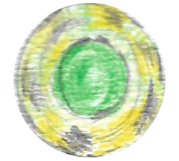

On the other side of Gonaga, the five individuals who brought Maverick to this land were still observing the townspeople. Ove stepped behind Casimir during their walk through the crowded streets. Concern in Ove’s mind turned into an audible question about whether or not a random Gonagan would remember them.
Agrona reminded Ove, “Like all animals, these people have short memories. When something brutal happens to them, they forget their tragedy and rebuild. Or banish you.”
Unlike Ove, Hamza found himself at ease with his surroundings.
Ove spoke upon noticing Hamza’s body language, “Your right, Hamza. This is a nice place.”
Trailing the two giants was an agitated Agrona almost screeched her question for the conversationalists, “Will you two shut up for five minutes?”
Ove suddenly halting his walk saw Agrona bumping into Ove’s back.
With his baritone voice ever so soothing, Ove calmly asked Agrona, “What’s the matter?”
“I appreciate your nature,” Agrona replied without physically focusing on her target Ove. “But would you kindly shut your gigantic trap?”
Casimir – who was in the front of this robed line – turned around to calm his quarreling cohorts.
Instead of heeding their leader’s command, Agrona voiced her growing frustration about being around people she felt were inferior to her, “I’m tired of this place. I’m tired of these insects that don’t have a clue what kind of power is walking by them. Where’s the boy? You said he’d bring us the key.”
“He will,” Ove responded. “Just give him time. We have waited years to get to this point. What’s a few more hours?”
Agrona crossed her covered arms, mumbling, “Whatever.”
Not far from the five walked Maverick still contemplating about giving Casimir the crystal he found in Gonaga Castle’s library. Maverick’s eyes moved from the believed key to see Casimir leading his partners through the streets of Gonaga.
“I guess I have no choice if I wanna save Miri,” Maverick said to himself.
A loud swallowing sound could be heard coming from Maverick before he said in Casimir’s direction, “Hey, Casi!”
Casimir didn’t understand the name, but could tell it was Maverick who shouted the statement.
Running over to Casimir, Maverick asked him, “Did you hear me call your name?”
“My name is not ‘Casi,’” Casimir retorted.
Agrona moved beside Casimir to tell him, “I think it sounds great. Casi it is.”
Noticing the notebook in Maverick’s left hand allowed Casimir to ignore Agrona’s comment about his new nickname.
Casimir immediately asked Maverick, “Where did you find that?” as he reached for Jade’s book.
Maverick yanked his arm back so Casimir couldn’t get a hold of this important item.
“Before I answer, can I see your face?” Maverick said. “I’m helping you guys. At least you could show me your faces.”
For the first time since meeting Maverick, Casimir’s words were a lot less gentle, “You’ll see our faces in due time. Now, what about that book?”
Maverick took a seat roadside after handing Jade’s writings to Casimir.
As Casimir flipped through the pages, Maverick answered Casimir’s question in regards as to how he attained the notebook, “Queen Athena gave it to me. She said it might help me find my birth parents. I also found something--”
A familiar sound of the crystal falling out of his hand broke Maverick’s train of thought.
Agrona squealed, “The key!” before jumping to the ground to grab what was once in Maverick’s possession.
Nervousness ran through Maverick again when Agrona held the crystal skyward.

In Gonaga Castle, Queen Athena felt something wrong in the air. The Queen of Gonaga shouted for her royal guards. When four of the patrolling Gonagan sentinels entered her Throne Room, Queen Athena asked her guards about the surrounding areas’ statuses.
“No problems,” one of the men informed his queen. “Nothing’s happened all day.”
Just as Gonaga’s queen questioned her senses, the castle started vibrating. Queen Athena ordered her soldiers to find out what was happening. When the Gonagan sentries left their designated areas, they witnessed townspeople scurrying like scared animals. The men who are sworn to protect their royal family pushed and prodded their way through the crowd to see the source of this abrupt anarchy. Concrete slabs that made the streets were splitting. Two of the slower guards were caught between the dividing ground, plummeting into the planet. Thankfully for one of the patrolmen, his right hand latched onto the jagged concrete while the other Gonagan met his end. Hearing frightened screams from their fellow sentry alerted the vanguard runners. The two guards turned around, hoping to save their fellow Gonagan before he fell to his death as well.
An intense heat flowing from the molten lava below immediately loosened the grip of the guards when they grabbed onto the life-threatened individual. Unable to hold onto his attempted saviors any longer, the Gonagan grasping on for dear life couldn’t keep his clutch and soon plummeted toward the liquefied rock. Both topside Gonagan royal guards yelled out as their ally approached his death. The unluckly soul was falling fast when a loud roar ripped through the sea of lava.
Following this thunderous bellowing from the planet’s depths saw an enormous, two-horned beast fly out of its holding below. The monster’s right horn impaled the descending Gonagan, ripping him in half. This dragon-like creature circled the area as the sun reflected beautifully off of its bright red body; its eyes like pools of blood. The dragon’s golden horns sat on its head like a crown. Gonagans witnessing this event couldn’t help but marvel at this beast whose size was that of a large whale.
Floating above the hole it appeared from, the creature asked with a voice as terrifying as booming thunder; a tone methodical and downright cold, “WHO HAS AWAKEN ME?”
Casimir stepped through and eventually to the forefront of the crowd to garner the beast’s attention.
The dragon proclaimed after seeing Casimir remove his hood to reveal his face, “YOU? ONE MAN WOULDN’T HAVE THE CAPABILITY TO SECURE ALL OF THE KEYS!”
“My brethren and I unlocked you from your molten state,” Casimir responded.
Slightly shifting its red eyes upon spotting Maverick taking a stand near Casimir, the beast queried, “DID HE HELP YOU?”
Casimir refused to acknowledge Maverick’s assistance, sending the person denied his credit into a verbal tizzy. Before Maverick could reach Casimir and physically remind him what he just went through, Hamza grabbed the belligerent Yafanite by his waist. Maverick couldn’t free himself from Hamza’s grip no matter how hard he tried. Wearing himself out, Maverick calmed down to the mysterious giant’s silent approval.
Suddenly, the monster cried out, “WHERE IS SHE?”
Casimir asked the dragon who “she” was.
“THE MORTAL KEY,” the creature explained.
With great haste, Casimir said to the dragon, “There’s nothing about a ‘Mortal Key’ in the writings.”
Repositioning itself in the sky as if was taking a stand on its hind legs & tail, the beast’s words echoed through the area,
“WHEN I AWAKEN, SHE TOO AWAKENS: THE ONE WHO WILL CONNECT THE TWO. BUT IF SHE REVEALS HERSELF TO YOU FIRST, CALL MY NAME WITH YOUR GREATEST CRIER. I AM CADEYRN.”
The beast unexpectedly took flight upward, disappearing in the clouds.
Approaching Casimir as he covered his head again, Agrona asked her spokesman, “Now what?”
Maverick wanted to know the same thing as Agrona. Casimir completely ignored Maverick and Agrona’s queries, moving toward Gonaga’s north gates.

Miri awoke to find herself lying on a magnificent bed in the middle of this blinding white room. When Miri prepared to stand up her left foot kicked a small box on the floor. From this little black box sat a silver locket shaped like a pair of wings. Underneath the locket were two paper slips.
Miri unfolded the top piece of paper after noticing something was written on it, reading it, Here is a family heirloom. Open it to reveal the truth.
Miri did as the note apparently ordered by taking the other slip. What Miri saw upon looking at the second paper startled her.
“Is that me?” Miri said to herself. “But it’s such an old picture. How could…?”
Miri’s thoughts immediately deteriorated in mid-sentence when she felt her body being taken over by a strange force. Miri looked down at her hands to see them glowing. The locket illuminated brightly alongside Miri while the light from her hands enveloped her entire body.
The light consumed Miri as she fell to her knees and screamed out, “What’s happening?”
Two white, scaly wings suddenly sprouted from Miri’s back. Miri moaning deeply was a precursor to the ceiling collapsing around her. This new opening gave Miri the surprising opportunity to fly away.

Casimir returned to his cave of a home to finalize his deal with Maverick. Leading the pack into the Crystal Room was Hamza so he could place a green crystal on top of the platform with the other colored jewels. The powerful “keys” glowed immaculately once the fifth was added to the collection. In the crystals shown a wrecked and empty room Miri occupied before Maverick traveled to Gonaga.
With good reason, Maverick screamed at Casimir, “What did you do with her?”
Once again, Maverick grabbed the group’s main speaker by the front of his robe. Before Maverick could attain an answer, Hamza shoved the person clutching his friend so Maverick forcibly released Casimir.
Casimir admitted when Maverick stopped making advances toward him, “I-I do not know what happened to her. She was there when we left as you saw.”
Casimir called in Baqir – the guard who watched over the cave – to find out what happened while they were gone. Baqir explained that he heard a loud crash resonate from the room, only to find Miri gone when he entered.
Waving Baqir away, Casimir whispered, “Thank you.”
Maverick stepped in with a retort, “No you don’t leave now! Where is she?”
Following his question, Maverick grabbed Baqir by the throat. As his grip tightened around Baqir’s neck, Maverick’s eyes sparked like lightning in the night. Baqir begged for Maverick to let him go before he couldn’t breathe for good.
Everyone felt a tremendous energy rising inside Maverick, forcing Agrona to ask Casimir, “What is wrong with him?”
“Seems like he’s gifted,” Casimir mumbled. “His ancestors were, too.”
“What kinda gift?” Maverick queried – relinquishing his hold of Baqir’s neck. “How am I ‘gifted’, Casimir?”
Casimir changed the subject, “Don’t worry about my insignificant ramblings. We need to find your friend first.”
While Ove, Hamza & Agrona searched the cave and San visited nearby, uninhabited islands surrounding the area, Casimir and Maverick investigated the room Miri once took rest.
Rather calmly, Maverick asked Casimir after scanning the wrecked room for almost ten minutes, “What’s your synopsis?”
“It looks like she found the locket,” Casimir replied.
Maverick’s ears perked up, wondering what Casimir was talking about.
Casimir leaned against a door that was only visible from the outside when he said, “We don’t know where it came from, but it was folded in a picture that featured her as a child.”
Stopping himself from grabbing Casimir in the same manner as he did when last confronting Baqir, Maverick shouted at the only other person in the room other than himself, “So that’s why you locked her in a room after abducting her? You coulda left it on her desk or something. You didn’t have to put her through this, you jerk!”
“No,” Casimir said as he turned to exit the room. “We needed to know what was in the locket and why it was here so long ago.”

Ove and Hamza were walking around the cave’s outside while Agrona complained behind them, “Why do we need them? We didn’t need that little worm to help us find the other keys.”
Ove chimed in, “Yes, but after what we did all of those years ago, there was no way we could get into Gonaga Castle.”
A quick response to Ove exited Agrona’s mouth, “Did I ask you?”
Stopping in his tracks, Hamza pointed at the sky. Agrona and Ove looked up to see a human with white wings flying in the distance.
Without making an initial sound, San appeared behind his three cohorts with a message, “She’s finally awakened.”
Agrona asked San, “What are you talking about?”
“The third dragon has awakened. The White Dragon. The Black Dragon. The Red Dragon. Just like the writings said, ‘One must sleep. One must succumb. One must sacrifice.’”
Ove wanted to know from his knowledgeable friend, “So which one is that one.”
“The one that slept has awakened. The White Dragon. The spawn of death and hope. We must tell Casimir.”
The four individuals who were outside moments ago reentered the cave to discover Casimir and Maverick returning to the Crystal Room.
Upon seeing Casimir, San informed him, “Casimir, we have some bad news. I believe the White Dragon has risen.”
Agrona needed to know, as did Maverick, “What’s the big deal?”
There was worry in Casimir’s voice when explained his reason for concern, “The writings say that two dragons were sent to the land below after Gonan was banished from Baten. These dragons would protect Baten by destroying the land if the inhabitants got too powerful and found the keys.”
Maverick hastily asked, “So, what happened to the other one; the Black Dragon?”
Even though Casimir read the books written by Gonan, he still never understood what happened to the Black Dragon, “According to Gonan, the Black Dragon flew for six months following Gonan’s banishment. Then it vanished. For years, the White Dragon tried to find the Black Dragon, but had to rest after searching. Then the Black Dragon reappeared to give a task that would free the White Dragon from its bondage to this land.”
The following sentence stumbled out of Maverick’s mouth, “A-and wh-what’s that?”
“To kill the Red Dragon.”
Frustration contorted Maverick’s face when his want to leave increased more with this dragon talk. Agrona jumped in front of Maverick to block his path.
Low in tone, Casimir ordered Agrona, “Let him go. He might find her better without us.”
Agrona followed Casimir’s command, allowing Maverick to reenter the portal to Gonaga.
As Maverick disappeared, Casimir demanded that Ove summon Cadeyrn, “I believe I know what the ‘Mortal Key’ is now. It’s time for a family reunion.”

Though Miri and he were from Yafan, Maverick had this unyielding urge to return to Gonaga. Maverick entered Gonaga Marketplace; discovering its people still coming to grips what what happened during his last trip.
A woman suddenly said to Maverick, “So, you’ve come back. And you’ve ditched the killers.”
Though the voice was unfamiliar to him, Maverick turned in the sound’s direction to find a statuesque female standing behind him. Her light brown hair sparkled in the sun, as did her skin. Her hazel eyes had innocence to them similar to Miri’s.
Maverick asked this now grinning woman, “Who are you?”
“Just your first babysitter. It’s good to see you again, Junior.”

…to be continued

