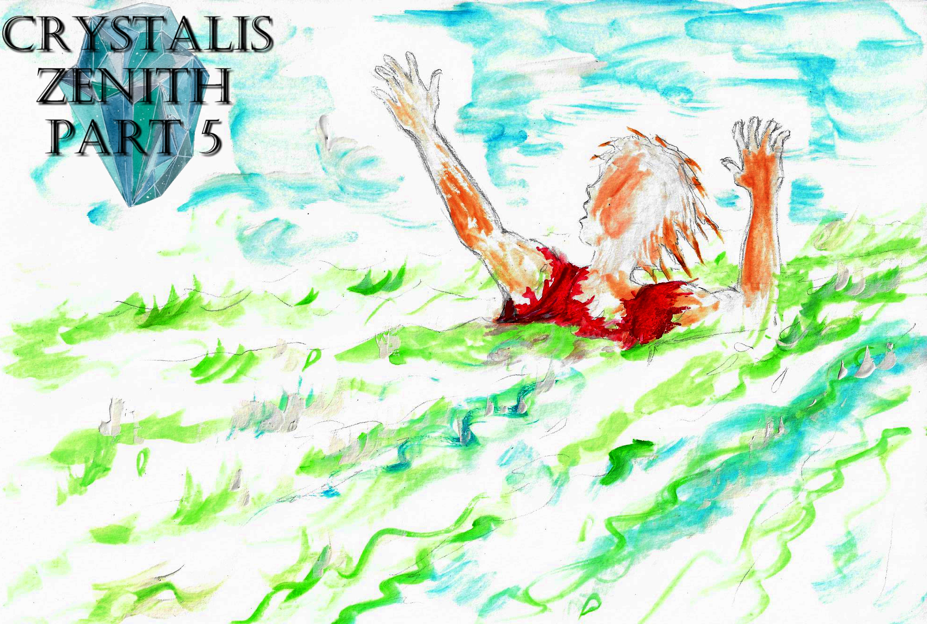
Crystalis Zenith (A Part of The Crystalis Saga)
Copyright © 2013 James Bullock
Copyright Registration #: TXU001847418
Cover art and design: Vickie Bullock (vickiesart.com)

All rights are reserved to the author. No part of this ebook may be used or reproduced in any manner whatsoever without written permission except in the case of brief quotations embodied in critical articles or reviews.
This is a work of fiction. Names, character, places and incidents are either the product of the author’s imagination or are used fictitiously, and any resemblance to actual persons, living or dead, business establishments, events or locales is entirely coincidental.

A Father’s Wake

So much happened to Maverick in the past few days. Completing his obligation to a mysterious group of five cave-dwelling crystal hunters by retrieving the fifth “key” that supposedly revealed a lost city in the sky, Maverick demanded to see Miri – who was captured by the aforementioned quintet. Unfortunately, Miri vanished from her holding place before Maverick could save her. Maverick left the cave, returning to Gonaga – an area recently terrorized by a mysterious red dragon that exited the planet when the five-some attained the “key” Maverick found inside Gonaga Castle thanks to some inadvertent assistance from Queen Athena. A few moments after returning to Gonaga, a stately woman claiming to be Maverick’s babysitter stopped the anxious young man.
Maverick informed the person who apparently knew him, but called him out of his name by stating, “My name’s not ‘Junior.’ It’s Maverick; always has, always will. And why do you think you know me?”
Nonchalantly she answered, “I told you I was the first person besides your mom to look out for you.”
“How come I don’t remember you then?”
The woman thought about her previous proclamation before explaining herself, “When you were just two years old, I would help you when your mom was having her reunion. You used to kiss me as a thank you.”
Maverick’s eyes lit up with joy before asking, “You know my mother? Where is she?”
Disappointment enveloped the woman’s words, “I don’t know. On that terrible day, she fled with you.”
Maverick’s shoulders slumped alongside his face.
Abruptly, a thought shot through his mind and fell out of Maverick’s mouth, “Wait, why should I believe you? Why am I believing someone who I’ve never met? And if I did meet you before, I don’t remember.”
She grabbed Maverick’s wrists, telling him, “Just come with me. I’ll show you everything.”
“We have to make this quick, though. I’m looking for my friend.”
“Don’t worry. I have a feeling she’ll turn up real soon.”
This enthusiastic lady led Maverick through the streets by his arms with the promise of revealing to him everything she knew. They arrived at a damaged house moments after Maverick asked about his whereabouts in this city larger than anything he ever imagined when thinking about Gonaga. The roof had been nearly burned off from the shooting lava that erupted during the red dragon Cadeyrn’s awakening. A man seemingly in his late fifties stood on the roof while another male who looked a tad bit younger than the first person climbed a ladder with his toolbox in hand.
Maverick’s escort said upon entering the yard, “Father, I’m home.”
The toolbox-carrying individual jumped down to greet his daughter before asking her a question, “Rachel, who is this? He looks so familiar.”
Her father watched Rachel’s eyes gleam upon saying, “It’s Junior!”
“You mean…. Oh, it’s so good to see you!”
Rachel’s father gripped Maverick’s hands, shaking them until Maverick’s arms grew tired.
Maverick decided to end this lengthy handshake by getting something straight, “First of all, my name is not ‘Junior.’ It’s Maverick. And who are you?”
Rachel’s father, still sporting a smile from ear to ear, had question of his own for Maverick, “Before I answer that, would you like something to eat?”
The roof repairer – who climbed the ladder during this quick verbal exchange until he was on the ground as well – had a message for Rachel’s parent, “Don’t startle the boy, Ken. After seein’ what happened today, he must be exhausted.”
“Actually, I’m just fine,” Maverick said. “This…. Rachel is your name, right? Well, Rachel told me she knew my birth mother.”
The unidentified man revealed, “Yeah, she did. But we knew her since she was a baby.”
Maverick wanted to hear everything these three strangers knew about the people responsible for his birth.
Poking Maverick’s left side with her right elbow, Rachel asked him, “I thought you had to find your friend.”
Maverick hadn’t forgotten his reason for returning to Gonaga.
“I know,” Maverick told Rachel. “But this is what I’ve been searching for, too. Do me a favor, Rachel. Stay right here. I need to find my friend. When I do, I’ll come back ASAP.”
Before he could leave, Rachel hugged Maverick while telling him, “Promise you’ll come back a lot quicker this time.”
For some reason, Maverick felt a rush of déjà vu following Rachel’s words and a need to make an audible commitment to return.
Maverick sprinted past a store, hearing the news reporting, “We are live in Sonfa. A red dragon is flying around the city, destroying everything it sees fit.”
Stopping in his tracks, Maverick listened to this unwarranted turn of events.
“Wait!” the reporter bellowed. “Another dragon just appeared! This one’s white! It’s only half the size of the first dragon. The red dragon looks to be about thirty feet tall, and maybe just as long.”
For some reason, Maverick couldn’t shake the desire to go to Sonfa and find out what was going on. Maverick ran as fast as he could toward the docks two miles east.
Spotting a lone fisherman, Maverick asked, “Sir, can I get a ride to Sonfa?”
The gray haired, balding, seemingly feeble fisherman responded, “Sure, but it’ll cost ya.”
Maverick grimaced after checking his pockets and discovering the only money he had was what his mother gave him before leaving Yafan in search for Miri.
“I don’t have much money,” Maverick admitted. “But I can get some more as soon as we get back.”
The fisherman opened a jar sitting to his left to retrieve a pair of eyeglasses.
Putting on his spectacles, this angler sized up Maverick; stating, “Well, you look like an honest fella. Hop in.”
Maverick followed the fisher’s command, peering around for a paddle. The fisherman leaned over, showing Maverick a motor that the captain of this vessel was blocking from Maverick’s view.
“I’m the fastest fisher in all the world,” the angler said with a grin. “Pull that cord and you’ll see why.”
Once again, Maverick listened to his elder’s order. Before Maverick could sit down, the boat shot out of the dock. Maverick barely hung on as his transportation ripped through the sea.

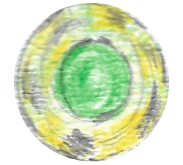

Cadeyrn sat atop the Sonfanian Temple – the land’s tallest building. The white dragon circled Cadeyrn with its golden eyes not looking away. With its wings expanded and chest bared, Cadeyrn physically begged for death. Cadeyrn’s optics suddenly shifted in the direction of an incoming missile. Before either dragon could react, the projectile collided with the white dragon. Though not seriously injured, the white dragon descended toward Sonfa; crushing everything its body touched.
Cadeyrn’s cry of, “NO!” shattered nearly all the windows directly below him. “YOU CAN NOT DIE HERE!”
Cadeyrn jumped off of the temple, partially crumbling this impressive structure under its forceful movement. Sonfanians scurried as a ball of fire started materializing from Cadeyrn’s open mouth. The jet responsible for shooting the white dragon positioned itself in front of Cadeyrn next. Sadly for this pilot, Cadeyrn’s fireball left the dragon’s mouth and obliterated its would-be attacker. Tanks showed up moments later, but were quickly destroyed by Cadeyrn. After slaughtering many Sonfanians with a barrage of fireballs, Cadeyrn noticed the white dragon was still motionless. In the middle of Sonfa’s now decaying metropolis ran one female doing her best to avoid every falling piece of stone & mortar debris.
“I guess this ain’t the end after all,” she said to herself as Cadeyrn shot down one final fireball.

Maverick and the fisherman were about five miles south of Sonfa when the boat’s motor died.
The fisher understandably shouted in anger, “My baby! I used everything I had to buy it! Worthless piece of junk!”
Distressed over his current predicament, Maverick asked, “How are we supposed to get to Sonfa now?”
“Plum if I know. Got an ore?”
Without warning, the fisherman’s eyes saw a fiery blast emanate from the sky above Sonfa.
Maverick’s driver wiped his forehead in relief after witnessing the catastrophic event, “Maybe it’s best we got stuck. Could you imagine if we got caught in that mess?”
The only thing on Maverick’s mind was the possibility of Miri being stuck in the middle of whatever was happening in Sonfa. This fear turned into determination for Maverick when he dove into the water, deciding to swim for Sonfa.
Maverick’s former escort screamed as Maverick fought through the raging waters, “Come back here! You’re gonna get yourself killed! And then where’s my money comin’ from?”
After swimming for almost an hour, Maverick noticed what appeared to be a landmass.
Maybe I can get a chance to catch my breath on that island, Maverick thought as his strokes slowed from fatigue.
A buzzing sound attracted Maverick’s ears until something cracked him on the head.

Unlike the white dragon, Cadeyrn fought the military assault sent by Majan to assist Sonfa. For every attack sent his way Cadeyrn retaliated with an even bigger fireball. The sudden halt in Cadeyrn’s fiery barrage was due to him losing sight of the now missing second beast.
Cadeyrn growled, “SHE’S RETREATED. I UNDERSTAND SHE HATES THE THOUGHT, BUT SHE MUST COMPLETE HER BIRTHRIGHT. I MUST SEE HER AGAIN!”
The Sonfanians that survived Cadeyrn’s onslaught began assisting wounded townspeople while reports started going out to other lands to warn them about Cadeyrn’s movement. Unfortunately, many dead bodies scattered the area surrounding the Sonfanian Temple. Several miles east of the destruction lay Maverick after he washed ashore. Maverick was barely conscious when a little girl spotted him. The child’s father prevented his daughter from touching this presumed dead body. Instead, the man checked Maverick upon seeing some type of movement from his torso.
This reasonably protective father ordered his offspring to acquire their neighbors, “Tell them we got a downed man here that needs to be taken to the shelter with the other girl they found.”
When he fully awoke, Maverick discovered himself surrounded by injured Sonfanians. Maverick immediately sat up, giving himself an even worse headache. The father who discovered Maverick was on a cot to his left and found himself surprised to see the injured foreigner moving so quickly.
After getting a conformation that Maverick’s head slightly hurt, the man responsible for saving him told Maverick, “My little girl found you. Funny thing is I found a girl almost at that exact same spot a couple of hours earlier. She passed out from dehydration”
Maverick hastily asked, “Who was the girl you found? Can I see her?”
The father didn’t understand why Maverick needed to meet a random person, but felt she could use some company. Helping Maverick to his feet, this helpful Sonfanian guided Maverick to a nearby mat where the girl lay.
It’s not Miri, Maverick said to himself when he sat down in front of a ten-year-old girl named Amanda.
Wearing a fake smile, Maverick introduced himself before stating, “It’s nice to meet you.”
The look on Maverick’s face changed as he explained, “I’m actually searching for another girl. She’s about a foot taller than you. She has brown hair and light hazel eyes. And a really smooth face even though she fights with me. Her favorite color is yellow and her favorite condiment is mustard. And her dream job is--”
“I didn’t know you knew so much about me” a familiar, feminine voice interrupted.
Maverick turned around to see Miri standing behind him. Without thinking about his head injury, Maverick jumped off of this new sitting place to tightly embrace his friend. After a couple of seconds, Maverick could feel Miri struggling to pull away.
Maverick quickly released his friend, apologizing to her, “I’m sorry. I’m just so…. I mean--”
“Don’t be upset,” Miri interrupted again. “Just a little sore. It’s good to see you again, too. How did you get here?”
“A nice fisherman brought…. Oh! You got a few bucks I can have?”
Miri couldn’t help but stare at Maverick in utter shock. Before the conversation could restart, Amanda brought two sodas she hoped would make Miri, Maverick, and herself feel better.
When everyone sat down, Maverick asked the girl he was most familiar with, “So, what happened to you? How did you get here?”
Miri motioned for Maverick to hand her his opened soda so she could take a sip.
“Honestly, I don’t know,” Miri said after swallowing some of Maverick’s beverage. “The night when Jeff was attacked you took me home. That’s the last thing I remember. Wait… I do remember being in a white room.”
Maverick mumbled to himself, “Yeah, that’s where they were holding you.”
Unable to make out what Maverick said, Miri ordered her friend to repeat himself.
Instead, Maverick told Miri, “Well, you weren’t the only one captured that night. I had to help those robed guys to save you. But it looks like you saved yourself.”
Once again, a stunned feeling ran through Miri. But unbeknownst to her, Miri’s golden face started blushing upon hearing Maverick’s amazing statement.
“You went out of your way like this to save me?” Miri asked.
Miri leaned forward, kissing Maverick’s left cheek. Continuing her upward movement, Miri announced that she needed to find a bathroom.
As Miri walked away, little Amanda tapped Maverick’s left shoulder to say something, but her words fell on deaf ears thanks to Miri’s kiss putting Maverick in a love-struck stupor.
When Miri returned, she had to know from Maverick, “Hey, what are you gonna do now?”
“I wanna go back to Gonaga,” Maverick replied. “I made a few promises to a couple of people over there.”
Miri jumped from her cot to excitedly say, “I guess that means I’m going to Gonaga for the first time!”
It was several days before the ports in Sonfa started running again. Maverick and Miri stayed at the shelter until they could travel – spending all of Maverick’s money in the process. They arrived at Gonaga a day after the first ship docked. Even with the destruction, Gonaga was still a very awe-inspiring sight.
After a couple of hours of walking and talking about what happened to them between the last time they saw each other, Miri wanted some answers about Rachel, “So, she knows about your real family?”
“Yeah,” Maverick responded; bringing a smile to his face. “But I don’t remember how I got to her house. Look for a messed up house with two old guys working on it.”
“Which one?”
Maverick realized Miri wasn’t being sarcastic when he saw that there were a lot of buildings being worked on by older men.

In Sonfa, the female who witnessed the entire incident with Cadeyrn & the white dragon was still alive. She watched as fireball after fireball destroyed everything around her, but somehow avoided injury. With nothing but the clothes on her back and her parents missing, she stayed in the same shelter that Maverick and Miri took residence.
It was there that this Sonfanian mentally noted a correlation between the white dragon and Miri, That beast had a pair of silver wings on its chest just like her. And she just showed up outta nowhere with burn marks when the dragon disappeared. I’ve heard some crazy things, but people turnin’ into dragons ain’t one of ‘em. But I gotta find out if it’s the same thing I saw up close. I gotta get to Gonaga.

…to be continued

